Financial Stability Report August 2020 Financial Policy Summary i

Financial Policy Summary



**The Financial Policy Committee (FPC) aims to ensure the UK financial system is prepared for, and resilient to, the wide range of risks it could face ― so that the system can serve UK households and businesses in bad times as well as good.**

**The Covid-19 pandemic is having a severely disruptive economic impact, with repercussions for UK households and businesses. The FPC is focused on ensuring that the financial system does not amplify economic stress, and that its resilience is put to good effect in the service of the UK economy during this period.**

**The performance of the UK financial system during the pandemic**

**UK households and businesses have needed support from the financial system to weather the economic disruption associated with Covid-19. Reflecting the resilience that has been built up since the global financial crisis and, alongside the extraordinary policy responses of the Government and of the Bank of England, the financial system has so far been able to provide that support.**

The Committee estimates that, under the central projection in the August 2020 *Monetary Policy Report* (*MPR*), companies could face a cash-flow deficit of up to around £200 billion. Although in aggregate they hold substantial buffers of cash, many UK businesses have needed additional financing to minimise the impact on employment and productive capacity.

With government-backed loan guarantee schemes in place, the financial system has met the initial surge in demand for credit. Stabilised by central bank actions, financial market functioning has recovered after an abrupt and disruptive ‘dash for cash’ in March. Since the start of the Covid-19 pandemic, businesses have raised over

£70 billion of net additional financing from banks ― primarily through government-backed loan guarantee schemes

* and through access to financial markets. Over the same period, they have borrowed £18 billion through the Covid Corporate Financing Facility (CCFF).

UK households entered the Covid-19 shock in a stronger financial position than at the start of the global financial crisis, in part due to financial policies that have guarded against an increase in the number of highly indebted households. This has been further supported by 1.9 million mortgage payment holidays granted to households, so that debt-servicing pressures remain low overall. It will be important for lenders to work flexibly with borrowers as they resume repayments.

**The outlook for financial stability as the Covid-19 shock evolves** Banks

While the number of corporate insolvencies has remained low to date, it is likely to increase. Some companies may struggle because they were highly leveraged or unprofitable at the outset and others face pressure because of structural changes in the economy. Unemployment is expected to rise. These developments mean banks will incur losses on their corporate, consumer and mortgage loan books.

In May, the FPC judged that banks had buffers of capital that were more than sufficient to absorb the cumulative losses under the illustrative economic scenario in the May *MPR* which, under prudent assumptions, generated credit losses of just over £80 billion.

As set out in the Monetary Policy Committee’s (MPC’s) central projection in the August *MPR*, economic output is expected to have fallen substantially, but the cumulative loss of output resulting from the pandemic is projected to

Financial Stability Report August 2020 Financial Policy Summary ii



be somewhat smaller than in the illustrative economic scenario in the May *MPR*. The FPC judges that the central projection would be consistent with credit losses of somewhat less than £80 billion and **therefore continues to judge that banks have buffers of capital more than sufficient to absorb the losses that are likely to arise under**

**the MPC’s central projection.** Also taking into account the Government’s lending guarantee schemes, banks have the capacity to continue providing credit to support the UK economy.

That said, the banking system cannot be resilient to all possible outcomes ― there are inevitably very severe economic outcomes that would challenge banks’ ability to lend.

However, the FPC recognises that, having entered a period of stress, there are costs to banks taking defensive actions, such as cutting lending to seek to boost their resilience. By restricting lending, those actions could make the central outlook materially worse.

The FPC therefore takes an explicitly countercyclical approach to stress testing banks; building up their resilience outside stress periods so that their buffers of capital can then be used in a stress to continue to lend. Defensive actions may be necessary in stress but only if there is a material probability of the economy following a path so severe that it might jeopardise banks’ resilience and challenge their ability to absorb losses and continue to lend.

The FPC has carried out a ‘reverse stress test’ to analyse how much worse than the central projection the economic outcome would need to be in order to deplete regulatory capital buffers by as much as in the 2019 stress test that informed the setting of those buffers. In that exercise, banks’ capital ratios were depleted by more than

5 percentage points. Because banks actually have capital buffers that are bigger than this, such a depletion of capital would, in aggregate, use up only around 60% of the buffers which sit above their minimum requirements.

To deplete capital ratios by more than 5 percentage points, banks would need to incur credit impairments of around £120 billion. The Committee estimates that, to generate such losses, the cumulative loss of economic output resulting from the Covid-19 pandemic would need to be around twice as big as in the MPC’s central projection and the unemployment rate would need to rise very sharply, to around 15%. This would require events to have an economic impact worse than that seen from March onwards.

**Based on this exercise, the FPC judges banks to be resilient to a very wide range of possible outcomes. It would therefore be costly for them and for the wider economy to take defensive actions. It remains the FPC’s judgement that banks have the capacity, and it is in the collective interest of the banking system, to continue to support businesses and households through this period.**

Markets

Companies, including financial institutions, rely on the smooth functioning of a set of important markets, such as corporate debt and equity markets to raise funds, and government bond and repo markets to meet their cash-flow needs. Material economic damage can be caused when these markets fail to function properly.

In times of severe stress, central banks can effectively restore market functioning with large-scale market interventions, as they did in March. But these interventions can pose risks to public funds and can encourage excessive risk-taking by investors. There must be an appropriate balance between private sector resilience and reliance on central bank liquidity support.

While the recent shock was exceptionally severe, the reliance on extraordinary central bank support to address dysfunction in key markets suggests there is a need to review the resilience of investors and markets under stress.

Recognising the global nature of the markets, this work needs to be internationally co-ordinated.

**The FPC welcomes the work by the Financial Stability Board (FSB) to undertake a comprehensive review of the provision of market-based finance in light of the Covid-19 shock.** The FPC has identified the need for further work

Financial Stability Report August 2020 Financial Policy Summary iii



domestically and internationally to examine: margin calls in stress; limits to dealers’ capacity to intermediate markets; the role of leveraged investors; risks relating to money market funds and other open-ended funds, and to assess the linkages and exposures between different parts of the system.

Equity finance for companies

**Companies that are not currently listed may benefit from greater access to equity finance:** as a source of finance for already highly leveraged companies, as a means to repair balance sheets after the economic disruption eases, and to support the entry of new companies and growth of incumbents.

HM Treasury has asked the FPC to consider, as part of its remit, how the UK financial system could better support the supply of finance for productive investment, including how financial regulation and changes to the financial system’s structure may have affected the balance between financial stability and the supply of productive finance in all regions and nations of the UK.

While recognising that reforms to regulation alone are unlikely to transform levels of productive investment in the UK, the FPC intends to focus on **examining possible distortions to the supply of illiquid long-term and equity-like investments.** It will examine why pension funds allocate only a small proportion of assets to illiquid investments and, through the Government’s review of Solvency II, consider whether any disincentives to insurance companies investing in longer-term assets can be removed without reducing insurers’ safety and soundness or policyholder protection.

The FPC will also seek, through the joint Bank of England and Financial Conduct Authority review of open-ended funds, to address distortions that discourage the use of funds with longer redemption notice periods or closed-ended funds. These may be a more appropriate vehicle for investing in certain illiquid assets.

The FPC welcomes the FCA seeking views on whether existing frameworks limit access to capital markets for willing investors and particularly for smaller companies, as they seek to recapitalise after the Covid-19 shock.

**Maintaining the resilience of the financial system**

*The UK’s relationship with the EU after the transition period*

**Most risks to UK financial stability that could arise from disruption to cross-border financial services have been mitigated, even if the current transition period ends without the UK and EU agreeing specific arrangements for**

**financial services.** This reflects extensive preparations made by authorities and the private sector. Thus far, the Covid-19 pandemic has not materially delayed preparations in the financial sector overall.

Further action is needed to minimise risks of disruption to derivatives markets. Although such disruption would primarily affect EU households and businesses, it could increase volatility and spill back to the UK in ways that cannot be fully anticipated or mitigated. Disruption to cleared derivatives markets can be avoided by ensuring clarity on the recognition of UK central counterparties by the end of September.

Irrespective of the particular form of the UK’s future relationship with the EU, and consistent with its statutory responsibilities, the FPC will remain committed to the implementation of robust prudential standards in the UK. This will require maintaining a level of resilience that is at least as great as that currently planned, which itself exceeds that required by international baseline standards, as well as maintaining UK authorities’ ability to manage UK financial stability risks.

Libor

**It is essential to end reliance on Libor benchmarks before end-2021. After that point, Libor benchmarks could cease to be available at short notice.**

Financial Stability Report August 2020 Financial Policy Summary iv



Authorities and industry working groups have revised plans which seek to ensure that the transition from Libor is delivered by then. The FPC welcomes the forthcoming publication of a protocol for legacy Libor-linked derivatives contracts by ISDA. Firms should seek to incorporate appropriate fallback language into their legacy derivatives contracts.

Contractual parties who can transition away from Libor should do so on terms that they themselves agree with their counterparties. This provides the best route to certainty for parties to contracts referencing Libor. By contrast, those who rely on regulatory action, enabled by the legislation that the Government plans to bring forward, will not have control over the economic terms of that action ― and it may not be able to address all issues, or be practicable in all circumstances.

Payments innovation

**New ways of making payments that become critical to the functioning of the economy will need to be regulated to clear standards.**

Regulation should ensure that innovation can progress safely, without causing serious interruptions in payment and settlement services. The chains of activities that are relied upon for payments to be made need to be operationally and financially resilient.

Stablecoins are crypto-assets that purport to achieve a stable value against a fiat currency or other assets. Where stablecoins are used in systemic payment chains in place of money, they must offer the equivalent protections to stable and reliable money currently used in traditional systemic payment chains, whether central bank money―in the form of reserves held at the central bank or cash ― or private commercial bank money ― bank deposits.

Some major stablecoin proposals do not appear at present to meet these expectations. While this might be acceptable for speculative investment purposes, it would not be for payments widely relied upon by UK households and businesses.

In the December 2019 *Report*, the FPC noted that the current UK regulatory framework would need adjustment in order to accommodate innovation in payments. The FPC supports the work of the UK authorities to consider reforms to payments regulation to ensure that these principles can be met, and welcomes the launch of the Call for Evidence by HM Treasury as part of its Payments Landscape Review. The FPC will continue to monitor developments closely. Consistent with its statutory responsibilities, it will where necessary, make Recommendations to HM Treasury regarding gaps in the regulatory perimeter which might represent risks to financial stability.

Financial Stability Report August 2020 Performance of the UK financial system during the Covid-19 pandemic 1

Performance of the UK financial system during the Covid-19 pandemic

The Financial Policy Committee (FPC) aims to ensure that the UK financial system is able to continue to support the economy in bad times as well as good. The economy has been severely disrupted by Covid-19, and has relied on the Government, the Bank of England and the financial system to provide support.

As businesses look to weather the disruption to their cash flows, the UK banking system has so far been able to meet most of the initial surge in demand for credit, primarily through government-backed schemes. This reflects the resilience that has been built up since the global financial crisis, as well as the extraordinary policy responses of the Government and the Bank. Businesses have also raised a significant amount of finance from markets. And many households have been able to benefit from payment holidays on their loans.

Critical financial infrastructure on which the economy relies has also been resilient.

Market functioning has recovered since the ‘dash for cash’ in March, largely helped by central bank actions. Underlying vulnerabilities remain and disruption could resurface in the face of certain triggers. Risky asset prices could correct sharply if the economic outlook changes. There could also be an amplified tightening of credit conditions in the event of a large wave of downgrades of corporate bonds or leveraged loans.

**The performance of the system in recent months**

*The FPC aims to ensure that the UK financial system is able to continue to support the economy in bad times as well as good. The economy has been significantly impacted by Covid-19…*

The spread of Covid-19 and the actions to contain it continue to have a significant impact on the UK and global economy. Lower demand for goods and services and disruption to production and supply chains have caused many companies’ revenues to decline, and increased their financing needs. The reduction in production and demand has resulted in downward pressure on some households’ incomes, as unemployment has increased, and some employees faced reductions in their income while furloughed.

The impact on the economy, while deep, has so far been less sharp than was incorporated in the scenario set out in the May *Monetary Policy Report* (*MPR*). Governments have provided substantial and continuing fiscal support in response to Covid-19, which has prevented a larger financial hit to households and businesses. Furthermore, the recovery in the UK has been somewhat more rapid than was expected at the time of the May *interim Report,* mainly reflecting that lockdown measures were eased earlier than had been assumed. However, as set out in the [August *MPR*,](https://www.bankofengland.co.uk/report/2020/monetary-policy-report-financial-stability-report-august-2020) the pandemic has had a profound effect on the labour market and unemployment is likely to increase. Significant uncertainty remains over the path of recovery from here, both in the UK and abroad.

Financial Stability Report August 2020 Performance of the UK financial system during the Covid-19 pandemic 2

The FPC, alongside other regulatory authorities domestically and internationally, has increased the standards required of financial firms over the past decade, following the global financial crisis. In line with its primary and secondary objectives, the Committee is now seeking to ensure that the financial system uses this resilience to support the economy through this shock, rather than amplify it by retrenching from lending and the provision of core financial services to businesses and households. The supply of finance to businesses, in particular, will be crucial in helping the economy maintain its productive capacity and support economic growth.

*…so has relied on the Government and the financial system to provide support, through the provision of finance to corporates…*

Many companies have large and continuing financing needs (see The UK corporate sector and Covid-19 chapter), and so have turned to banks, market-based finance and government support to help them through the shock.

The banking system has so far been able to meet the additional financing needs of most companies. In March, UK banks’ net lending to corporates was £32 billion, over 30 times the average monthly lending over the previous three years, driven by large companies drawing down on credit facilities (**Chart A.1**). Since then, lending has shifted to smaller businesses, supported by the Government’s Coronavirus Business Interruption Loan Scheme and Bounce Back Loan Scheme. These schemes reduce potential impairments for banks, which alongside favourable funding conditions, has allowed banks to support riskier loans. In addition, the Covid Corporate Financing Facility also reduces the need for banks to provide financing to eligible (investment-grade and predominantly larger) companies, thereby preserving bank lending capacity for other businesses. Net lending to small and medium-sized companies was a record £18.5 billion in May and £10.7 billion in June, substantially more than the previous monthly high of £0.6 billion in 2016. Despite this strength in aggregate lending, it is likely that a significant number of businesses remain either unwilling or unable to access external finance, with some falling outside banks’ risk appetite, even with government guarantees.

Larger companies have also used market-based finance in increasing volumes. UK corporate gross bond issuance has totalled £50 billion in 2020 so far, which is more than the average in recent years (**Chart A.2**). This issuance has been driven mainly by less risky — investment -grade — companies, as high -yield bond issuance by UK companies has only recently resumed. Equity issuance by UK companies has also been stronger than in recent years, totalling £14.3 billion in the year so far, compared with an average of £6.5 billion in the same period in 2012–19 (**Chart C.8**).

**Chart A.1** Net lending to UK corporates has increased

Net lending to UK non-financial businesses, split by firm size(a)(b)(c)

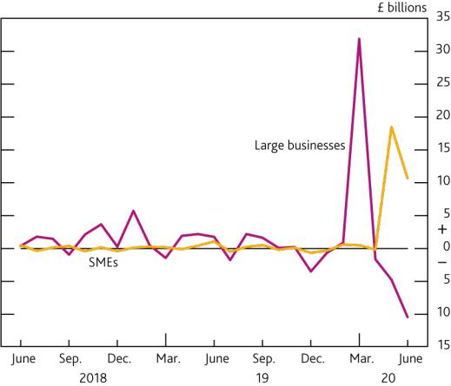

**Chart A.2** UK corporate bond issuance has been larger than the average of recent years

UK PNFC gross bond issuance across all currencies

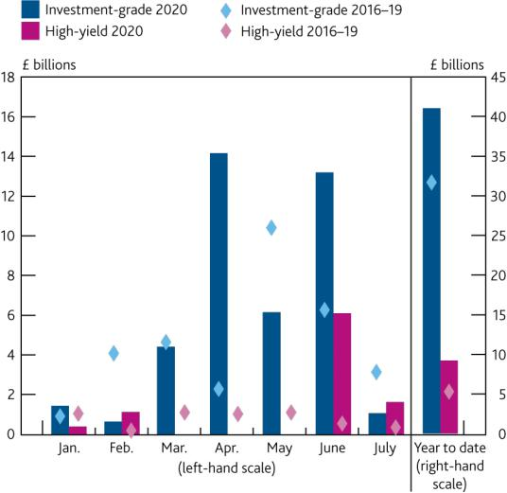

Source: Bank of England.

1. Monetary financial institutions’ all-currency lending to UK non-financial businesses.
2. Excludes lending to businesses in the public administration and defence industry.
3. Net lending is defined as gross lending minus repayments.

Sources: Refinitiv – Deals Business Intelligence and Bank calculations.

*...and support for households, including from the Coronavirus Job Retention Scheme and payment holidays.*

The Government’s policy response — in particular, the job retention and self-employment support schemes — alongside measures such as lenders’ payment holidays, have helped to mitigate the effects of the economic

Financial Stability Report August 2020 Performance of the UK financial system during the Covid-19 pandemic 3

disruption on households to date. This reduces the extent to which household indebtedness could amplify the downturn (see UK household indebtedness and Covid-19 chapter).

Mortgage lending has been weak, as housing market activity fell following the introduction of official social distancing measures, and there was some reduction in the supply of credit. There has been limited availability of high loan to value mortgages for new borrowers, as lenders guard against the risk of near-term volatility in house prices. Monthly mortgage approvals — an indicator of future lending — fell to a record low 9,300 in May, but picked up to 40,000 in June, as housing market activity recovered somewhat following the easing of social distancing measures. June approvals remained around half the levels seen in February.

Consumer credit net lending has also been extremely subdued, as consumption has fallen. In April, households

repaid £7.3 billion more consumer credit than they borrowed. While net borrowing has since picked up to

-£0.1 billion in June, this remains weaker than the average of £1.1 billion in the 18 months prior to the shock.

Despite this overall weakness, some households have needed to take on additional unsecured debt, as a result of

the shock to their finances. Some households have also benefited from payment holidays on their unsecured debt.

*Critical financial infrastructure on which the economy relies has also been resilient.*

Financial market infrastructure firms have responded quickly to the necessary operational changes resulting from Covid-19 to ensure continued provision of essential services to the economy. Retail payments systems have operated well as consumer spending patterns shifted markedly. The use of cash declined sharply. Cash withdrawals through the LINK ATM network dropped around 50% in late March and have increased only gradually since mid-April, remaining well below levels seen prior to the shock. This underscores the importance of resilient payment systems, at a time of rapid innovation in this sector (see Box 1). Wholesale payment systems have coped well with increased market activity, and settlement rates have returned to normal levels following some deterioration in March.

During the market turbulence, particularly in March, central counterparties (CCPs) and margining requirements played a crucial role in preventing concerns about counterparty credit risks from adding to the market disruption. CCPs reduce systemic risks, and simplify the networks of exposures within the financial system, which helps to reduce aggregate payment flows between counterparties as the market value of derivatives contracts changes.

*Asset prices have responded to Covid-19 developments.*

Financial markets have reacted to the expected economic impact of the evolving public health measures to contain Covid-19, and uncertainty around their scope and duration. **Charts A.3** and **A.4** summarise changes since the December *Report* in risky and safe asset prices respectively.

Risky asset prices fell sharply in March, as the worldwide spread of Covid-19 became apparent, but have since gradually recovered. The FTSE All-Share index fell around 35% from January to its trough in March, but has since regained around a half of its losses. The recovery in some equity indices has been stronger, with the S&P 500 now exceeding its January levels. Corporate bond spreads increased sharply in March as the outlook for businesses deteriorated, but investment-grade spreads have since returned to close to their levels at the start of the year. High-yield spreads remain somewhat more elevated, having recovered around two thirds of their trough to peak increase.

*Underlying vulnerabilities in the financial system catalysed an abrupt and extreme ‘dash for cash’ in March…*

The May *interim Report* described how precautionary demand for liquidity and the need for a dramatic redistribution of cash around the financial system resulted in an abrupt and extreme ‘dash for cash’ in mid-March. This was associated with a period of severe market dysfunction, which, if it persisted, could have had damaging effects on the ability of the financial system to continue to provide its core services to the economy. For example, corporate bond spreads rose, particularly for short-maturity, US dollar-denominated bonds, as investors sought to sell their most liquid assets to raise cash [(Haddad *et al* (2020))](https://www.nber.org/papers/w27168.pdf). Dysfunction affected even advanced-economy government bond markets, which are typically among the deepest and most liquid in the world. Ten-year gilt yields rose sharply from 9 to 24 March (**Chart A.4**), as the ‘dash for cash’ spread around the global financial system: institutional investors sold their most liquid assets, including to meet margin calls; and dealers’ capacity to

Financial Stability Report August 2020 Performance of the UK financial system during the Covid-19 pandemic 4

intermediate the gilt market became constrained. The 18 March and morning of 19 March saw particularly sharp intraday moves, with some fast overshooting and retracement, pointing to particular market dislocation on those days.1 Since March, gilt markets have stabilised, with yields at a lower level once normal functioning returned.

**Chart A.3** A range of risky asset prices have recovered somewhat from their large and sudden shifts earlier in the year

Changes in equity indices and corporate bond spreads since the December *Report*(a)

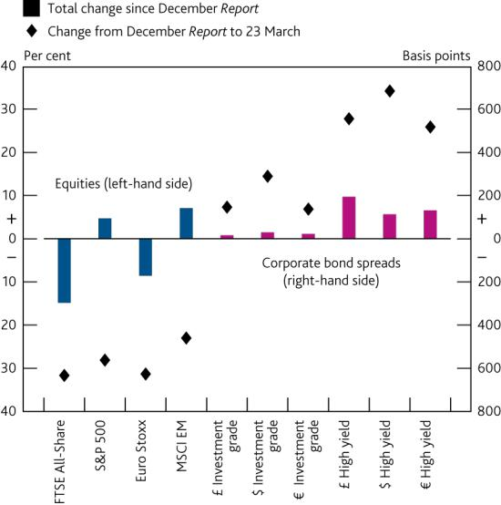

**Chart A.4** In mid-March, even 10-year government bonds came under selling pressure

Changes in 10-year nominal yields since the December *Report*

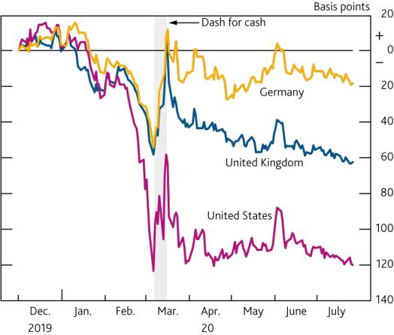

Sources: Bloomberg Finance L.P. and Bank calculations.

Sources: Bloomberg Finance L.P, ICE/BofAML and Bank calculations.

(a) Changes are from 4 December 2019 to 23 March 2020 and 4 December 2019 to 29 July 2020.

During March, a range of financial institutions sought to raise cash to meet margin calls, or build up liquidity buffers in anticipation of future margin calls, catalysing the sudden and sharp redistribution of liquidity around the system. The very large moves in asset prices, increased trading volumes and asset price volatility led to significant increases in initial and variation margin calls, on both cleared and uncleared derivatives. For example, at the peak in March, daily variation margin calls, which cover actual changes in the market value of the contract, reached £30 billion for UK centrally cleared derivatives. Variation margin calls on uncleared derivatives are likely to have been even larger. This had implications for the distribution of liquidity within the financial system.

In particular, non-banks appear to have seen larger increases in daily net margin calls than banks. Large banks and

other major derivatives market players tend to access CCPs directly as ‘clearing members’, which also allows them

to offer clearing services to their clients, including a large number of non-banks. Daily variation margin calls on

UK CCP clearing members’ client accounts went up by proportionally more than calls on clearing members’ own

accounts, peaking at 5.6 times the January average, compared to 5.0 for clearing members’ own accounts

(**Chart A.5**). Using a different data set, new analysis since the May *interim Report* shows the periods during March

when the non-bank sector was paying larger volumes of margin than it was receiving (**Chart E.2**). Over the ‘dash for

cash’ period (9 to 23 March), variation margin paid by a subset of non-banks on some cleared and uncleared

derivative positions is estimated to have totalled £33 billion, while they only received £25 billion over that period.2

As market conditions improved, the scale of daily margin calls declined (**Chart A.5**).

Initial margin requirements, which increased with rising market volatility and position sizes, have since fallen back, but remain elevated. Initial margin is posted at the beginning of a transaction to cover expected losses in the event of a counterparty default and is recalculated on a regular basis. It typically adjusts more gradually in response to changes in market conditions, and therefore does not result in daily margin calls on the same scale as for variation

1

2

To assess the presence of market distress during these days, Bank staff used the V-statistics proposed in [Flora and Renò (2020),](https://papers.ssrn.com/sol3/papers.cfm?abstract_id=3554122) which are specifically designed to test for significant overshooting and retracement in prices.

Variation margin calls estimated using position-level trade repository data on sterling interest rate swaps and forward rate agreements, and on GBPUSD, EURUSD, JPYUSD, USDGBP, USDEUR and USDJPY FX forwards. Covers over 400 UK pension funds, insurers, liability driven investment funds and other open-ended funds.

Financial Stability Report August 2020 Performance of the UK financial system during the Covid-19 pandemic 5

margin. Initial margin requirements at UK CCPs rose steadily through March, as market volatility and trading activity increased, peaking towards the end of the month at levels 30% higher than the average for January-February. Non -UK CCPs reported similar or larger increases in initial margin requirements — the median increase across the five largest non-UK CCPs was 67% between end-December and end-March. The stock of initial margin collateral held by UK CCPs has now reduced somewhat, but remains around 25% above levels prior to the shock, reflecting the way in which recent elevated volatility is captured in risk calculations. This helps to reduce the risk of another sharp increase in initial margin should market volatility increase again.

**Chart A.5** For daily margin calls, the biggest increases were on client accounts, and the scale has declined as market conditions have improved

Variation margin on centrally cleared derivatives, as a ratio to the January average(a)

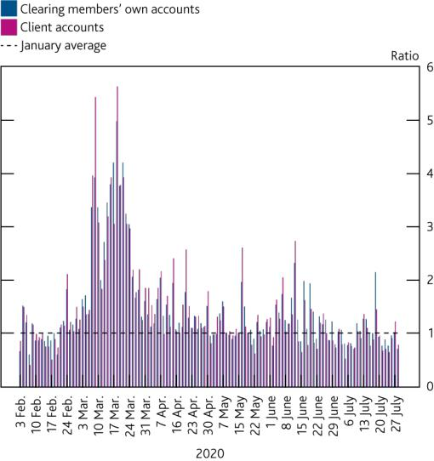

**Chart A.6** At the start of the Covid-19 shock, open-ended funds became net sellers of UK corporate bonds

Five-day rolling sum of net purchases of sterling denominated UK corporate bonds by sector(a)

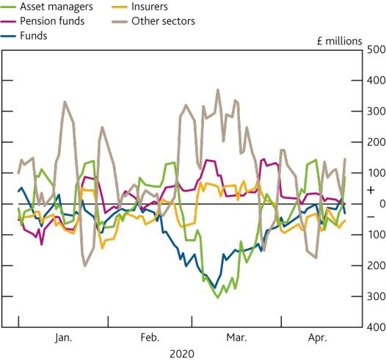

Source: Supervisory returns.

1. Chart shows the index of the total profit and loss across clearing member accounts of UK CCPs. This is a proxy for the changes in actual variation margin flows between clearing members and CCPs which could differ due to netting arrangements and for operational reasons.

Sources: FCA transaction (MiFID II) data, Bloomberg Finance L.P. and Bank calculations.

1. Trades by legal entity identifiers (LEIs) which Bank staff were able to match to individual investment funds using Bloomberg data are shown as ‘funds’ on the chart. Where the LEI corresponds to an asset management company, rather than a specific fund, these trades are shown as ‘asset managers’.

Market participants seeking liquidity drew down bank credit lines, sold or borrowed against their asset holdings, and redeemed from money market funds (MMFs). For example, sterling -denominated MMFs saw outflows of £25 billion, equivalent to 11% of assets under management, in just over a week (see Box 8). MMFs, in turn, sought to sell assets to meet redemptions and build cash buffers, and their preference for more liquid assets meant that demand for bank-issued short-term debt instruments remained constrained even in the aftermath of the shock.

Open-ended funds also experienced large redemptions, and there were indications that there may have been potential incentives for investors to redeem investments ahead of others. The large outflows in March were particularly acute for bond funds, with outflows from global bond funds reaching US$315 billion in March, equivalent to 4.9% of assets under management.3 New analysis since the May *interim Report* shows that, during March and April, in aggregate, funds and asset managers behaved more procyclically (selling when asset prices were falling) in sterling corporate bond markets than other market participants (**Chart A.6**), in particular for the most liquid, AAA, bonds. Open-ended funds’ net selling of UK corporate bonds was to meet investor outflows, margin calls and, in some cases, to build cash buffers pre-emptively. In UK equities, asset managers were generally buyers of equity on the days of the largest price falls, and redemptions from UK equity funds appeared to follow asset price falls, rather than precede them.

In mid-March, extreme selling pressure spread even to government bond markets. For example, foreign holders

sold, net of purchases, US$299 billion of US Treasury bonds and notes in March (a record high), of which

US$61 billion were by foreign official institutions. Selling pressures also reflected some highly leveraged market

participants, such as hedge funds, being forced to exit from large leveraged positions in US Treasury markets

1. Covers Sterling, Europe, US and Emerging Market fixed-income funds in the Morningstar database.

Financial Stability Report August 2020 Performance of the UK financial system during the Covid-19 pandemic 6

[(Barth and Kahn (2020))](https://www.financialresearch.gov/briefs/2020/07/16/basis-trades-and-treasury-market-illiquidity/). Large-scale unwinding of these trades, of almost US$90 billion during March, was one of the contributors to the short period of extreme illiquidity, which also spread to other government bond markets such as gilts. The direct impact of hedge fund behaviour on the gilt market in March is less clear. Initial analysis of transaction data suggests much less trading of differences between bonds and futures by hedge funds in the gilt market than in the US Treasury markets. During March, hedge funds increased aggregate net borrowing in gilt repo (**Chart A.7**). But more recently, they have reduced their activity in gilt repo markets, becoming net lenders rather than borrowers, suggesting a reduction in leverage. Nonetheless, the overall size of leveraged positions by these investors across government bond markets means that risks remain.

**Chart A.7** Hedge funds have reduced their gilt repo activity since March

Outstanding stock of hedge fund repo positions(a)

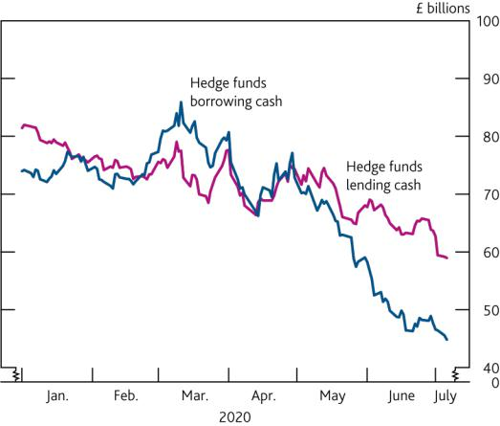

**Chart A.8** Dealers widened bid -offer spreads during the ‘dash for cash’, but have since reduced them

Bid-offer spreads on gilts and US Treasuries(a)

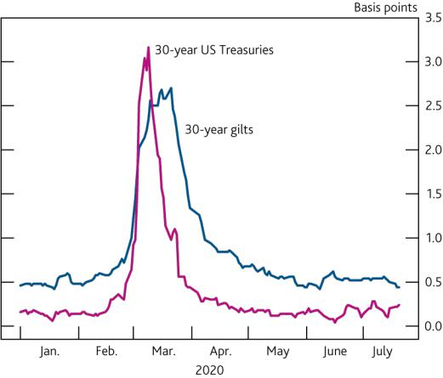

Sources: Bank of England Sterling Money Market data collection and Bank calculations.

(a) For all gilt repo and reverse gilt repo maturities up to one year.

Sources: Eikon by Refinitiv and Bank calculations.

(a) The bid-offer spread is a five-day moving average.

Dealers contribute to market liquidity by acting as ‘market makers’ — building up inventories of assets to meet selling pressure that can then be sold when demand for assets increases. In March, although dealers did not immediately step back as the demand for liquidity surged, evidence suggests their capacity became constrained quickly. For example, dealers initially absorbed large amounts of US Treasuries. But as the dash for cash intensified, the speed and size of sales overwhelmed dealers’ capacity to intermediate further. In response, dealers widened bid-offer spreads, increasing the cost of trading. A similar dynamic was seen in the gilt market (**Chart A.8**).

*…but market functioning has since recovered, supported by central bank actions.*

In response to the economic shock and disruptions to market functioning, central banks took actions to maintain monetary and financial stability, through monetary easing, liquidity facilities, and enhanced US dollar liquidity arrangements. Without these actions, it is likely that the liquidity stress would have been even more severe.

The Bank’s Monetary Policy Committee (MPC) reduced Bank Rate by 65 basis points in March, from 0.75% to 0.1%, and announced increases to the stock of asset purchases in March and June, totalling £300 billion and taking the stock of purchases to £745 billion. Following the March announcement, gilt yields declined (**Chart A.4**) and liquidity conditions and functioning in gilt markets broadly normalised. Bid-offer spreads are now in line with those seen prior to the shock (**Chart A.8**), which suggests improved liquidity. The commitment to purchase sterling non-financial investment-grade corporate bonds as part of the MPC’s asset purchase programme has also helped conditions in corporate bond markets. Conditions in secondary corporate bond markets have improved since March, and outflows from bond funds have stabilised, but bid-offer spreads remain somewhat more elevated than prior to the shock.

Central banks also enhanced their liquidity facilities, which, alongside asset purchases, have supported conditions in repo markets. Repo market functioning improved following the Bank’s activation of the Contingent Term Repo Facility, such that pressure on term repo rates has eased, and overnight repo rates have been close to Bank Rate (**Chart A.9**). In light of liquidity improvements, this facility’s operations have now been discontinued.

Financial Stability Report August 2020 Performance of the UK financial system during the Covid-19 pandemic 7

Enhancements to central bank dollar swap lines made in March eased pressures on dollar funding. Given their reliance on the dollar, during the ‘dash for cash’, non-US companies and financial intermediaries saw a significant spike in the cost of dollar financing and of hedging their dollar assets. There was extensive usage of the enhanced dollar swap lines by advanced-economy central banks, approaching US$0.5 trillion. Alongside the easing of the demand for the dollar, this helped to calm funding conditions. The cost of raising dollars from other currencies subsequently reduced (**Chart A.10**) and reliance on the swap lines has diminished, with balances rolling off.

|  |  |  |
| --- | --- | --- |
|  |  |  |
| **Chart A.9** Repo spreads have returned to historical | **Chart A.10** The cost of raising dollars from other | |
| averages | currencies is closely aligned to ‘onshore’ dollar funding | |
| Gilt repo rates as a spread to reference rates(a)(b) | Onshore and offshore rates for three-month dollar funding(a) | |

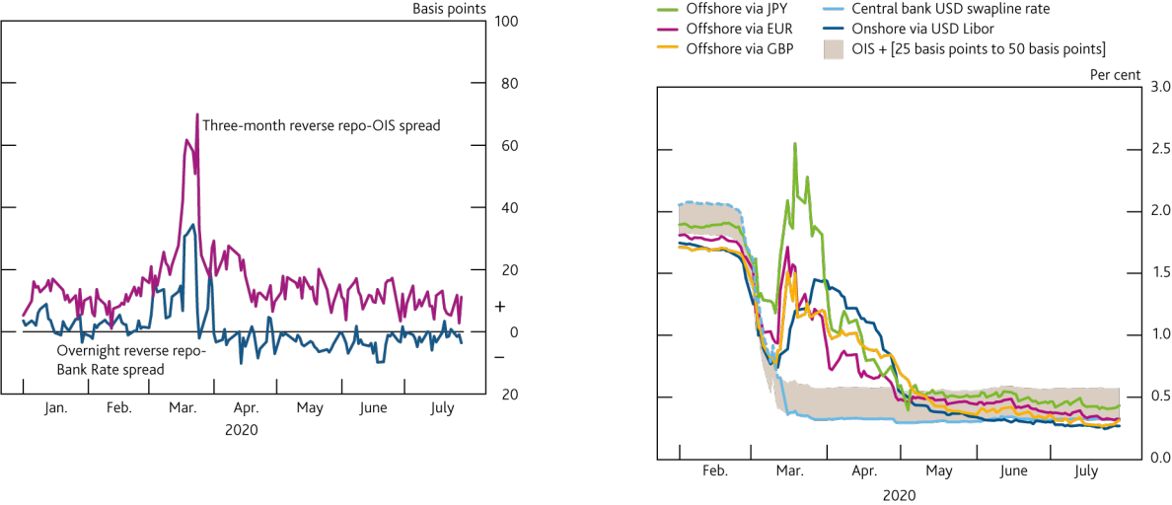

Sources: Bank of England Sterling Money Market data collection, Bloomberg Finance L.P. and Bank calculations.

1. Volume-weighted spread to Bank Rate of overnight cleared DBV (general collateral) gilt reverse repo transactions.
2. Volume-weighted spread to three month sterling overnight indexed swaps of three month gilt reverse repo transactions estimated to be non-nettable under leverage ratio rules.

Sources: Bloomberg Finance L.P. and Bank calculations.

1. Offshore funding calculations use FX swaps referencing three-month Libor. The dashed light blue line indicates that prior to the 15 March 2020, swap lines were only offered at a one-week, not three-month, maturity.

**Near-term risks and FPC actions**

*Underlying vulnerabilities could cause a resurfacing of market dysfunction, in the face of certain triggers. For example, risky asset prices could sharply correct if the recovery path shifts…*

Corporate bond and equity prices might be expected to reflect the still highly uncertain outlook for the evolution of the virus, the policies to control it, and their implications for businesses and households. However, there is some evidence that measures of the compensation equity investors demand for risk — in particular, estimates of equity risk premia — have retraced materially from their highs in mid-March. In addition, some corporate bond spreads appear compressed, and are below historical averages, despite the uncertain outlook. For example, Bank staff analysis suggests that, once adjusted for the deterioration in credit quality and increase in duration, US dollar corporate bond spreads are within the lower third of their historical distribution.

Markets might therefore be vulnerable to a sharp repricing if corporates’ credit fundamentals deteriorate and risk appetite falls. In this scenario, financial conditions could tighten sharply, as investors demand higher compensation for the risk they are taking. Such moves could — once again — be amplified by underlying vulnerabilities, such as: liquidity mismatch in open-ended funds; liquidity management responses by non-bank derivatives users; constraints on dealer intermediation; and unwinding of trades by leveraged investors. This amplification could accentuate a tightening of financial conditions and impact the effective functioning of markets, adversely impacting the real economy.

*…and there could be an amplified tightening in credit conditions if a large wave of ‘fallen angels’ leads to a deterioration in market liquidity and demand for issuance across the high-yield market…*

One underlying vulnerability, which the FPC has highlighted in previous *Reports*, is the potential for selling of corporate bonds downgraded from investment grade to high yield — so called ‘fallen angels’. There has been a significant increase in the share of BBB-rated bonds (the lowest rating in the investment-grade category) over

Financial Stability Report August 2020 Performance of the UK financial system during the Covid-19 pandemic 8

recent years — now representing around half the stock of the sterling investment-grade corporate bond index. This leaves a large volume of securities that could drop to high yield.

Given the scale of the shock to corporate revenues, there has been a significant volume of ‘fallen angels’ since the start of the year, and the increase in volumes could accelerate if the outlook for businesses deteriorates. Four per cent of the overall sterling BBB stock has been downgraded to high yield in the year so far. That volume is expected to increase further, with rating agencies placing a number of companies issuing BBB instruments on negative credit watch, suggesting an increased chance of downgrade. During previous downturns in 2002 and 2008, 11% of sterling BBB bonds were downgraded.

There could be an acceleration in the pace of sales of ‘fallen angel’ bonds in the face of higher downgrade rates. Some institutional investors may be forced to sell downgraded bonds if, for example, their investment mandates prevent them from holding high-yield bonds. Half of corporate bonds held by open-ended funds are rated BBB, and during March, they sold these bonds in higher proportions than other bonds in their portfolios.

An acceleration of selling by institutional investors could put pressure on the capacity of investors and dealers in the sterling high-yield corporate bond market, leading to a disproportionate tightening in credit conditions by impairing market functioning and restricting high-yield corporates from accessing funds via the primary market. For example, if downgrades were to reach the same rates in 2002 and 2008 and funds and insurers sold all of their downgraded assets, these sales could be higher than the largest monthly issuance in the high-yield market over the previous five years. This downgrade rate could also make it difficult for dealers to intermediate the volume of potential sales. The sales in this scenario could be over five times bigger than the largest aggregate monthly increase in sterling high-yield inventories of global dealers since 2011 (**Chart A.11**).4

**Chart A.11** Large-scale selling of ‘fallen angels’ could make it difficult for dealers to intermediate high-yield bond markets

Potential monthly sales of sterling fallen angels relative to the largest monthly increase in high-yield dealer inventories

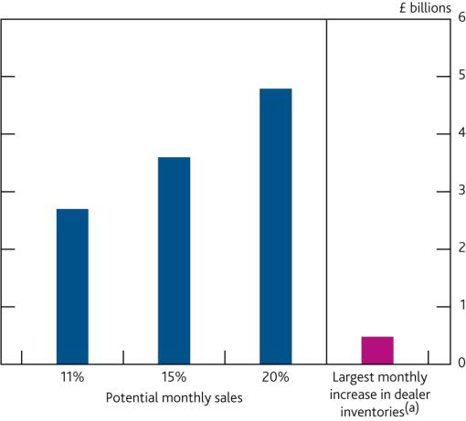

**Chart A.12** A large number of leveraged loans have been downgraded during the shock

Leveraged loan downgrade to upgrade ratio (three-month rolling average)(a)

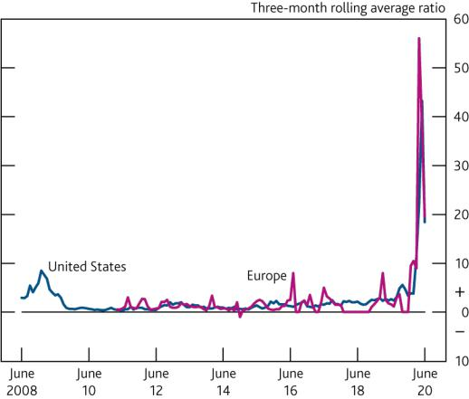

Sources: Morningstar, Solvency II regulatory returns, ZEN and Bank calculations.

(a) Due to availability, data on sterling high-yield dealer inventories cover the period 2011–17.

Sources: S&P/LSTA Leveraged Loan Index, S&P European Leveraged Loan Index, LCD, an offering of S&P Global Market Intelligence and Bank calculations.

(a) The chart plots the three-month rolling averages; data through 30 June 2020.

*…or in the face of leveraged loan downgrades.*

The leveraged loan market grew rapidly over the past few years, and that growth has been accompanied by increasingly accommodative lending standards. The FPC has highlighted in previous *Reports* that this could increase loss rates in stressed periods.

A significant number of leveraged loans have been downgraded since March. The US leveraged loan downgrade to upgrade ratio averaged 43:1 in the three months to May, five times larger than the peak of 8:1 during the global financial crisis (**Chart A.12**). Around a quarter of leveraged loans are held through collateralised loan obligations

1. Fact relates to 2011–17, for which the data in **Chart A.11** are available.

Financial Stability Report August 2020 Performance of the UK financial system during the Covid-19 pandemic 9

(CLOs). CLOs have certain thresholds and tests that are linked to ratings, and therefore downgrades could trigger shifts in CLO manager behaviour. For example, CLOs have a threshold on the proportion of CCC-rated loans they can hold which, when breached, causes excess CCC loans to be marked to market, reducing portfolio value, which can lead to overcollateralisation test breaches. As higher proportions of loans are downgraded, CLO managers may be incentivised to sell underlying assets, in anticipation of price falls, test breaches, and loss of portfolio value.

UK bank holdings of leveraged loans and CLOs are small, at around 4% of the global stock. Non-banks now hold increasing shares of these markets. They hold around half of global leveraged loans, and within the CLO sub-market, they make up around two thirds of global holdings. Furthermore, non-banks generally hold the riskier tranches of CLOs, which could suffer significant losses in a stress. Funds have the potential to amplify stress in these markets, if downgrades lead to underperformance, redemptions and ultimately selling pressure. At the extreme, selling pressure of leveraged loans could impair the functioning of corporate debt markets, making it harder for businesses to access finance.

*Widened pension funds deficits, if they persist, may mean that employers have to contribute more to their pension funds.*

UK defined-benefit pension scheme deficits have widened since end-2019, due to the impact of the pandemic on interest rates and asset prices. That said, deficits have become less sensitive to falls in interest rates in recent years

— in part due to greater hedging of interest rate risk by pension funds — and despite the recent widening, schemes remain better funded than they have been for much of the past decade. Over time, wider deficits mean that employers may have to contribute more to their pension funds, which could adversely impact corporate cash flow. However, some businesses have been able to take advantage of temporary measures, such as short-term deferrals of deficit repayment contributions.

*The FPC has taken action to respond to the UK financial stability risks associated with the economic disruption resulting from Covid-19, and is identifying lessons and potential mitigants to address underlying issues in market-based finance.*

The FPC’s actions during the shock so far have sought to ensure that the UK financial system can be a source of strength for the real economy, helping to absorb, rather than amplify the shock. In March, the Committee reduced the UK countercyclical capital buffer (CCyB) rate to 0%. This action supported the ability of UK banks to supply the credit needed by the real economy, and reinforced the FPC’s expectation that all elements of the substantial capital and liquidity buffers that have been built up by banks could be drawn down on, as necessary, to support the economy. The FPC expects to maintain the 0% rate until at least March 2021, absent any material change in the outlook. Due to the usual 12-month implementation lag, any subsequent increase is not expected to take effect until March 2022 at the earliest. The pace of a return to a standard times UK CCyB rate in the region of 2% would depend on banks’ capital depletion over this period, and their ability to rebuild capital while supporting the UK economy. The FPC welcomed announcements from the PRA that support the banking system’s ability to continue to support the economy, including the PRC’s supervisory guidance that banks should not increase dividends or other distributions in response to these policy actions.5

Banks could face losses in the face of the economic impacts of Covid-19, and the measures to contain it. Increasing unemployment could lead to impairments on consumer credit, and corporate distress could cause losses on lending to businesses. The FPC has carried out a ‘reverse stress -test’ exercise to analyse how much worse than the central projection the economic outcome would need to be in order to deplete regulatory capital buffers, using as a reference point the 2019 stress test of major UK banks and building societies, and judges them to be resilient to a very wide range of possible outcomes (see The resilience of the UK banking sector chapter).

The market vulnerabilities that were exposed during the ‘dash for cash’ could cause liquidity issues to resurface were the outlook, or perceptions of the outlook, to deteriorate sharply. The FPC is monitoring these vulnerabilities closely and is identifying lessons from this episode and setting out its views on areas for future work, domestically and internationally (see Building the resilience of market-based finance chapter).

1. Other announcements include: [Conversion of Pillar 2A capital requirements from RWA percentage to a nominal amount;](https://www.bankofengland.co.uk/-/media/boe/files/prudential-regulation/publication/2020/conversion-of-pillar-2a-capital-requirements.pdf?la=en&hash=2A5E282730858C7A4C4E165E08C6F513F7709D0B) and [Statement on credit risk mitigation](https://www.bankofengland.co.uk/-/media/boe/files/prudential-regulation/publication/2020/statement-on-bbls-and-leverage-ratio-treatment.pdf?la=en&hash=41877EE26855CDC6E8EAD0A5BFA3485C4D953656) [eligibility and leverage ratio treatment of loans under the Bounce Back Loan Scheme.](https://www.bankofengland.co.uk/-/media/boe/files/prudential-regulation/publication/2020/statement-on-bbls-and-leverage-ratio-treatment.pdf?la=en&hash=41877EE26855CDC6E8EAD0A5BFA3485C4D953656)

Financial Stability Report August 2020 Performance of the UK financial system during the Covid-19 pandemic 10

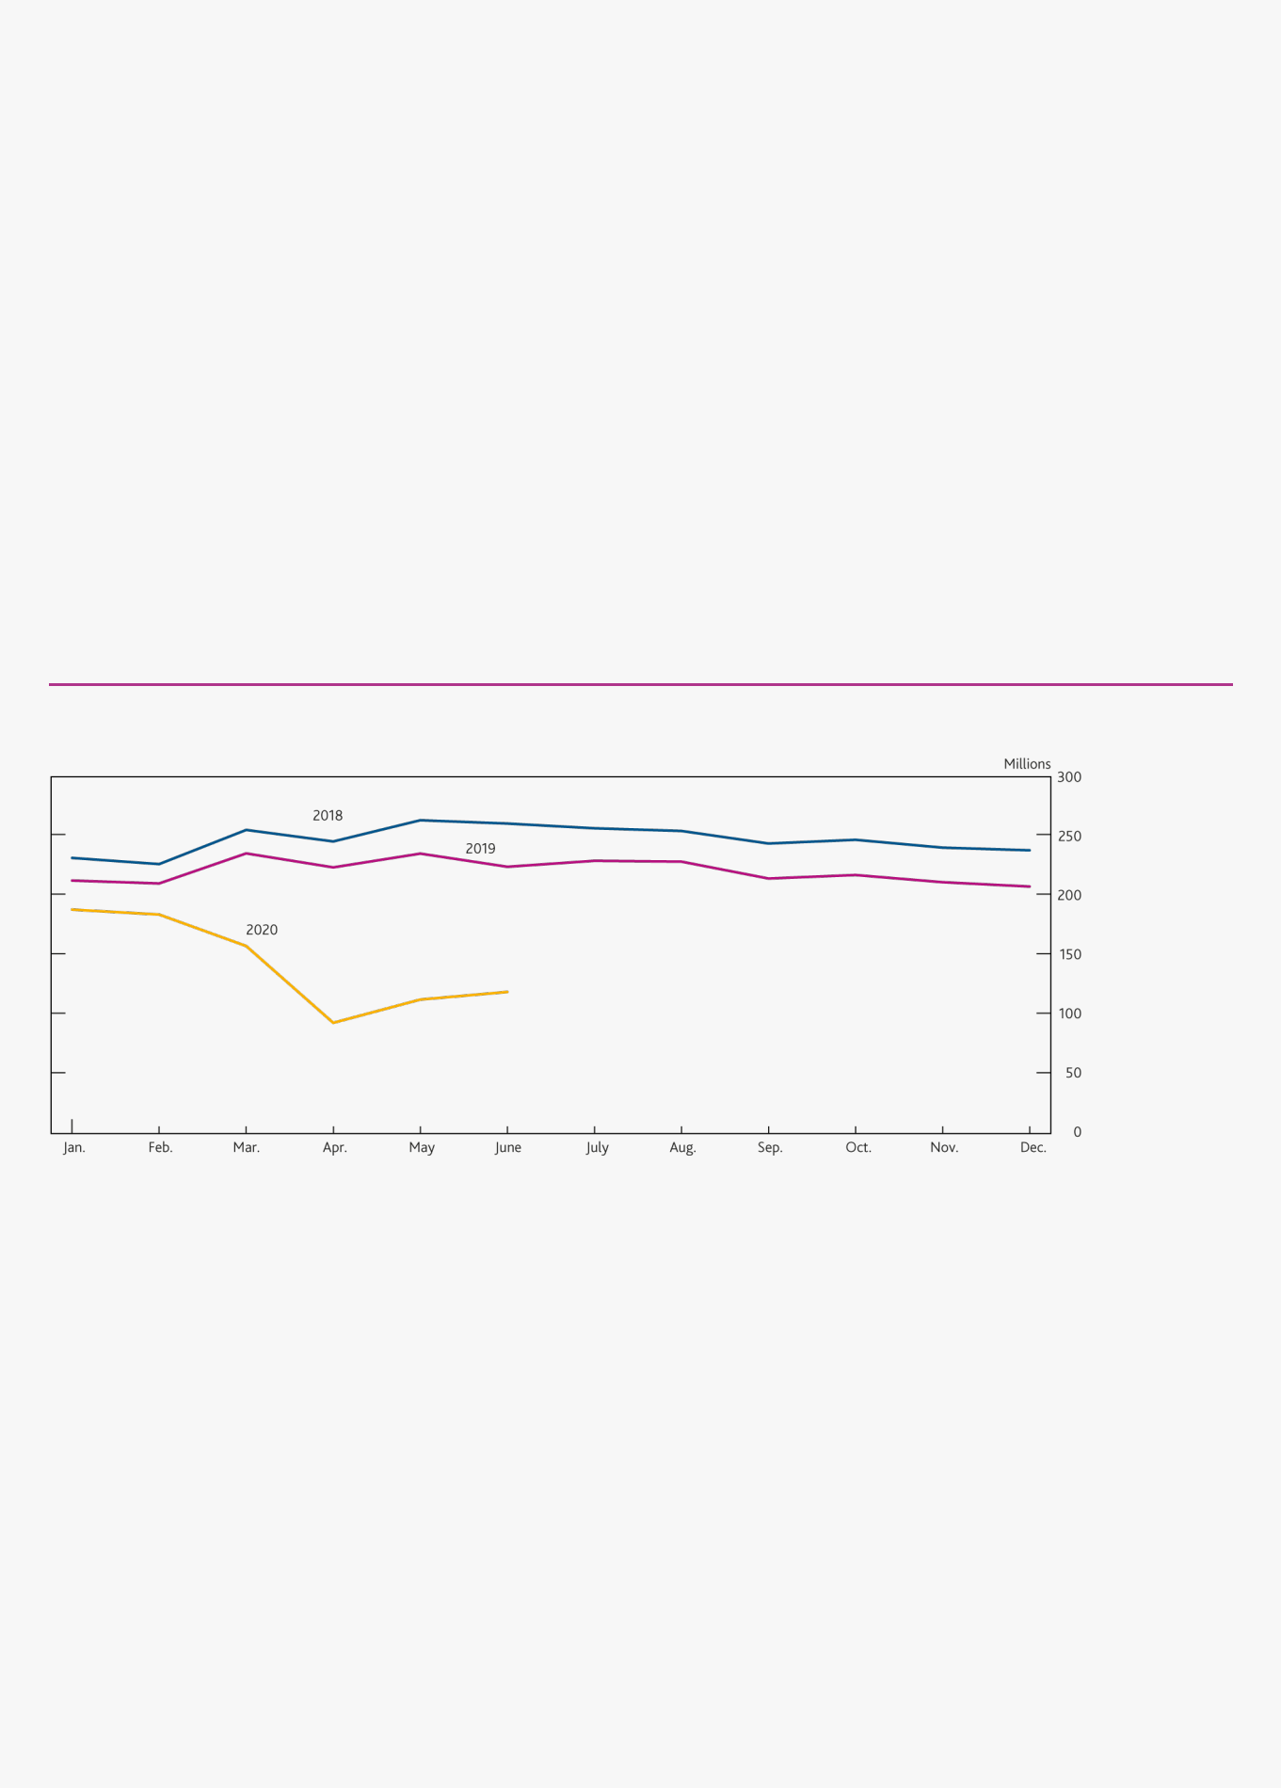

**Box 1**

**Payments innovation and the need for changes to the regulatory framework**

*How people and businesses pay in the UK was changing even before the Covid-19 pandemic. The Covid-19 pandemic has likely accelerated these trends.*

In the [December 2019 *Report*,](https://www.bankofengland.co.uk/financial-stability-report/2019/december-2019) the FPC noted the considerable innovation taking place in the UK’s payments landscape and the need for the regulatory framework to keep pace with payments innovation. New technologies, the rise of e-commerce and European regulations aimed at lowering barriers to entry for innovative payment firms have contributed to the emergence of new payment innovators. These new institutions, including non-banks, and changing consumer behaviour have driven a shift towards digital payments. From 2017 to 2019 the number of people using cash once a month or less in the UK doubled to 7.4 million.

Temporary closure of shops and restaurants has led people to increasingly turn to online shopping. UK online sales in April increased to 30% of total retail transactions from just over 18% a year earlier. Many shops are encouraging contactless forms of payment over the use of cash. ATM withdrawals and cash use in the UK have fallen significantly. At their lowest during the UK lockdown, cash withdrawals were [60% lower](https://www.link.co.uk/about/news/coronavirus-cash-usage-data/) in April 2020 than a year before. Even as the UK lockdown has eased, cash withdrawal volumes have remained low. In June 2020 they were still around [50%](https://www.link.co.uk/about/statistics-and-trends/) lower than in June 2019 (**Chart A**).

**Chart A** Impact of Covid-19 on UK cash withdrawals

LINK transaction volumes(a)

Sources: LINK and Bank calculations.

1. These figures include balance enquiries and rejected transactions made through the LINK network, but do not include transactions made by customers at their own banks’ or building societies’ ATMs. Cash withdrawals account for a majority of these transactions.

*Payments innovation is likely to continue and it is important that it meets the FPC’s principles.*

If sustained, the rise in electronic payments and possible changes in consumer habits could continue to increase the importance of new non-bank payment service firms that have already emerged and added to the number of firms involved in a typical electronic payment. This rise may further accelerate innovation, including innovation that could provide further competition and replace existing ways to pay entirely.

Innovation and competition in payments could bring significant benefits for users. However, changes to the

UK regulatory framework will be important to ensure that regulation can keep pace with innovation. The current regulatory framework was designed when systemic payments activities were generally provided by payment systems and commercial banks. As set out in the [December 2019 *Report*,](https://www.bankofengland.co.uk/financial-stability-report/2019/december-2019) new entrants could ultimately become critical links in systemically important ‘payment chains’ (the set of activities necessary for a payment to be made) without being subject to commensurate financial stability regulation. Clear, transparent regulatory expectations are critical to ensure innovation can progress safely, without causing serious interruptions in payment and settlement services.

Financial Stability Report August 2020 Performance of the UK financial system during the Covid-19 pandemic 11



In 2019 Q3, the FPC outlined principles to guide its assessment of the regulation and supervision of payments.

Payments regulation should reflect the financial stability risk, rather than the legal or technological form, of payments activities.

Regulation should ensure end-to-end operational and financial resilience across systemic payment chains that are critical for the smooth functioning of the economy.

And sufficient information from payments firms should allow monitoring of emerging risks to financial stability.

The FPC supports work of the UK authorities to identify systemic payment chains and the systemic firms within them.

*Stablecoins used for payments must meet relevant payments standards…*

Changes in the way we pay may also accelerate the development of ‘stablecoins’ used as means of payment. Like other crypto-assets, stablecoins involve the issuance of digital ‘coins’. However, they aim to achieve a stable value against a fiat currency or other assets and could maintain reserves or backing-assets to help achieve this and to address volatility issues associated with early forms of crypto-assets.

If a stablecoin were to significantly replace current systemic payments chains as a way to pay ― it would pose at least the same risks to the economy associated with existing systemic payment systems. Each entity in the stablecoin arrangement should be regulated to the same standards as those applied to traditional payment activity. Any stablecoin which intends to launch with sterling-based activities in the UK should first meet relevant standards and be appropriately regulated.

*…and they must meet standards equivalent to those expected of commercial bank money.*

Where stablecoins are used in systemic payment chains in place of money, they must offer the equivalent protections to stable and reliable money currently used in traditional systemic payment chains ― public central bank money ― in the form of reserves held at the central bank or cash; or private commercial bank money — bank deposits. Prudential regulation, access to central bank liquidity, and deposit insurance give holders confidence to receive commercial bank money as payment.

Under international standards, systemic payment systems are expected to settle in central bank money and, where that is not possible, to settle in commercial bank money and to strictly minimise any credit and liquidity risk in the money instrument being transferred and settled. Stablecoin arrangements propose to transfer instruments that they create themselves and to settle most of their transactions across their own books. The payment transfer takes place internally via the stablecoin’s own settlement system rather than via traditional payment settlement rails.

In December, the FPC set out two expectations for stablecoin-based payment chains:

Payment chains that use stablecoins should be regulated to standards equivalent to those applied to traditional payment chains. Firms in stablecoin-based systemic payment chains that are critical to their functioning should be regulated accordingly.

Where stablecoins are used in systemic payment chains as money-like instruments they should meet standards equivalent to those expected of commercial bank money in relation to stability of value, robustness of legal claim and the ability to redeem at par in fiat.

With the right regulation, stablecoins may be safe for use in systemic payments chains. But the protections need to be clear and the stablecoin should meet the requirements to offer their users the stability required of existing money-like instruments, such as commercial bank deposits, including in stress or insolvency, as well as the necessary consumer protections. **Some major stablecoin proposals do not appear at present to meet these**

Financial Stability Report August 2020 Performance of the UK financial system during the Covid-19 pandemic 12



**expectations.** Some do not propose a legal claim for coin-holders. And some stablecoins propose backing in instruments that may have material market, credit and liquidity risk, but do not currently have protections such as appropriate deposit insurance, prudential requirements and liquidity backstops at key points in the ecosystem to ensure these risks do not lead to instability and disruption of payments. While this might be acceptable for speculative investment purposes, it would not be for payments widely relied upon by UK households and businesses.

*The current regulatory framework will need adjustment in order to accommodate innovation in payments.*

In the [December 2019 *Report*,](https://www.bankofengland.co.uk/financial-stability-report/2019/december-2019) the FPC noted that the current UK regulatory framework would need adjustment in order to accommodate innovation in payments, both to reflect the expectations above and to ensure it reflects end-to-end financial and operational resilience. The FPC supports the work of the UK authorities to consider reforms to payments regulation to ensure that these principles can be met, and welcomes the launch of the Call for Evidence by HM Treasury as part of its Payments Landscape Review. The FPC has a statutory duty to monitor and identify risks to the UK financial system. Consistent with its statutory responsibilities it will, where necessary, make Recommendations to HM Treasury regarding gaps in the regulatory perimeter which might represent risks to financial stability.

**Table 1** Protections offered by current and proposed money-like instruments designed for wide-scale use in the UK

|  |  |  |  |  |  |  |  |  |  |  |  |
| --- | --- | --- | --- | --- | --- | --- | --- | --- | --- | --- | --- |
|  | **Central bank money** | |  | **Scottish and Northern Ireland** |  | **Commercial bank money** | |  | **Private Stablecoins** |  |  |
|  |  |  |  |  |  |
|  | **(notes and reserves)** | |  | **Banknotes** |  |  |  |  |  |  |  |
|  | ✓ Claim on central bank. | |  | ✓ Claim on issuing bank with |  | ✓ | Claim on issuing bank. |  | ? |  |  |
|  | ✓ | Monetary stability |  | recourse to backing assets. |  | ✓ Access to central bank | |  |  |  |  |
|  |  | mandate. |  | ✓ 1-for-1 backing in |  |  | liquidity. |  |  |  |  |
|  | ✓ | Inflation-targeting regime. |  | ring-fenced assets held at |  | ✓ | Deposit insurance. |  |  |  |  |
|  |  |  |  | central bank or authorised |  | ✓ | Prudential regime |  |  |  |  |
|  |  |  |  | locations. |  |  | including capital and |  |  |  |  |
|  |  |  |  | ✓ Regulation by Bank of |  | ✓ | liquidity requirements. |  |  |  |  |
|  |  |  |  | England. |  | Insolvency regime |  |  |  |  |

prioritises deposits.

Source: Bank of England.

Financial Stability Report August 2020 UK household indebtedness and Covid-19 13

UK household indebtedness and Covid-19



UK households entered the Covid-19 shock in a stronger financial position than before the global financial crisis, in part due to financial policies that have guarded against an increase in the number of highly indebted households.

The sharp fall in economic activity has put pressure on many households’ incomes. But the policy response, in particular the Coronavirus Job Retention Scheme, and measures such as payment holidays, have provided substantial support to UK households, helping to cushion the increase in debt-servicing pressures. This has reduced the extent to which the economic downturn might have been amplified to date by UK mortgagors cutting consumption to make loan repayments.

As set out in the [August 2020 *Monetary Policy Report*](https://www.bankofengland.co.uk/report/2020/monetary-policy-report-financial-stability-report-august-2020) (*MPR*)*,* unemployment is projected to rise to around 7.5% by the end of 2020. This will put pressure on the ability of some households to service consumer and mortgage debts. Nevertheless, the share of households with high mortgage debt-servicing burdens is expected to remain lower than was reached in the global financial crisis.

Banks will incur losses, particularly on consumer loans. But they have the capacity to absorb those losses (see The resilience of the UK banking sector chapter). It remains the Financial Policy Committee’s (FPC’s) judgement that banks have the capacity, and that it is in the collective interest of the banking system, to continue to support businesses and households through this period.

It will also be important for lenders to work flexibly with borrowers, in line with published Prudential Regulation Authority (PRA) and Financial Conduct Authority (FCA) guidance, as the Government support schemes unwind and those on payment holidays begin to resume repayments or seek to extend them. Supporting UK households through this period of disruption can mitigate the extent to which households have to cut spending further, which might slow the pace of the economic recovery and increase banks’ losses.

*UK households entered the Covid-19 shock in a stronger financial position than before the global financial crisis.*

The total stock of UK household debt (excluding student loans) was £1.8 trillion in 2020 Q1, equivalent to around 123% of total household income. Although high compared to historical standards, this was materially below its 2008 peak of 144%. Furthermore, higher debt levels were more affordable than prior to the global financial crisis given the recent low level of interest rates, which have contributed to more sustainable borrowing costs. Financial policies, such as the FPC’s mortgage market Recommendations, put in place in 2014, have also helped to insure against a significant increase in the number of highly indebted households.

Financial Stability Report August 2020 UK household indebtedness and Covid-19 14

The FPC has identified two channels through which high household indebtedness may be a source of risk to

UK financial stability:

**Borrower resilience:** highly indebted households may cut back sharply on spending during a stress, which may amplify a downturn and, in turn, the risk of losses to lenders on all forms of lending. The FPC has previously

judged that this channel is most material for mortgage debt.

**Lender resilience**: the resilience of lenders could be tested if highly indebted households default on their debt, resulting in losses. This poses a direct risk to financial stability. The FPC has previously judged that this channel would tend to be more material for consumer credit, but it could also be material for mortgage debt in a severe stress. This is particularly the case if house prices fall sharply.

*Policymakers have taken significant action to mitigate the effects of the economic disruption from the Covid-19 shock.*

Policymakers have taken significant action to support employment and household incomes, largely via the Coronavirus Job Retention Scheme (CJRS) and the Coronavirus Self-Employed Income Support Scheme (SEISS).1 Both schemes have been extended until the end of October, and should continue to dampen the impact of the economic disruption on households over this period.

Payment deferral schemes, known as ‘payment holidays’, announced by the FCA and offered by lenders have also provided a form of forbearance to support borrowers who may be experiencing financial difficulties, by allowing a temporary freeze on mortgage and other loan repayments.

*Despite extraordinary policy action, the Covid-19 shock is likely to have a large impact on UK households’ incomes and put pressure on household finances…*

Despite the unprecedented nature of the policy response, the spread of Covid-19 and the measures to contain it are having a significant impact on UK households. Survey data show that around a third of earners, across the earnings distribution, are reported to have suffered an earnings loss of more than 5%. The central projection in the [August 2020 *MPR*](https://www.bankofengland.co.uk/report/2020/monetary-policy-report-financial-stability-report-august-2020) (hereafter ‘the *MPR* projection’) assumes that the direct impact of Covid-19 on the economy dissipates gradually over the forecast period. Conditional on that assumption, UK GDP is projected to continue to recover. But unemployment is expected to rise over 2020 H2, and is projected to reach a peak of 7.5% by the end of the year.

*…and is likely to lead to higher loss rates on consumer credit in the period ahead.*

The stock of consumer credit is small compared to the overall stock of household debt in the UK. However, loss rates on consumer credit can be far higher than for mortgages, as borrowers are more likely to default on unsecured debt and lenders do not have collateral to cushion losses. Arrears on consumer credit have remained stable since the start of the Covid-19 shock. This is consistent with the improvement in underlying credit quality since the global financial crisis, and the reduction in the proportion of people with debt-servicing ratios (DSRs) above 20% on their consumer credit (**Chart B.1**). Evidence shows the proportion of borrowers in arrears increases markedly for borrowers with consumer credit DSRs in excess of 20%, which is lower than the equivalent DSR threshold of 40% for mortgages (**Chart B.2**).

Given the pressure placed on households’ finances, the current level of arrears may also be reflective of the significant amount of Government support for household incomes, particularly at the lower end of the income distribution (see [HM Treasury (2020))](https://www.gov.uk/government/publications/impact-of-covid-19-on-working-household-incomes-distributional-analysis-as-of-may-2020) and the take-up of payment holidays on unsecured products (see below). Underlying financial distress may become more visible as unemployment rises.

For example, survey evidence suggests that while higher-income households were more likely to report increases in savings over this period, lower-income households — who are more likely to use consumer debt than mortgage debt — were more likely to report running them down (see Box 3 of the August *MPR*). This reflects the fact that, among other factors, lower-income households have not been able to cut consumption by the same degree as other households. And a number of households have reported needing to increase their consumer credit debt as a



1. Under the CJRS, the Government pays 80% of furloughed individuals’ wages up to £2,500 a month, plus National Insurance and minimum pension contributions. Some furloughed individuals will receive less than 80% of their income, given the £2,500 limit. From July to October, employers will have to increasingly bear part of the cost currently borne by the Government.

Financial Stability Report August 2020 UK household indebtedness and Covid-19 15

result of the Covid-19 shock. Survey respondents from the [2020 Q2 *Credit Conditions Survey*](https://www.bankofengland.co.uk/credit-conditions-survey/2020/2020-q2) also suggested defaults on unsecured lending had started to increase in 2020 Q2, and were expected to increase in 2020 Q3.

Historically, there has been a strong, positive relationship between unemployment and consumer credit loss rates (**Chart B.3**). The central projection for unemployment in the *MPR* would imply the proportion of people with consumer credit DSRs at or above 20% would rise to around 15% (**Chart B.1**). This is below the level seen in the global financial crisis, of around 17%.

**Chart B.1** The tail of highly indebted households with consumer credit has fallen since the global financial crisis

The percentage of people with consumer credit DSRs at or above 20%

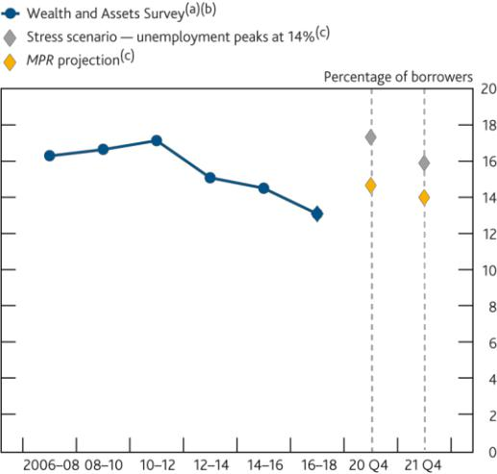

**Chart B.2** Higher DSRs are also associated with arrears on consumer credit and mortgage debt

Percentage of product holders in arrears

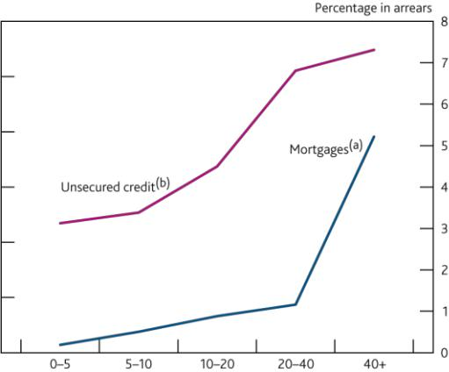

Sources: Wealth and Assets Survey and Bank calculations.

1. Percentage of individuals with consumer credit DSR at or above 20% calculated using Wealth and Assets Survey Wave 1—6 (2006—18).
2. Consumer credit DSR calculated as total consumer credit payments as a percentage of pre-tax earnings.
3. Projections account for an increase in unemployment consistent with the

August *MPR* projections, and the reverse stress test. Individuals made unemployed receive standard Universal Credit for singles aged 25 or over. Projections assume no change in repayment terms.

Sources: Wealth and Assets Survey and Bank calculations.

1. The share of mortgagors who have been in arrears for at least two months, calculated between 2010 and 2016. The mortgage DSR is calculated as total mortgage payments on the household’s main property (including principal repayment) as a percentage of pre-tax income.
2. The share of the consumer credit holders who are in arrears of any length on their unsecured debt products, calculated between 2016 and 2018. The consumer credit DSR is calculated as total consumer credit payments on all consumer products held as a percentage of pre-tax income.

For the share of borrowers with high DSRs to reach the levels of the global financial crisis, unemployment levels would need to reach around 14%. This is around the unemployment rate generated by the ‘reverse stress test’ exercise set out in the Resilience of the UK banking sector chapter, which estimates how much worse than the central projection the economic outcome would need to be to deplete banks’ regulatory capital buffers.

*The debt-servicing burdens of some UK mortgagors has started to increase...*

In the UK, mortgages are households’ largest financial liability and lenders’ largest loan exposure. Household debt-servicing burdens had been low, with the share of households with a mortgage DSR at or above 40% — a level above which households are much more likely to experience repayment difficulties — around 0.9% at the end of 2019. Staff estimates using the more timely special Covid-19 survey from Understanding Society show this may have risen to 1.7% in May, remaining well below levels seen in the global financial crisis (**Chart B.4**).

*…but so far, support schemes and payment holidays appear to have prevented households with higher levels of mortgage debt having to make larger cuts to their spending…*

Government support schemes, primarily the CJRS and the SEISS, have limited the rise in unemployment to date, which in turn has limited the rise in households with high DSRs on their mortgage debt. And payment holidays offered by lenders have also been effective at supporting households that might otherwise have experienced difficulties repaying their mortgage.

According to UK Finance, the number of mortgage payment holidays granted by lenders reached 1.9 million in June, while supervisory intelligence suggests around 10–15% of unsecured borrowers have applied for payment holidays.

Financial Stability Report August 2020 UK household indebtedness and Covid-19 16

The latest NMG survey suggests mortgagors who had taken out a payment holiday were less likely to report a cut in spending so far, despite being more likely to report a fall in income (**Chart B.5**). Staff estimate that without payment holidays, the share of households with high mortgage DSRs would have more than doubled from their end-2019 level, to 2.1%. Taken together, these suggest payment holidays have helped to minimise the extent to which mortgage debt has amplified the shock to date.

**Chart B.3** Write-offs have historically increased with the unemployment rate

Write-off rates of consumer credit compared to change in unemployment

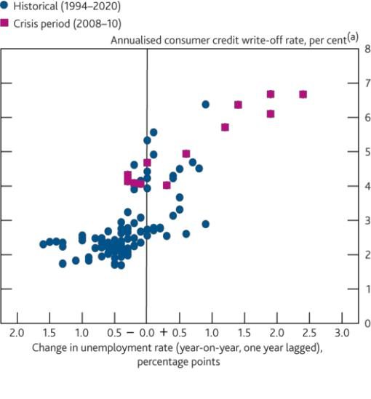

**Chart B.4** The tail of highly indebted households with a mortgage is increasing

Percentage of households with mortgage DSRs at or above

40%(a)(b)(c)

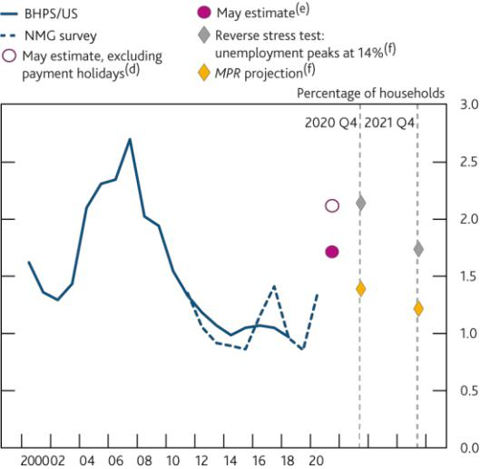

Sources: Bank of England, ONS and Bank calculations.

1. Four-quarter moving sum of consumer credit write-offs of monetary financial institutions (MFIs), divided by the outstanding stock of consumer credit at MFIs one year earlier.

Sources: British Household Panel Survey/Understanding Society (BHPS/US), NMG Consulting survey and Bank calculations.

1. Percentage of households with mortgage DSR at or above 40% calculated using BHPS

(1991–2009), US (2009–19), and the online waves of NMG Consulting survey (2011–20). NMG data are from H2 surveys only, aside from in 2020.

1. Mortgage DSR calculated as total mortgage payments as a percentage of pre-tax income.
2. A new household income question was introduced in the NMG survey in 2015. Adjustments have been made to data from previous waves to produce a consistent time series.
3. May estimate based on responses from Wave 1 and Wave 2 of the Understanding Society Covid-19 survey, conducted in April and May respectively. Estimated on the basis of the difference in reported household earnings between January/February and May. Assumes no other changes to gross household income and repayments since the last time respondents were surveyed in Wave 9 of the Understanding Society main survey.
4. May estimate accounting for payment holidays assumes any respondents who reported being on mortgage holidays as of May have repayments of zero.
5. Projections account for an increase in unemployment consistent with the *MPR* projection, and the reverse stress test. Individuals made unemployed receive standard Universal Credit for singles aged 25 or over. Projections assume no change in repayments.

*…and internal product transfers continue to support households’ debt-servicing burdens.*

The reduced availability of mortgage products may have affected households’ ability to refinance existing mortgages and thereby reduce their debt-servicing costs. This may have been particularly acute for households with high loan to value mortgages.

But many lenders have offered internal product transfers to customers coming to the end of a fixed-rate mortgage, which will have helped guard against an increase in the number of borrowers paying a higher contractual reversion rate — often the standard variable rate (SVR). Despite the tightening mortgage availability, the share of UK mortgage balances on SVRs has remained stable since the beginning of the year.

*Buy-to-let borrowers tend to have relatively diversified income sources to finance their mortgage repayments.*

Buy-to-let mortgages represent around one sixth of outstanding mortgages in the UK. If house prices or the income received from rental payments were to fall significantly, there is a risk that some leveraged investors may look to sell their properties quickly, forcing further house price falls in the downturn.

Survey data indicates that renters have been among those most likely to experience an income shock. As they spend a significant portion of their income on accommodation, this may translate into challenges keeping up with

Financial Stability Report August 2020 UK household indebtedness and Covid-19 17

rental payments. Data from the May Understanding Society survey suggests that only around 2% of private renters have agreed a rent deferral or reduction. However, a greater share of renters (around 6%) reported being behind on rent. But a survey by the Resolution Foundation in May suggests these figures may be higher: they find 5% of private renters have agreed a rent deferral or reduction, and the share of renters behind on rent to be closer to 13%.

Recent survey evidence suggests that most buy-to-let borrowers are not overly reliant on rental income, with only 7% of borrowers receiving the majority of their income from rents. Moreover, the vast majority of buy-to-let borrowers also have sufficient liquid assets to cover their mortgage payments for a six-month period, giving them some further resilience to an income shock. However, buy-to-let investors with other forms of debt may be more vulnerable. While the proportion of buy-to-let investors with high DSRs on their owner-occupier mortgages remains low, these borrowers generally have lower incomes and a greater reliance on rental incomes.

**Chart B.5** Mortgagors with payment holidays were less likely to cut spending

Changes in income/spending due to Covid-19, reported in the April NMG survey(a)

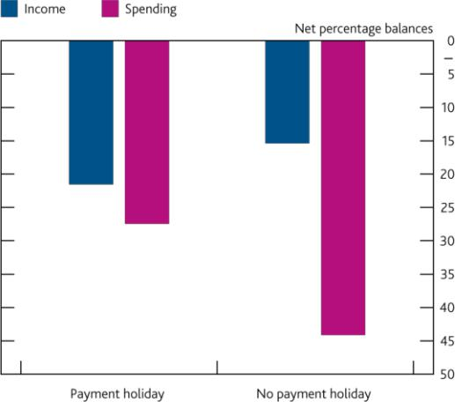

**Chart B.6** Many payment holidays appear to have been taken out on a precautionary basis

Percentage of households taking out payment holidays, by earnings change(a)

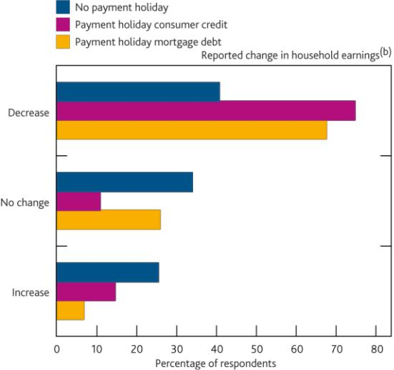

Sources: NMG Consulting survey and Bank calculations.

1. Net percentage balances are calculated by averaging over responses. A negative net percentage balance indicates more people reporting falls in income/spending than rises.

Sources: British Household Panel Survey/Understanding Society (BHPS/US) and Bank calculations.

1. Based on Wave 1 and Wave 2 of the Understanding Society Covid-19 survey, conducted in April and May 2020 respectively.
2. Change in earnings is calculated as the change in household take-home earning reported for January/February 2020 and take home earnings in the month in which the payment holiday was granted (April or May), or taking April figures where May was not reported. Earnings is net of tax and excluding benefits income.

*Looking ahead, despite a rise in unemployment, the share of households with high debt burdens should remain below levels seen in the global financial crisis.*

Looking ahead, the Government’s income support schemes are assumed to unwind during 2020 H2 and, for those households that made use of payment holidays, the initial three-month payment deferral period began to expire in June. Borrowers with new or ongoing financial difficulties can take out a new payment deferral, or extend an existing one, if agreed before the end of October. The FCA and PRA recently also finalised guidance on how lenders should treat mortgagors at the end of the deferral period, and issued similar guidance to provide continued support to borrowers struggling to repay credit cards and other unsecured debts.

The loan balances of customers with payment holidays will generally grow over the deferral period, since principal payments are frozen and interest continues to accrue. This may pose risks to households’ debt-repayment capacities once the measures end, particularly for borrowers with consumer credit loans, which typically have higher interest rates and shorter tenors than mortgages. So far, a number of those households who took out payment holidays in the early weeks of the schemes opening have already resumed repayments. This is consistent with survey evidence, which suggests that around 30% of the households with payment holidays have not faced a change in their earnings (and so may have been acting in a precautionary manner — **Chart B.6**). Nevertheless, some households will struggle to make repayments once the initial period ends, and may seek to extend payment holidays to cushion losses of income. Supervisory intelligence from the beginning of July indicates that although

Financial Stability Report August 2020 UK household indebtedness and Covid-19 18

there were only limited signs of household distress at this stage, consumer credit, rather than mortgage debt, was proving more challenging for many households.

Despite the unwinding of support schemes and payment holidays, estimates by Bank staff suggest that if the unemployment rate evolves as in the *MPR* projection, the share of households with high mortgage DSRs will remain well below the levels reached in the global financial crisis (**Chart B.4**). That share is projected to fall to around

1.4% at the end of this year, and fall marginally further by the end of 2021. This fall reflects the fact that the *MPR* unemployment projection implies the majority of those employees who exit furlough return to work and so incomes recover.

These estimates are, however, subject to considerable uncertainty. For example, if the incomes of those employed do not fully recover to their levels prior to the shock when support unwinds, then the tail of highly indebted households would be expected to remain elevated for longer. Bank staff have also considered the effects of a more severe scenario for unemployment on the tail of highly indebted households (see below).

*It is in the collective interest of the banking system to continue to support businesses and households through this period.*

Even if the unemployment rate rose to 14%, the share of households with high mortgage debt-servicing burdens would remain below the peak reached at the time of the global financial crisis (**Chart B.4**). As noted, this is around the level of unemployment generated in the ‘reverse stress test’ described in The resilience of the UK banking sector chapter, which estimates how much worse than the central projection the economic outcome would need to be in order to deplete banks’ regulatory capital buffers.

Based on this ‘reverse stress test’, the FPC judges the major UK banks to be resilient to a very wide range of possible outcomes. It remains the FPC’s judgement that banks have the capacity, and it is in the collective interest of the banking system, to continue to support businesses and households through this period. The FPC and Prudential Regulation Committee have also previously taken action to ensure firms hold appropriate capital against consumer lending.

As noted, a number of borrowers that took out payment holidays have already resumed repayments. But as Government support schemes end and borrowers’ payment holidays come to an end, it will be important for lenders to work with those borrowers who may find it difficult to resume full payments, in line with published PRA and FCA guidance. Supporting UK households through this period of disruption can mitigate the extent to which households have to cut spending further, which might slow the pace of the economic recovery and increase banks’ losses.

Financial Stability Report August 2020 The UK corporate sector and Covid-19 19

The UK corporate sector and Covid-19



The UK corporate sector is in the midst of a very significant shock. After taking into consideration the impact of the substantial package of fiscal measures put in place by the Government, but before using government-backed lending schemes, the Committee estimates that UK companies could face a cash-flow deficit in the current financial year of up to around £200 billion under the central projection set out in the August 2020 *Monetary Policy Report (MPR)*. Of this, around £125 billion relates to larger companies,and around £40–£70 billion to smaller companies. UK companies also have around £275 billion of debt maturing this year, much of which will need to be refinanced.

Since the onset of the Covid-19 shock, UK companies have raised a large amount of external finance, providing them with liquidity to help bridge some of the disruption. Through the provision of finance, the UK financial system continues to play a key role in helping UK companies manage the impact of the shock. This has been possible due to the resilience that was built up following the global financial crisis, and the extraordinary policy response of the Government and the Bank of England. Nonetheless, some additional financing will be needed to fill companies’ estimated cash-flow deficits, refinance maturing debt and ensure viable businesses survive the shock.

While the number of corporate insolvencies has remained low to date, insolvencies are likely to increase. Some companies were vulnerable at the outset of the pandemic, and may become insolvent as a result of the shock. Others may face challenges to their long-term viability given structural change in the economy, some of which may have been accelerated or precipitated by the pandemic.

Based on the results of its ‘reverse stress test’ exercise, the Committee judges that major UK banks would be resilient to risks from corporate distress even under severe economic paths. It remains the Committee’s judgement that banks have the capacity — and it is in the collective interest of the banking system — to continue to support UK companies through this period.

Some companies will enter the recovery phase with more leveraged balance sheets, having accumulated debt to finance themselves through the shock. While the current low level of interest rates supports the sustainability of UK corporate debt, higher leverage would make the corporate sector more vulnerable to interest rate or earnings shocks. During the recovery phase, equity finance likely has a role to play: as a source of finance for highly leveraged companies, to support entry of new companies and growth of incumbents, and as a means for some companies to repair their balance sheets. This reinforces the importance of increasing the supply of productive finance.

Financial Stability Report August 2020 The UK corporate sector and Covid-19 20

**The UK corporate sector and Covid-19**

*The UK corporate sector is in the midst of a significant shock...*

Economic activity has fallen sharply as a consequence of Covid-19 and the widespread public health measures introduced to contain its spread. Lower demand for goods and services and disruptions to production and supply chains have caused many companies’ revenues to decline sharply, putting pressure on cash flows and increasing the financing needs of companies large and small, both within the UK and abroad (see **Box 3** for an analysis of the impact of Covid-19 on corporate sector financing in the US and euro area).

Around 60% of companies that responded to the Office of National Statistics (ONS) Business Impact of Covid-19 Survey (BICS) in June, reported declines in turnover. And 16% reported declines of more than 50% compared to normal times (**Chart C.1**). Given the scale and speed of the turnover shock, there was a very sharp increase in the demand for credit from many UK companies in 2020 Q2 (**Chart C.2**).

**Chart C.1** The Covid-19 shock has reduced turnover for a large amount of companies

Impact of the pandemic on businesses' turnover compared to normal

(a)(b)(c)

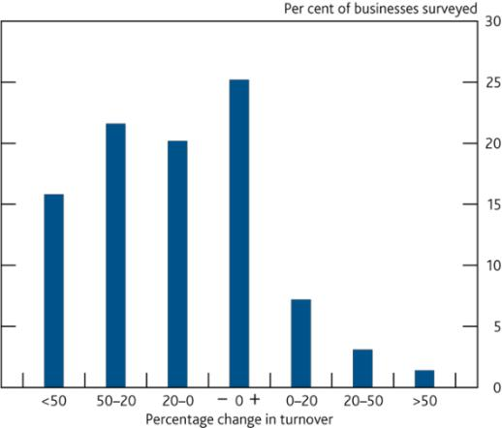

Sources: ONS BICS Survey and Bank calculations.

1. Question: In the last two weeks, how has the coronavirus (COVID-19) pandemic affected your business‘s turnover, compared to what is normally expected for this time of year?
2. Final results, Wave 8 of the ONS BICS (n = 4,911). 15 June to 28 June 2020.
3. Bars might not sum to 100% due to rounding.

**Chart C.2** Lenders reported a spike in the demand for corporate credit

Corporate demand for lending, up to 2020 Q2, by firm size(a)

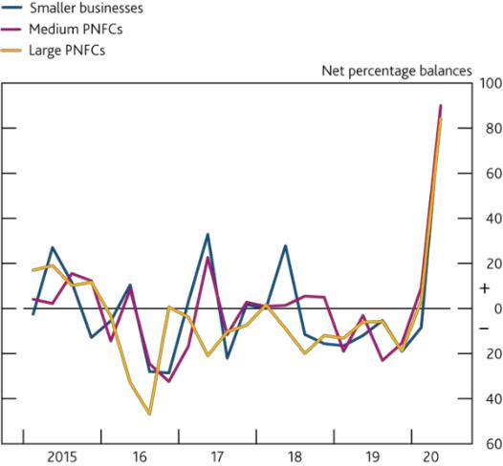

Sources: Bank of England *Credit Conditions Survey* and Bank calculations.

1. Net percentage balances are calculated by weighting together the responses of lenders who answered the survey question ‘How has overall demand for lending from small businesses, medium PNFCs and large PNFCs changed?’. A positive balance indicates an increase in demand over the previous three months.

*Fiscal measures put in place by the Government should continue to provide material support to companies through the economic disruption.*

The Government has put in place a number of important fiscal measures which should help reduce companies’ cash-flow pressures (see **Table C.A** for a summary):

The Coronavirus Job Retention Scheme (CJRS) will have supported employment and substantially reduced labour costs for many UK companies.1 Close to 80% of businesses that responded to the Bank’s June Decision Maker Panel (DMP) Survey reported having made use of the CJRS, and over 9 million jobs have been furloughed under the scheme at some point. This scheme will be in place until the end of October,

with the share of wages paid by the Government reducing incrementally from August.

Companies in the retail, hospitality and leisure sectors, as well as nurseries, will not have to pay business rates on eligible properties this year. Business rates relief for these sectors will provide a direct boost to cash flows through the shock.

1. Under the CJRS, the Government initially paid 80% of the wages of employees that were furloughed, up to £2,500 per month, as well as employer National Insurance Contributions (ER NICS) and pension contributions for the hours the employee is on furlough. From July, employers can bring furloughed employees back to work for any amount of time, while still being able to claim the CJRS grant for the hours not worked. For August, the Government will pay 80% of wages up to a £2,500 cap for the hours an employee is on furlough, but employers will pay ER NICs and pension contributions from this point onwards. For September, the Government will pay 70% of wages up to a £2,187.50 cap for the hours the employee is on furlough, while employers will top up employees’ wages (to 80% up to a £2,500 cap) from this point onwards. For October, the Government will pay 60% of wages up to a £1,875 cap for the hours the employee is on furlough.



Financial Stability Report August 2020 The UK corporate sector and Covid-19 21

The Government announced a ‘Plan for Jobs’ in July, aimed at supporting employment and corporate cash flow, primarily by encouraging companies to retain furloughed workers through the Job Retention Bonus. This will provide a one-off payment of £1,000 to UK employers for every furloughed employee who

remains continuously employed through to the end of January 2021.

The Government has also put in place several loan guarantee schemes to allow companies access to financing (discussed further below).

**Table C.A** A package of government policy measures has been designed to support UK businesses

|  |  |  |  |
| --- | --- | --- | --- |
|  |  |  | OBR estimated |
|  | Medium and | Small | budgetary costs(b) |
|  | larger companies | companies(a) | (£ billion, 2020–21) |
| **Business support: tax and spending measures** |  |  | **30.2** |
| Business grant schemes |  | ✓ |  |
| Business rates relief | ✓ | ✓ |  |
| VAT payments deferral | ✓ | ✓ |  |
| Self-assessment tax payment deferral |  | ✓ |  |
| Statutory sick pay support |  | ✓ |  |
| **Business support: loans and guarantees** |  |  | **20.0** |
| Bounce Back Loan Scheme |  | ✓ |  |
| Covid Corporate Financing Facility (CCFF) | ✓ |  |  |
| Coronavirus Business Interruption Loan Scheme (CBILS) | ✓ | ✓ |  |
| Coronavirus Large Business Interruption Loan Scheme (CLBILS) | ✓ |  |  |
| Coronavirus Future Fund |  | ✓ |  |
| Trade credit insurance | ✓ | ✓ |  |
| **Employment support measures** |  |  | **62.2** |
| Coronavirus Job Retention Scheme | ✓ | ✓ |  |
| Self-employment income support scheme |  | ✓ |  |
| **Summer Economic Update, specifically:** |  |  | **9.1(C)** |
| Job Retention Bonus | ✓ | ✓ |  |
| Reduced VAT for hospitality, accommodation and attractions | ✓ | ✓ |  |
| Eat out to help out | ✓ | ✓ |  |

Sources: [Office for Budget Responsibility](https://obr.uk/coronavirus-analysis/) (OBR), Coronavirus Policy Monitoring database, 14 July 2020.

1. While for the purpose of the cash-flow deficit analysis, ‘smaller companies’ have been defined as those with annual turnover of less than £10 million, there are several definitions of small and medium-sized enterprises (SMEs). For example, some definitions refer to businesses with less than 250 employees, and other definitions reference a combination of assets, employees and turnover.
2. The ‘OBR estimated budgetary costs’ column references the current estimates of the possible costs of the specified policy interventions in 2020–21, as published by the OBR on 14 July 2020.
3. The estimated budgetary cost for the ‘Summer Economic Update’ row refers to the current estimates of the possible costs of the three specified policy measures only.

**UK corporate sector cash flows under the August 2020 *MPR* scenario**

*Companies’ responses to the reduction in turnover are a key factor in assessing how the Covid-19 shock could affect the economy and financial stability of the UK.*

Many businesses have faced and will continue to face cash-flow pressures as their financial positions deteriorate. Without sufficient internal or external finance, companies would be forced to take actions to reduce their costs, including cutting back on employment and investment, thereby reducing the productive capacity of the economy and increasing the risk of longer-term economic damage.

In the May 2020 *interim Report*, the Financial Policy Committee (FPC) estimated that UK companies could face a cash-flow deficit summing to around £140 billion in total for the 2020–21 financial year. This ‘cash-flow deficit’ was a mechanical estimate of how much financing companies could require to maintain their productive capacity at pre-Covid-19 levels between 2020 Q2 and 2021 Q1 under the illustrative scenario set out in the May *Monetary Policy Report (MPR)*.2 By using this exercise to determine the financing needs of the UK corporate sector, the FPChas been better positioned to assess the performance of the financial system in supporting the real economy during the Covid-19 shock (see Performance of the UK financial system during the Covid-19 pandemic chapter).

**The updated UK corporate cash-flow deficit estimate**

*The FPC has updated its estimates of the corporate cash-flow deficit for UK companies…*

The FPC has considered estimates of how UK corporate cash flows could evolve under the latest central projections set out in the August *MPR*. Bank staff have projected the cash flows of private non-financial companies for the financial year 2020–21, assuming turnover evolves in a way that is broadly consistent with the central projection



1. For a detailed account of the data and assumptions underlying the estimates of the May 2020 cash-flow deficit estimate, please see the [‘Technical annex’](https://www.bankofengland.co.uk/-/media/boe/files/financial-stability-report/2020/technical-annex-may-2020.pdf) published alongside the *interim Report*.

Financial Stability Report August 2020 The UK corporate sector and Covid-19 22

set out in the August *MPR.* This exercise is based on a data set comprising the annual accounts of around 95,000 companies.3 These companies account for around £4 trillion in annual sales.

The data set used to produce the cash-flow deficit estimate presented in this chapter covers a large proportion of UK companies with an annual turnover in excess of £10 million (‘larger companies’), but, due to limited legal reporting requirements, has very low coverage of UK companies with an annual turnover of less than £10 million.4 In **Box 2**, Bank staff have therefore conducted a separate exercise to estimate the cash-flow deficits of smaller companies with turnover of less than £10 million. This estimate is subject to even more uncertainty than that for larger companies, reflecting the additional assumptions that were necessary.

*…based on the central projection set out in the August Monetary Policy Report.*

Since the publication of the *interim Report*, there have been signs of recovery as economic activity has resumed somewhat following the gradual easing of lockdown restrictions. Nonetheless, many companies were not able to operate at their previous level of capacity, or at all, while social distancing measures were in place. And most businesses expect Covid-19 to have a large and persistent negative impact on their sales (see Section 2 of the *MPR)*.

The MPC has presented its central projections for the UK economy in the August *MPR*. In it, UK GDP is expected to have fallen sharply in 2020 Q2, before recovering over the remainder of the year. The projected decline in economic activity, while substantial, is materially less sharp than was the case in the illustrative scenario set out in the May *MPR*. Nonetheless, the recovery is not rapid and output is projected to be persistently weaker than it would otherwise have been. In the *MPR* central projections GDP does not exceed its level in 2019 Q4 until the end of 2021 (see Section 1 of the *MPR*).

For the purpose of the analysis set out in this section, Bank staff have mapped out how the aggregate output projected in the August *MPR* could vary across sectors and, in some cases, sub-sectors of the economy. These sectoral paths for turnover take into account the latest monthly GDP data for April and May, as well as real-time spending indicators, survey results and intelligence from the Bank’s Agents. Consistent with the evidence to date, companies in sectors most affected by the Covid-19-related disruption face the largest reductions, with the peak of the turnover shock occurring in 2020 Q2 (**Chart C.3**).

*Larger UK companies face a substantial cash-flow deficit under the August MPR central projection.*

The cash-flow projections are conditioned on the assumption that companies will seek to maintain their productive capacity through the shock by maintaining their capital stock at pre-Covid-19 levels and retaining staff, except for furloughing through the CJRS. Companies are assumed to cut their capital expenditure to a ‘maintenance level’, defined as the level necessary to offset depreciation. This exercise is designed to provide an indication of the amount of finance that the corporate sector might need to weather the economic disruption, while minimising damage to output and employment as much as possible. The full list of assumptions is summarised in **Table C.B.**

Given these assumptions, Bank staff projected net cash flows for each company in the sample. A company is projected to have a cash-flow deficit if their projected expenditure is larger than their projected income. The aggregate ‘cash-flow deficit’ is the sum of deficits of all companies that have one. Even in the absence of sharp falls in turnover, a number of companies normally have negative cash flows, reflecting standard fluctuations in their turnover, costs or investment plans over time. Negative cash flows before dividend distributions and share buybacks amounted to around £80 billion in aggregate according to the latest available data. For a detailed description of the data and methodology, see the [‘Technical annex’](https://www.bankofengland.co.uk/financial-stability-report/2020/updated-estimates-of-the-cash-flow-deficit-of-uk-companies-in-a-covid-19-scenario-technical-annex) published alongside this *Report*.



3

4

The increase in the number of companies in the data set since May reflects the inclusion of an additional c. 10,000 smaller companies that file detailed accounts at Companies House.

In general, small companies do not have to file granular profit and loss information with Companies House. A small company can prepare and submit accounts according to special provisions in the Companies Act 2006 and relevant regulations. This means they can choose to disclose less information than medium-sized and large businesses.

Financial Stability Report August 2020 The UK corporate sector and Covid-19 23

**Table C.B** Calculations and key assumptions underpinning cash-flow deficit estimate(a)



Estimated cash-flow deficit at individual company level

|  |  |  |
| --- | --- | --- |
|  | Modelled by Bank staff to be broadly consistent with the August *MPR* central |  |
| Turnover | projections, with variation across sectors and, in some cases, sub-sectors. |  |
| Adjusted for CHAPS real-time payments data for individual companies where |  |
|  |  |
|  | possible. |  |
| — Operating costs, *of which*: |  |  |
|  |  |  |
| — Labour costs | Companies maintain employment, hours and compensation at pre‑shock levels |  |
| absent furloughing (see CJRS treatment below). |  |
|  |  |
| — Property rental costs | Companies facing negative cash flows in 2020 Q2 defer their property rental |  |
| costs and smooth them over the remaining quarters of the year. |  |
|  |  |
|  | Change in line with turnover, consistent with proportional decline in the use of |  |
| — Other operating costs | intermediate inputs (and value-add falling in line with output). Assume that |  |
|  | companies continue to pay operating leases. |  |
| — Other impacts on cash flow, *of which*: |  |  |
|  |  |  |
| — Interest paid | Assume companies pay interest expenses on their outstanding debt, taking into |  |
| account the recent cuts to Bank Rate. |  |
|  |  |
| — Corporation tax | Model exact timings of corporation tax payments in line with tax legislation. |  |
| Assume no change in corporation tax rate. |  |
|  |  |
| — Capital expenditure | Cut to a maintenance level, equal to depreciation. |  |
|  |  |  |
| — Dividends/buybacks | Cut to zero, unless firm faces a positive shock. |  |
|  |  |  |
| +/– Change in working capital | Inventories change by a third of the change in turnover each quarter. Trade |  |
| creditors and trade debtors change in proportion to turnover. |  |
|  |  |
| **= Cash-flow deficit before policy response** |  |  |
|  |  |  |
|  | Estimate number of furloughed workers proportional to 75% of the fall in |  |
|  | turnover over the period of the shock. 25% of the fall in output is explained by a |  |
| + Coronavirus Job Retention Scheme (CJRS) | fall in turnover per employee. Assume workers furloughed earn 70% of the |  |
|  | average wage within their company. Assume companies do not pay the |  |
|  | remainder of labour costs of furloughed workers. |  |
| + Business rates relief and cash grants for | Estimate ‘rateable value’ — the commercial rents measure to which business |  |
| certain sectors | rates apply — for firms in eligible sectors to estimate eligibility. |  |
| + Coronavirus Job Retention Bonus (CJRB) | Assume all companies that furloughed workers claim the £1,000 bonus per |  |
| worker rehired. |  |
|  |  |
| + Value Added Tax (VAT) cut | Assume 80% pass through to consumer prices for temporary VAT cut in eligible |  |
| sectors. |  |
|  |  |
| +/– VAT deferral | Estimate current VAT receipts and payments. Assume lag between cash inflow |  |
| and cash outflow when company pays HMRC for liabilities due in 2020 Q2. |  |
|  |  |

* **Cash-flow deficit after fiscal policy response**

Sources: Bank of England, HM Government and Policy announcements.

(a) For more information on the assumptions used in the cash-flow deficit analysis, including a comparison to the assumptions from the May interim *Report*, refer to the [‘Technical annex’.](https://www.bankofengland.co.uk/financial-stability-report/2020/updated-estimates-of-the-cash-flow-deficit-of-uk-companies-in-a-covid-19-scenario-technical-annex)

As described above, fiscal measures that the Government has put in place will provide material support to companies through the disruption. On the assumption that companies access these schemes if they are eligible, the Committee estimates that companies included in the sample could face a cash-flow deficit of around £135 billion in the 2020–21 financial year under the central forecast presented in the August *MPR* (middle blue bar, **Chart C.5**). This is similar to the estimate presented in the May *interim Report*. The moderate improvement in the projected path for output in the August *MPR* projection reduces the estimated cash-flow deficit by around £20 billion, but this is almost offset by various modelling improvements, including, for example, using real-time payments data to more accurately estimate turnover in some sectors.5

Around £125 billion of the £135 billion cash-flow deficit estimate is accounted for by the larger companies included in the data set. The remaining £10 billion is accounted for by the small proportion of smaller companies for whom granular accounting information exists. As detailed in **Box 2**, Bank staff have also estimated the cash-flow deficits of smaller companies using an alternative and more experimental approach. While more uncertain, this approach suggests that smaller companies could have a deficit of around £40–£70 billion (see **Box 2**). In total, the estimated



1. These modelling improvements also include updating the accounting information for companies that have recently filed updated pre-shock accounts; more detailed modelling of the timing of corporation tax payments; an assumption that companies continue to make operating lease payments; an assumption that distressed companies can defer Q2 commercial rent payments; and improved estimates of the level of maintenance capital expenditure at firm level.

Financial Stability Report August 2020 The UK corporate sector and Covid-19 24

cash-flow deficit for larger and smaller UK companies in the current financial year is, therefore, up to around £200 billion.

**Chart C.3** The shock to turnover varies for each sector

Average turnover shock applied by sector and sub-sector in 2020

Q2(a)

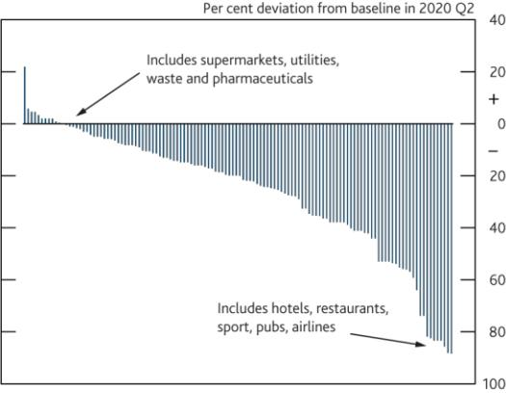

Sources: Bank of England, Companies House, Fame (Bureau van Dijk), ONS, S&P Capital IQ and Bank calculations.

(a) See the [‘Technical annex’](https://www.bankofengland.co.uk/financial-stability-report/2020/updated-estimates-of-the-cash-flow-deficit-of-uk-companies-in-a-covid-19-scenario-technical-annex) for more detail on the data set and methodology.

**Chart C.4** Employment growth and turnover growth are highly correlated in historical data on UK companies at firm level

Correlation between growth in employment (controlling for sector and firm characteristics) and growth in turnover(a)

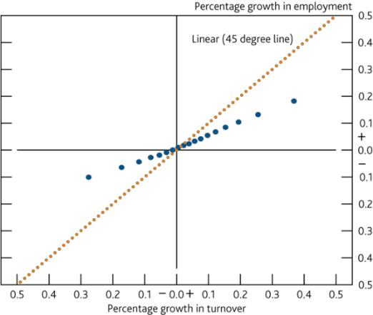

Sources: Fame (Bureau van Dijk) and Bank calculations.

1. The chart is based on a regression using historical data on individual UK companies. The regression finds that after controlling for a number of characteristics that affect employment growth at firm level — including wage growth, year fixed effects and firm characteristics like their industry group — there is a strong positive correlation between growth in turnover and growth in employment. This relationship is less than 1 for 1, as shown by the dotted 45 degree line.

The cash-flow deficit is estimated to be largest in 2020 Q2 and 2020 Q3, before falling back over the remainder of the financial year as turnover partially recovers (**Chart C.6**). The peak in the deficit is estimated to occur in 2020 Q3 despite the fact that the shock to turnover is largest in 2020 Q2. This partly reflects that rental and VAT deferrals are assumed to provide support to cash flows in 2020 Q2. It also partly reflects an assumption about inventory dynamics: companies are assumed to destock a proportion of their existing inventories in Q2, before rebuilding them as turnover recovers later in the year.

*The cash-flow deficit estimate remains large even after allowing for adjustments in labour costs and capital expenditure*

The FPC has also considered how alternative assumptions could affect the estimated cash-flow deficit. In particular, rather than assuming companies maintain their employment at pre-shock levels and cut capital expenditure to a maintenance level, Bank staff have considered how the estimated cash-flow deficit might change if companies’ employment and capital expenditure costs were to evolve broadly consistently with the paths underlying the MPC’s central projection.

Historically, changes in turnover have been closely correlated with changes in employment at a company level (**Chart C.4**). The CJRS is likely to have materially reduced the strength of this correlation. But some companies, particularly those in sectors that may be more persistently affected by the shock, are likely to cut employment somewhat. Indeed, employment has fallen since the start of the Covid-19 outbreak (see Section 2 of the *MPR*) and several larger UK companies have announced that they intend to make redundancies in the near future. In the August *MPR*, unemployment increases over 2020 H2, and declines gradually thereafter.

Separately, there is now more evidence on how UK companies expect their investment to evolve over the year. For example, companies that responded to the Bank’s DMP survey reported that they intended to cut capital expenditure sharply in 2020 Q2, then increase it gradually over the remainder of the year. In aggregate, this is broadly consistent with the August *MPR*, in which business investment is projected to recover over the second half of the year, though remain subdued, after falling materially in 2020 Q2.

Financial Stability Report August 2020 The UK corporate sector and Covid-19 25

Bank staff have used this evidence to construct alternative paths for labour costs and capital expenditure across different sectors of the economy:

Companies in sectors that are expected to face larger reductions in turnover are assumed to cut employment by more than companies in sectors less affected by the shock. The resulting reduction in labour costs is small while the CJRS is in place. That is because the employees that are made redundant were previously assumed to be furloughed, and the implied transfer from furlough to unemployment has

little effect on labour costs.

Separately, individual companies are assumed to have cut capital expenditure rapidly in 2020 Q2, before raising it later in the year as revenues recover gradually. This results in an aggregate increase in companies’ projected capital expenditure above maintenance levels in the second half of the year.

In aggregate, these projections for employment and capital expenditure are broadly consistent with those underlying the August *MPR* central projections. Allowing for companies to adjust their productive capacity in this way, the cash-flow deficit estimate is little changed (**Chart C.5**). The reduction in aggregate cash-flow deficit because of the decline in employment is more-or-less offset by an increase in the deficit from the adjusted capital expenditure profile over the year as a whole.

**Chart C.5** The aggregate cash-flow deficit estimate for the UK corporate sector has reduced slightly

Estimate of the cumulative UK corporate sector cash-flow deficit during the 2020–21 financial year, conditioned on the August *MPR* central projection(a)

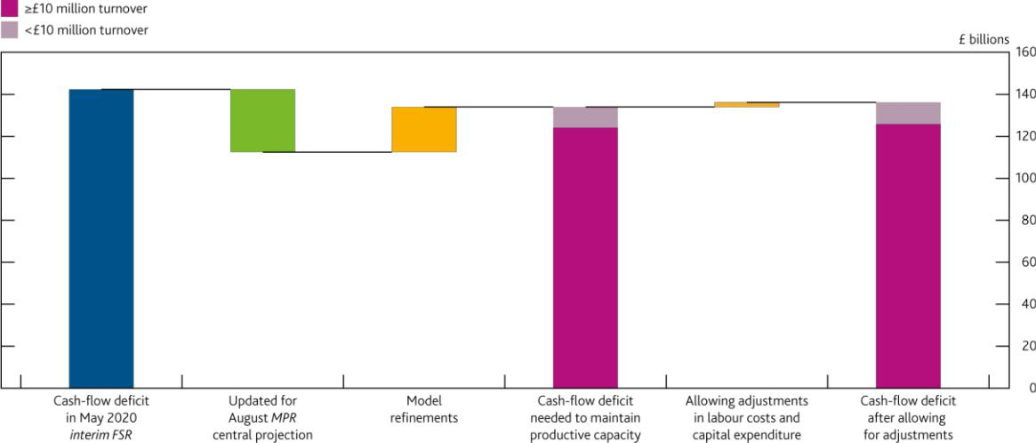

Sources: Bank of England, Fame (Bureau van Dijk), ONS, S&P Capital IQ and Bank calculations.

1. The light-pink portion of the bars showing the updated cash-flow deficit estimates reflects the share of the cash-flow deficit accounted for by the smaller companies that report profit and loss accounts, and are included in this data set. This amounts to around £10 billion. A fuller analysis of the cash-flow deficit for smaller companies is considered in **Box 2**.

*In addition, the FPC has considered companies’ refinancing needs.*

In addition to any extra financing UK companies may need to bridge through Covid-19-related disruption, many companies have existing debt obligations which will need to be refinanced over the coming year. This includes any debt that was issued with a maturity of less than one year and any longer-term debt coming due in the next year. Any maturing loans that are not refinanced would directly affect companies’ cash flows and would likely increase the scale of cash-flow deficits.

Bank staff have estimated that UK companies have around £275 billion of debt maturing over the coming year.6 By way of comparison, the total stock of outstanding UK corporate sector debt in 2019 was around £1.3 trillion. This estimate of companies’ refinancing needs is based on an analysis of the short-term debt reported by UK corporates on their latest publicly available balance sheets (which in many cases is 2018–19) and so carries a high degree of uncertainty.7



1. Refinancing needs are estimated, using data reported in companies’ accounts, as the sum of (i) short-term debt and (ii) long-term debt and on-balance sheet leases that matures within the next year.
2. This estimate can be broadly reproduced by adding up separate categories of debt due to mature using alternative data sources.

Financial Stability Report August 2020 The UK corporate sector and Covid-19 26

Bank staff analysis suggests that most companies’ refinancing needs are a small share of their turnover (**Chart C.7**). These companies may find it easier to refinance their debt. But for some companies, challenges in refinancing their existing debt could result in solvency problems in exactly the same way as failure to finance cash-flow deficits. Continued support from the banking system is therefore needed to minimise the risk of longer-term economic

damage to output and employment. Indeed, the FPC has judged that in the same way as it is in the collective

interest of the banks to provide new lending through the government-backed loan schemes, it is also in the

collective interest of banks to refinance outstanding loans to otherwise viable companies facing cash-flow

disruption. The FPC intends to monitor the risks to the economic outlook against the paths generated by the

‘reverse stress test’ exercise to assess whether banks can continue to absorb losses and lend through the shock

(see The resilience of the UK banking sector chapter).

**Chart C.6** The estimated cash-flow deficit declines over the 2020–21 financial year

Estimate of the cumulative corporate sector cash-flow deficit per quarter(a)(b)

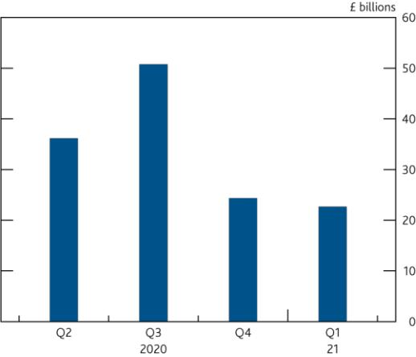

**Chart C.7** Many companies have small refinancing needs as a share of their turnover

Estimated refinancing need over the next year as a share of turnover(a)(b)

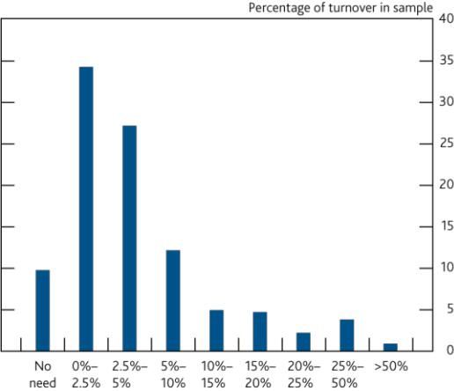

Sources: Bank of England, Fame (Bureau van Dijk), ONS, S&P Capital IQ and Bank calculations.

1. This chart summarises the estimates from **Chart C.5** on a quarterly basis, assuming companies’ maintain their productive capacity.
2. See the [‘Technical annex’](https://www.bankofengland.co.uk/financial-stability-report/2020/updated-estimates-of-the-cash-flow-deficit-of-uk-companies-in-a-covid-19-scenario-technical-annex) for more detail on the data set and methodology.

Sources: Bank of England, Fame (Bureau van Dijk), ONS, S&P Capital IQ and Bank calculations.

1. Estimated refinancing needs at company level are computed from accounting data on short-term debt and the current portion of long-term debt. These accounting data largely refer to debt maturing in 2019, so estimated refinancing needs will not capture any changes to the maturity profile of UK companies’ debt since then. Some companies report drawn revolving credit facilities which have a maturity of greater than one year as short-term debt, even though in practice this would not need to be formally refinanced in the next year. These facilities have been removed where possible, but may mean the refinancing needs of some companies are smaller than estimated.
2. See the [‘Technical annex’](https://www.bankofengland.co.uk/financial-stability-report/2020/updated-estimates-of-the-cash-flow-deficit-of-uk-companies-in-a-covid-19-scenario-technical-annex) for more detail on the data set and methodology.

**Financing of companies’ cash-flow deficits**

*There are various ways in which companies could finance their cash-flow deficits, including through existing cash balances.*

Many companies could meet some or all of their cash-flow deficits using existing cash balances. At one extreme, if all companies with a deficit in the above exercise used their cash balances available before the Covid-19 shock, they could reduce the aggregate cash-flow deficit estimate by around £85 billion. But the extent to which companies would choose to run down their cash reserves is uncertain, and where companies can access additional finance, many might prefer to preserve existing cash balances.

*Large companies can access finance through capital markets and the Covid Corporate Financing Facility.*

Market-based funding also plays a particularly important role for large UK companies, accounting for more than half of debt outstanding in 2019. Larger companies have used market-based finance in increasing volumes to fulfil their financing needs, with net UK corporate bond issuance totalling £17 billion in 2020 so far. Public and private equity markets have remained open and active through the shock. Equity issuance by UK companies has also been much larger than in recent years, totalling £14.3 billion in the year so far (**Chart C.8**).

The Covid Corporate Financing Facility (CCFF) also provides financing directly to investment-grade companies. The CCFF, for which the Bank acts as HM Treasury’s agent, provides funds through the purchase of commercial paper issued by companies that were investment-grade or equivalent as of 1 March 2020. The CCFF therefore reduces the

Financial Stability Report August 2020 The UK corporate sector and Covid-19 27

need for banks to provide financing to these predominantly large companies, thereby preserving bank lending capacity for other businesses. The Bank has lent £17 billion through the CCFF.8

*Supported by government-backed loan schemes, the UK banking system has also expanded the supply of credit to businesses…*

As businesses look to weather the disruption to their cash flows, the banking system has so far been able to absorb much of the initial surge in demand for credit (see The Performance of the UK financial system during the Covid-19 pandemic chapter). This reflects the resilience that has been built up since the global financial crisis, as well as the policy response of the Government and the Bank.

Many larger UK companies have access to committed credit lines and revolving credit facilities. In total, UK companies are estimated to have access to £280 billion in undrawn facilities with UK banks.

Since March, banks have lent £15 billion to many larger companies, around five times the average rate for a similar four month period, over the previous four years (**Chart C.9**). Some of this has been extended through government loan schemes. Companies borrowed around £2 billion through the Coronavirus Large Business Interruption Loan Scheme (CLBILS) and around £11 billion through the Coronavirus Business Interruption Loan Scheme (CBILS) from March to June.9

|  |  |
| --- | --- |
| **Chart C.8** Equity issuance has increased strongly in the | **Chart C.9** Banks’ net lending to businesses has increased |
| year to date | Cumulative net lending to UK non-financial businesses since March |
| Gross equity issuance by listed UK corporates from 2008–20 | 2020, split by firm size(a)(b)(c)(d) |

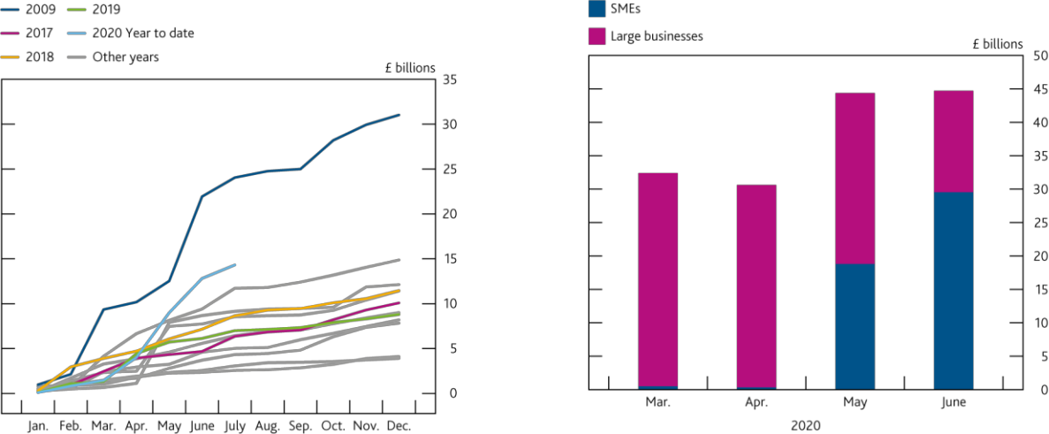

Sources: Bank of England and Bank calculations.

Sources: Bank of England and Eikon

(a) For this chart, large businesses are those with an annual debit account turnover of over

£25 million on their main business account, and cannot be compared to the ‘larger companies’

in the cash-flow deficit analysis. ‘SMEs’ refers to small and medium-sized enterprises with an

annual debit account turnover of less than £25 million.

(b) Monetary financial institutions’ all-currency lending to UK non-financial businesses.

(c) Excludes lending to businesses in the public administration and defence industry.

(d) Net lending is defined as gross lending minus repayments.

*Some companies may require additional finance to fill their cash-flow deficits.*

Larger UK companies have raised a significant amount of finance since the outbreak of Covid-19. Taking into account the different sources of finance described above, net finance raised by many of these larger UK companies exceeded £50 billion in the four months to June.10 Some of this finance is likely to have helped finance companies’ cash-flow deficits, but some may have been raised by companies on a precautionary basis or to fund investment — private non-financial corporations’ deposits increased by more than the net finance they raised in April and May.11 Overall, it is likely that some companies will need to raise additional finance to fill their cash-flow deficits.



1. As at 29 July 2020. As at the end of June, the Bank had lent £18 billion through the CCFF.
2. CBILS is available to companies with an annual turnover of less than £45 million that meet eligibility criteria, and so this figure is an upper bound estimate of the lending to ‘larger companies’ through the government schemes.
3. This £50 billion figure does not include companies’ repayments of non-CCFF commercial paper.
4. This could also reflect that companies with positive cash flows have been depositing cash rather than spending it.

Financial Stability Report August 2020 The UK corporate sector and Covid-19 28

*UK banks have an important role to play in helping businesses meet their cash-flow deficits, and it is in the collective interest of the UK banking system to continue to support businesses through the Covid-19 shock.*

The FPC reiterates that all elements of the substantial capital buffers that have been built up by banks exist to be used as necessary to support the economy. As set out in The resilience of the UK banking sector chapter, the FPC has carried out a ‘reverse stress test’ exercise to analyse how much worse than the central projection the economic outcome would need to be in order to exhaust regulatory capital buffers, using as a reference point the 2019 stress test of major UK banks. Based on this exercise, the FPC continues to judge that lending by banks, supported by government guarantee schemes, is essential to mitigate deeper and longer-lasting economic damage.

If banks withdrew credit provision, more companies could fail due to cash-flow deficits, resulting in banks incurring a higher level of impairments on their existing corporate lending and, by pushing unemployment higher, larger losses on existing lending to households too. There would be similar spill over effects — for both bank resilience and the wider economy — if the major UK banks opted out of refinancing companies’ maturing debt obligations over the next year. These spill over effects can be very large and, in the paths generated by the ‘reverse stress test’ scenario, outweigh the direct benefits to banks of cutting lending. It is therefore in the collective interest of the banks to continue lending through the shock (see The Resilience of the UK banking sector chapter).

**Challenges ahead**

*Despite the substantial public policy support, some signs of distress are emerging.*

Since March, rating agencies have downgraded around 100 UK companies, although the pace of downgrades has slowed (**Chart C.10**). But the aggregate level of insolvencies has so far remained low (**Chart C.11**). The UK corporate sector has benefited from unprecedented levels of public-sector support, as well as recent changes to insolvency legislation.

Reports from the Bank of England’s Agents suggest that there are increasing signs of stress in the corporate sector, including evidence of an increase in businesses in vulnerable sectors seeking restructuring help. This is consistent with some of the results of the Bank’s latest *Credit Conditions Survey*, which reported that lenders expect default rates to increase over the next three months.

*Some companies were highly leveraged at the outset of the pandemic, and may become insolvent as a result of the shock…*

While in aggregate the UK corporate sector had relatively strong liquidity and profitability positions before the Covid-19 pandemic, a subset of companies entered the stress in a vulnerable position. For example, the proportion of turnover accounted for by highly leveraged listed companies, with a ratio of net debt to earnings before interest, tax, depreciation and amortization (EBITDA) greater than or equal to four, was high compared to historical standards, at over 10% as of end-2019 (**Chart C.12**). Around £50 billion of the aggregate cash-flow deficit estimate arises from companies that were highly leveraged, had a low credit rating or were unprofitable before the Covid-19 shock.

Some of these companies may find it difficult to raise external debt finance because they may fall outside lenders’ risk appetites, even with government-guaranteed lending, and may not be able to access capital markets either. While investment-grade markets remained open through the shock, issuance in high-yield bond and leveraged loan markets was weak between March and May, although it picked up somewhat in June. High-yield bond spreads remain somewhat elevated, having recovered around two-thirds of their trough to peak increase (**Chart C.13**). These markets remain particularly vulnerable to a downturn in risk sentiment.

|  |  |  |
| --- | --- | --- |
|  | Financial Stability Report August 2020 The UK corporate sector and Covid-19 29 | |
|  |  |  |
| **Chart C.10** The pace of corporate downgrades has | **Chart C.11** Corporate insolvencies have yet to increase | |
| slowed | Total new corporate insolvencies (adjusted)(a)(b) | |
| Cumulative UK corporate downgrades since 1 March 2020(a) |  |  |

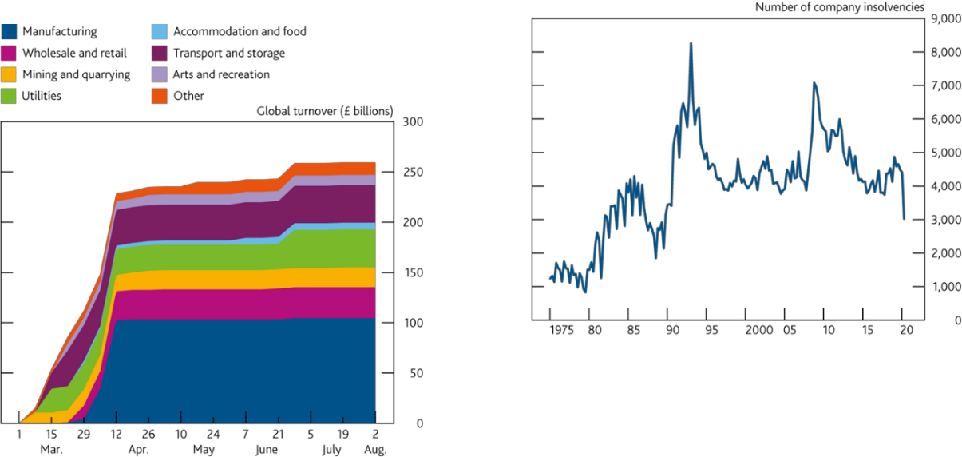

Sources: Bank of England, Eikon based on S&P, Fitch and Moody’s, Fame (Bureau van Dijk), S&P

Capital IQ and Bank calculations.

1. The chart shows the amount of global turnover downgraded by one or more notches since the start of March. Downgrades come from Eikon based on long-term issuer ratings from S&P, Fitch and Moody‘s on corporates’ domestic and foreign bond facilities. Data was produced by merging downgrades to a firm-level data set. Latest data-point: 2 August.

Sources: The Insolvency Service and Bank calculations.

1. Data adjusted for Personal Service Companies (PSC). Data from 2016 Q4 have been adjusted for one-off events of insolvencies of PSCs due to tax changes. Includes England and Wales only from 1975 to 1983 Q4. Includes Scotland from 1984 Q4 and Northern Ireland from 2003. Non-seasonally adjusted.
2. Data on members’ voluntary liquidation are not included in this chart.

**Chart C.12** Turnover generated by large listed companies **Chart C.13** High-yield bond spreads remain somewhat

with net debt to EBITDA at or above four is high by elevated

historical standards International non-financial corporate bond spreads(a)

Share of total turnover generated by listed companies at different net debt to EBITDA thresholds(a)(b)

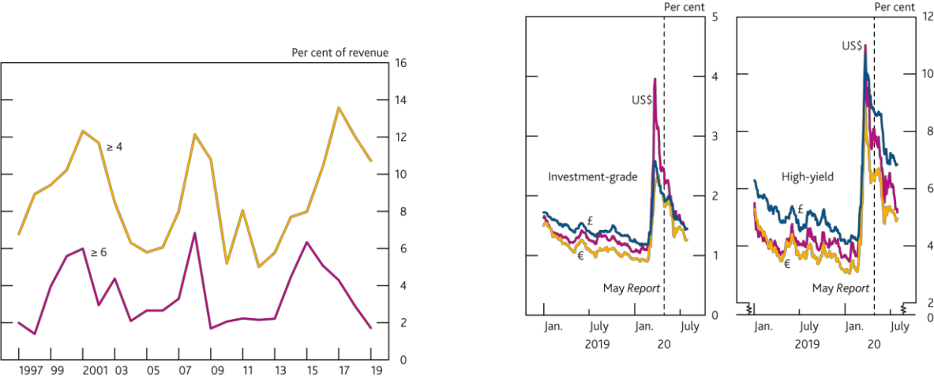

Sources: S&P Capital IQ and Bank calculations.

1. Net debt to EBITDA is calculated as the three-year moving average of earnings before interest, tax, depreciation and amortisation as a share of total debt net of cash and cash equivalents. Net debt excludes operating leases. An accounting change under IFRS 16 brought operating leases on balance sheet thereby increasing companies’ net debt in 2019. Operating leases are excluded to preserve the like-for-like comparison over time.
2. The sample includes non-financial corporates, outside of those engaged in real estate, oil, gas and mining, and for each year, includes only those companies that were listed at that point in time.

Sources: Eikon from Refinitiv, ICE/BoAML Global Research and Bank calculations.

1. Option-adjusted spreads on government bond yields. Investment-grade corporate bond yields are calculated using an index of bonds with a rating of BBB3 or above. High-yield corporate bond yields are calculated using aggregate indices of bonds rated lower than BBB3. Due to monthly index rebalancing, movements in yields at the end of each month might reflect changes in the population of securities within the indices.

Without access to internal or external financing, some companies in this group may require forbearance from lenders, or may be forced into bankruptcy. To prevent this, some companies could turn to equity markets. Equity financing may be an appropriate source of finance for highly leveraged companies without access to debt.

Some companies that struggle because of high debt levels may be able to restructure after insolvency. Around two-thirds of larger companies who enter insolvency usually enter administration (**Chart C.14**). This gives them

Financial Stability Report August 2020 The UK corporate sector and Covid-19 30

‘breathing space’ from creditor enforcement actions to prepare restructuring plans that can lead to the rescue of the company.12 Corporate restructurings could also result in some debt to equity conversions.

In exceptional circumstances, the Government has stated that where a company is of strategic importance, can be expected to have a long-term viable future and whose failure or distress could cause disproportionate economic harm, and where all other options have been exhausted, the Government may consider providing bespoke support.13

*….while others may face challenges to their long-term viability if the pandemic accelerates or precipitates*

*structural change in certain sectors.*

The post-Covid-19 outlook for many companies will depend on the strength of the economic recovery, as well as the extent to which the pandemic could accelerate or precipitate structural shifts in certain sectors. But an increase in the level of insolvencies is likely, given the severity of the Covid-19 shock. As described above, some companies that entered the shock in a more vulnerable position may struggle to survive. But even for companies that were not vulnerable prior to the Covid-19 shock, structural change — for example the adjustment from ‘brick-and-mortar’ to digital retail — may result in retrenchment and some forced or voluntary insolvencies.

In order for productive resources — employees, assets and intangible capital — to be reallocated and rebuilt as the economy recovers, it is necessary for new companies to enter the market and for incumbent companies to grow. Research suggests that limited resource reallocation was an important contributor to weak productivity and output growth in the United Kingdom after the financial crisis (see, eg, [Barnett *et al* (2014))](https://www.bankofengland.co.uk/-/media/boe/files/working-paper/2014/the-productivity-puzzle-a-firm-level-investigation-into-employment.pdf). The speed and extent of resource reallocation is likely to depend on a number of factors, including the number of insolvencies, the finance available to support entry and growth of new businesses, and the extent to which productive capacity needs to be reallocated across sectors, rather than rebuilt within sectors.

Equity finance could support the entry of new companies and the growth of existing ones, particularly if directed at unlisted and smaller businesses for whom access to finance might be more difficult.

*Looking ahead, some companies will exit the stress in a more highly indebted position, which could increase the number of vulnerable businesses and pose risks to financial stability.*

Some companies will naturally enter the recovery phase with more highly leveraged balance sheets, having accumulated debt to finance cash-flow deficits and survive the shock.

UK corporate debt servicing had been improving in recent years, supported by low interest rates. The share of debt owed by companies with interest coverage ratios (ICRs) less than 2.5 — a level below which listed companies are more likely to experience repayment difficulties — was low by historical standards prior to the Covid-19 pandemic (**Chart C.15**). But if the level of corporate debt becomes difficult to service, either because interest rates rise or because earnings come under pressure, some highly leveraged companies may default on their debts, and others may be forced to cut productive capacity further by cutting investment and employment. This could increase the risk of losses to lenders.

Corporate debt burdens may also contribute to a ‘debt overhang’ and weigh on investment in the recovery phase, as more highly leveraged companies may prioritise paying down existing debt. Highly leveraged companies might also find it difficult to refinance existing debt or raise finance if there is a future shock. Some UK companies could face difficulties refinancing the loans taken out through the lending schemes, as government-guaranteed lending may need to be refinanced at higher rates in the future.



1. Bank staff analysis of 50 recent insolvencies of large UK employers suggests that more than half were able to be partially or fully rescued after entering administration.
2. See, for example: [www.gov.uk/government/news/government-agrees-support-package-to-uk-steel-company.](http://www.gov.uk/government/news/government-agrees-support-package-to-uk-steel-company)

Financial Stability Report August 2020 The UK corporate sector and Covid-19 31

**Chart C.14** Larger businesses are more likely to enter administration when they become insolvent

Type of insolvency by company size(a)(b)

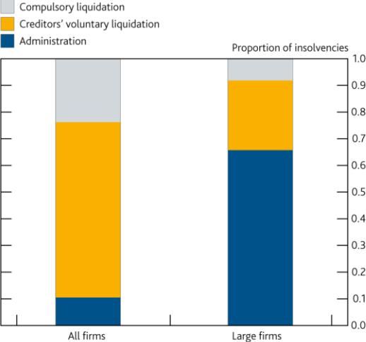

**Chart C.15** The share of debt held by large companies with low interest coverage ratios (ICR) has been low by historical standards

The share of total debt owed by listed corporates at different ICR thresholds(a)(b)

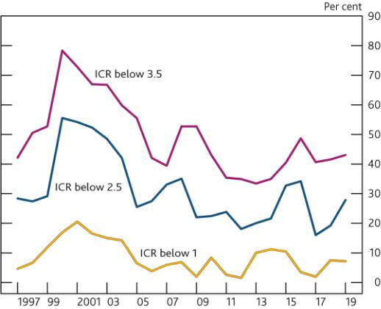

Sources: Fame (Bureau van Dijk), The Gazette, The Insolvency Service and Bank calculations.

1. Data cover 2011 to 2019. ‘Large firms’ includes 2,305 companies that reported annual turnover greater than £10 million in their last accounts prior to their insolvency. ‘All firms’ includes all new company insolvencies, according to the Insolvency Service, excluding company voluntary arrangements and receivership appointments (which combined account for around 3% of total insolvencies).
2. Liquidation involves the ‘winding up’ of the affairs of a company. It can follow either a court making an order for the company to be wound up (a ‘compulsory liquidation‘) or a meeting of shareholders to agree that the company be wound up (a ‘creditor voluntary liquidation‘). Administration involves the appointment of an administrator, who may seek to rescue the company as a going concern.

Sources: S&P Capital IQ and Bank calculations.

1. Interest coverage ratio is calculated as the three-year moving average of earnings before interest and tax as a share of interest expenses and interest capitalised.
2. The sample includes non-financial corporates, outside of those engaged in real estate, oil, gas and mining, and for each year, includes only those companies that were listed at that point in time.

Looking ahead, the low interest rate environment should support businesses’ debt-servicing costs, but some companies may seek to deleverage over the medium term, either through retained earnings or by raising equity.

*Equity finance is likely to play a greater role in the recovery phase.*

As described above, equity issuance by UK companies has been stronger than in recent years, totalling around £14.3 billion in the year to date, compared to an average of £6.5 billion in the same period in 2012–19. Equity finance also likely has a greater role to play in the recovery phase: as a source of finance for highly leveraged companies, to support entry of new companies and growth of incumbents, and as a means for some companies to repair their balance sheets.

The private sector can play a role helping to meet that demand for equity, including through the supply of finance for productive investment. This reinforces the importance of increasing the supply of productive finance to the economy, in line with the FPC’s secondary objective (see **Box 4**).

Financial Stability Report August 2020 The UK corporate sector and Covid-19 32

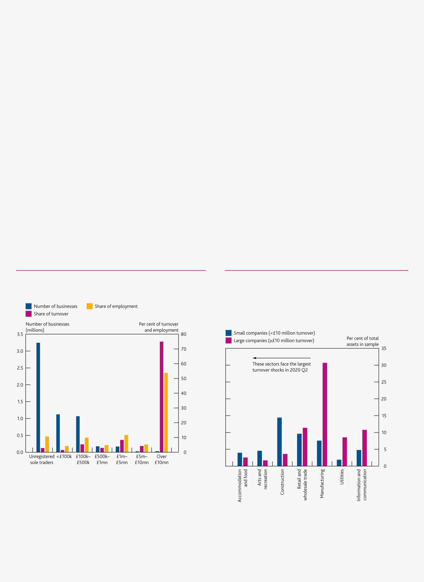

**Box 2**

**The financing needs of smaller companies**

The UK has around 5.8 million smaller businesses. These businesses account for 25% of UK turnover and almost half of total UK employment. They include 3.5 million sole proprietorships, 0.4 million partnerships and around 2 million small companies, all with an annual turnover of less than £10 million (**Chart A**).

This box focuses on the financing needs of the 2 million small companies with annual turnover below £10 million, for which balance sheet accounting data is available. The Covid-19 pandemic is also having a material impact on the self-employed, including the 3.9 million sole-proprietorships and partnerships. Almost half of self-employed workers have experienced a drop in income since the start of the pandemic. Survey evidence suggests that the self-employed are more likely to face financial difficulty due to Covid-19. But the Government’s Self-Employment Income Support Scheme (SEISS) provides support targeted at sole traders and the self-employed, which should help reduce their cash-flow pressures. Around 3.4 million self -employed individuals were identified by the Government as potentially eligible for the SEISS. Some self-employed workers may also be able to access lending through the Bounce Back Loan Scheme (BBLS).

*Smaller companies operate in sectors more affected by the Covid-19 pandemic…*

Smaller companies operate in the sectors that are more affected by the shock, including the hotel and restaurant sector and construction, than is the case for companies overall (**Chart B**). Recent evidence from the [ONS Business](https://www.ons.gov.uk/economy/economicoutputandproductivity/output/datasets/businessimpactofcovid19surveybicsresults) [Impact of Covid-19 Survey (BICS)](https://www.ons.gov.uk/economy/economicoutputandproductivity/output/datasets/businessimpactofcovid19surveybicsresults) also suggests that smaller businesses are more likely to have seen sharper falls in turnover than larger businesses.

**Chart A** Smaller businesses make up a quarter of UK turnover and almost half of UK employment

Firms’ contribution to employment and turnover(a)(b)(c)

**Chart B** Smaller companies are more likely to be concentrated in sectors vulnerable to the Covid-19 shock

Proportion of total assets among smaller and larger companies accounted for by firms operating in each sector, ordered by size of expected turnover shock(a)(b)(c)

Sources: Department for Business, Energy and Industrial Strategy (BEIS), ONS and Bank calculations.

1. The data set covers companies, partnerships, sole traders, charities and national entities. ‘Unregistered sole traders’ refers to zero-employee businesses that are not registered for VAT or PAYE. Registered zero-employee firms are included within the relevant turnover brackets.
2. The chart combines figures from the Inter-Departmental Business Register and the Business Population Estimates; there are some inconsistencies across these data sets due to differences in data collection.
3. This work was produced using statistical data from ONS. The use of the ONS statistical data in this work does not imply the endorsement of the ONS in relation to the interpretation or analysis of the statistical data. This work uses research data sets which may not exactly reproduce National Statistics aggregates.

Sources: Bank of England, Fame (Bureau van Dijk), ONS, S&P Capital IQ and Bank calculations.

1. The chart shows the share of total assets in the firm-level data accounted for by companies in each of the sectors shown. It uses total assets to proxy for real economy footprint. Smaller companies do not all report information on turnover or employees.
2. The sectors are ordered in terms of expected turnover shock in 2020 Q2 in the cash flow analysis presented in this chapter.
3. See the [‘Technical annex’](https://www.bankofengland.co.uk/financial-stability-report/2020/updated-estimates-of-the-cash-flow-deficit-of-uk-companies-in-a-covid-19-scenario-technical-annex) for more detail on the data set and methodology.

Financial Stability Report August 2020 The UK corporate sector and Covid-19 33

*…and could experience significant cash-flow pressures.*

If turnover evolves in line with the projections used in the corporate cash-flow calculation in the chapter, many of these smaller companies are likely to experience cash-flow pressures, creating a temporary need for extra financing. Without this financing, these companies might be forced to take actions to reduce their costs, including cutting back on employment and investment. The FPC has therefore considered estimates of how cash flows of smaller companies could evolve under the central projection set out in the August *Monetary Policy Report* (*MPR*) (see below).

**The estimated cash-flow deficit for smaller companies**

*Bank staff have estimated the cash-flow deficit for smaller companies using a large dataset.*

The data set used to produce the corporate cash-flow deficit estimate in the chapter includes all companies that submit profit and loss accounts to Companies House. But these companies only account for around 6% of the total UK turnover of smaller companies.1 This means that the cash-flow deficits of most of the smaller UK companies are not included in the estimate presented in the chapter. In order to supplement this analysis, Bank staff have built a separate data set using publicly available balance sheet information on smaller companies.

The balance sheet information is used to impute profit and loss accounting data — necessary to project cash flows

— using a machine learning algorithm which predicts turnover and employment based on company characteristics. These estimates are then ‘tuned’ so that the distribution of the resulting data set matches the distribution of small and medium-sized enterprises (SMEs) from the Business Population Estimates. For detailed information on the data and methodology, see the [‘Technical annex’](https://www.bankofengland.co.uk/financial-stability-report/2020/updated-estimates-of-the-cash-flow-deficit-of-uk-companies-in-a-covid-19-scenario-technical-annex).

The cash-flow deficit analysis for smaller companies is based on this imputed data set of 1.5 million registered companies with annual turnover of less than £10 million and the granular accounts information for around 74,000 of these companies which filed it at Companies House (included in the cash-flow deficit estimate from the chapter).2

Having constructed this data set, Bank staff have projected cash flows for smaller companies in a similar way to that described for larger companies (see **Table C.B** in the chapter). In particular, turnover is assumed to evolve on a sector-by-sector basis, consistent with the changes in output presented in the August *MPR*. Similar assumptions were also made about smaller companies’ costs albeit with some simplifications, reflecting less granular data. Given these assumptions, Bank staff projected cash flows to 2021 Q1 for each company in the sample. The aggregate ‘cash-flow deficit’ is the sum of deficits of all companies that have one. Given the inherent uncertainty of this analysis, Bank staff have calculated a plausible upper and lower bound for the total cash-flow deficit for smaller companies.

**Due to the unprecedented nature of the shock, the lack of granularity in reporting requirements for smaller companies and the associated imputations that were necessary for the analysis, estimating the impact of the Covid-19 shock on smaller companies carries an even higher degree of uncertainty than it does for larger companies. More information on the assumptions made in this analysis and the methodology used to project cash-flow deficits is set out in the** [**‘Technical annex’**](https://www.bankofengland.co.uk/financial-stability-report/2020/updated-estimates-of-the-cash-flow-deficit-of-uk-companies-in-a-covid-19-scenario-technical-annex)**.**

Even in the absence of sharp falls in turnover, a number of companies normally have negative cash flows, reflecting standard fluctuations in their turnover, costs or investment plans over time. Many companies in the sample had a cash-flow deficit before the shock occurred. Negative cash flows in 2018–19 amounted to around £20–£30 billion in aggregate according to the available data (blue line, **Chart C**).

*Government income support schemes and cash grants will provide material support to small businesses through the economic disruption.*

As described in **Table C.A** in the chapter, the Government has put in place a package of measures that should help to alleviate companies’ cash -flow pressures. In particular, the Coronavirus Job Retention Scheme (CJRS) will have supported employment and substantially reduced labour costs for many UK companies, including many smaller businesses. Around 60% of smaller businesses have furloughed workers through the CJRS.

Financial Stability Report August 2020 The UK corporate sector and Covid-19 34

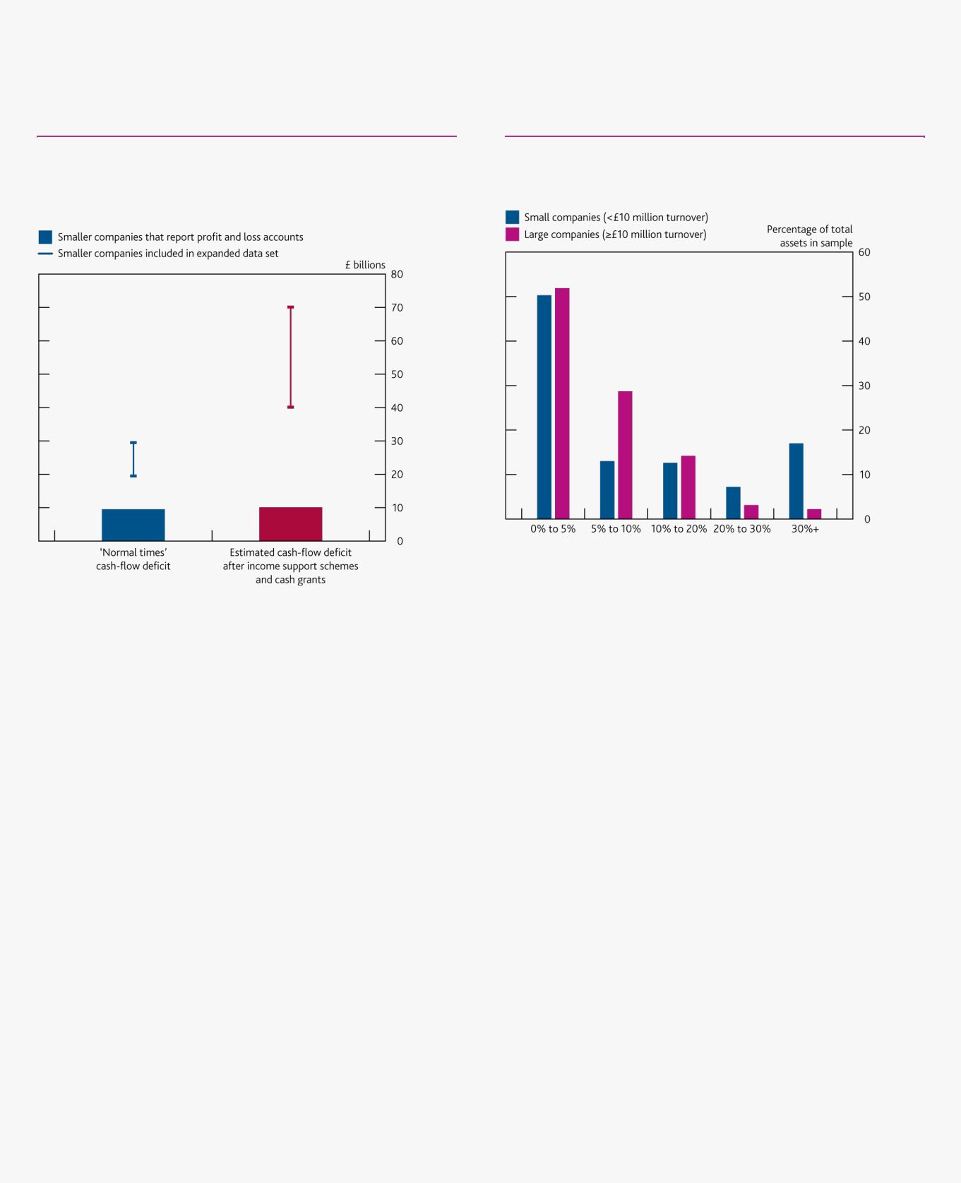

A number of measures have also been introduced that are specifically targeted to support smaller businesses. For example, cash grants are available to smaller companies and companies in vulnerable sectors. And, as discussed above, the SEISS has provided considerable support to sole traders.

**Chart C** Fiscal policy measures support smaller companies and reduce the estimated cash flow-deficit

Estimate of the cumulative corporate sector cash-flow deficit for smaller companies in 2020-21(a)(b)(c)

**Chart D** Smaller companies tend to have more cash as a share of total assets than larger companies

Cash as a share of total assets in the cash-flow deficit sample(a)(b)

Sources: Bank of England, Fame (Bureau van Dijk), ONS, S&P Capital IQ and Bank calculations.

1. ‘Smaller companies that report profit and loss accounts’ reflects the estimated cash-flow deficit for around 74,000 smaller businesses that provide profit and loss accounts at Companies House. ‘Smaller companies included in the expanded data set’ include the estimated cash-flow deficits for around 1.5 million smaller businesses that do not provide profit and loss accounts and for which these have been imputed.
2. ‘Normal times’ cash-flow deficit refers to the aggregate negative cash flows estimated from balance sheet data for the 2017-18 financial year , measured before dividend distributions and

share buybacks.

(C) See the [‘Technical annex’](https://www.bankofengland.co.uk/financial-stability-report/2020/updated-estimates-of-the-cash-flow-deficit-of-uk-companies-in-a-covid-19-scenario-technical-annex) for more detail on the data and methodology.

Sources: Bank of England, Fame (Bureau van Dijk), S&P Capital IQ and Bank calculations.

1. Cash includes cash in hand and at bank. The chart includes all companies that report cash on their balance sheets, which is around half of all companies in the data set.
2. See the [‘Technical annex’](https://www.bankofengland.co.uk/financial-stability-report/2020/updated-estimates-of-the-cash-flow-deficit-of-uk-companies-in-a-covid-19-scenario-technical-annex) for more detail on the data and methodology

On the assumption that all eligible smaller companies access support through these fiscal measures, the aggregate cash-flow deficit estimate for smaller companies is £40–£70 billion (red line, **Chart C**). Of this, around £10 billion is the deficit estimated for the 74,000 companies for which granular accounting information exists (red bar, **Chart C**), and is also included in the estimate of £135 billion presented in the chapter. In total, the aggregate estimated cash-flow deficit for larger and smaller UK companies is therefore up to around £200 billion.

Within that aggregate picture, the estimated cash-flow deficit for smaller companies is distributed unevenly. For example, companies in sectors suffering sharper turnover shocks tend to have larger estimated cash-flow deficits relative to turnover.

**Financing the cash-flow deficit for smaller companies**

*Typically, smaller companies operate with higher cash buffers…*

Existing cash balances could play an important role through the period of disruption. Bank staff estimate that smaller companies hold a higher proportion of their assets in cash than larger firms (**Chart D**). At one extreme, if all smaller companies with a deficit were prepared to fully deplete their cash balances available before the Covid -19 shock, they could finance around £20–£30 billion of the estimated aggregate cash-flow deficit.3 However, this

1. In general, small companies do not have to file granular profit and loss information with Companies’ House. A small company can prepare and submit accounts according to special provisions in the Companies Act 2006 and relevant regulations. This means they can choose to disclose less information than medium-sized and large businesses.
2. This data set includes around 2 million active smaller companies with an annual turnover of less than £10 million. After filtering out financial and public companies and consolidating companies’ accounts at the group level, the cash-flow deficit analysis for smaller companies is carried out on a sample of around 1.5 million companies.
3. This takes into account the cash balances of all companies with estimated cash-flow deficits that also report cash on their balance sheets, which accounts for at least 50% of small companies. A large share of the remaining companies are likely to have zero cash.

Financial Stability Report August 2020 The UK corporate sector and Covid-19 35

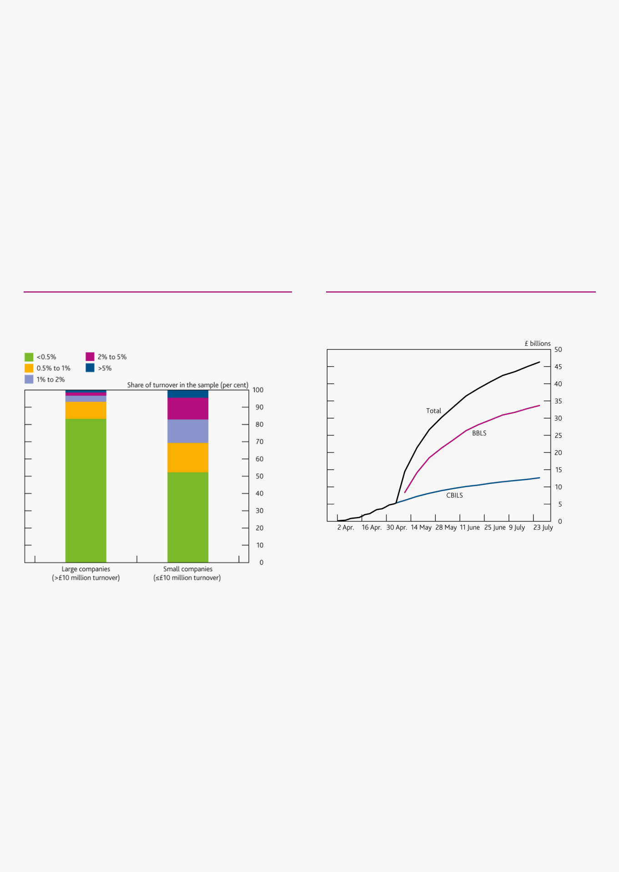

would leave many companies with much smaller cash buffers, which could affect working capital management and leave them more vulnerable to shocks.

*…in part because these businesses might find it more difficult to raise external finance…*

Typically, smaller businesses have fewer external financing options available to them than larger companies. Smaller businesses may also face tighter credit constraints than larger companies. For example, smaller businesses are estimated by credit reference agencies to face a higher likelihood of defaulting on their debt (**Chart E**). Small businesses also face challenges because of information asymmetries between lenders and the businesses. This affects younger firms without a visible track record especially, as well as companies that are more reliant on intangible assets that cannot be used as collateral against loans.

Smaller SMEs are also less likely to have banking relationships which could make it difficult to access external financing when needed. In response to the [June 2019 ‘Future of Finance’ report,](https://www.bankofengland.co.uk/report/2019/future-of-finance) the Bank is working to develop the concept of a portable SME credit file as a means to facilitate SMEs access to credit. This would augment credit history and financial data with tax data. It could then be shared with credit providers, to allow better access to diverse and competitive financing options, and to create a more level playing field.

**Chart E** Smaller companies tend to have higher probabilities of default than larger companies

Estimated probabilities of default for UK companies by firm size, at the end of 2019(a)(b)

**Chart F** Government loan schemes have been a major driver of the growth in lending to smaller companies

Combined loan scheme approvals(a)

Sources: Dun & Bradstreet and Bank calculations.

1. The Dun & Bradstreet failure Score predicts the likelihood that a business will seek legal relief from its creditors or cease operations leaving unpaid debts in the next 12 months. The chart shows the distribution of these probabilities across companies of different sizes.
2. The sample covers all non-financial UK companies in the Dun & Bradstreet database.

Sources: HM Treasury, UK Finance and Bank calculations.

1. Figures for CBILs prior to 06 May 2020 show cumulative loan approvals reported to UK Finance by close of business on 05 May 2020. Figures for CBILS thereafter and BBLS show cumulative approvals up to close of business on 26 July 2020 by accredited lenders, as reported to

HM Treasury by close of business 27 July 2020.

*…but government-backed loan schemes have supported lending to smaller businesses since the start of the Covid-19 shock.*

Since May, the vast majority of bank lending to smaller businesses has taken place through the government-backed loan schemes. In particular, the introduction of the BBLS materially accelerated the provision of government-guaranteed lending. The BBLS is targeted towards smaller firms, with loan sizes of up to 25% of a company’s turnover, and a maximum loan size of £50,000. Over a million companies have taken out ‘bounce back loans’, with approvals totalling over £30 billion in value (**Chart F**). The latest [*Credit Conditions Survey*](https://www.bankofengland.co.uk/credit-conditions-survey/2020/2020-q2) reported that, through BBLS and CBILS, lenders have been able to provide liquidity support to businesses across a wide industry range. The Bank’s Term Funding scheme with additional incentives for Small and Medium-sized Enterprises (TFSME) was also designed to encourage bank lending to small firms.

Under the analysis presented above, the majority of smaller companies with estimated cash-flow deficits have a deficit of under £50,000. This suggests that many of these businesses could finance their deficit via the BBLS. In

Financial Stability Report August 2020 The UK corporate sector and Covid-19 36

addition to existing cash reserves, some small companies may be able to reduce their cash-flow deficits via forbearance, either from lenders, landlords or suppliers.

Overall, the package of measures described above should materially reduce the cash-flow pressures on smaller businesses. The Committee will continue to develop its analysis of and monitor developments in the financing of smaller companies over coming months.

Financial Stability Report August 2020 The UK corporate sector and Covid-19 37

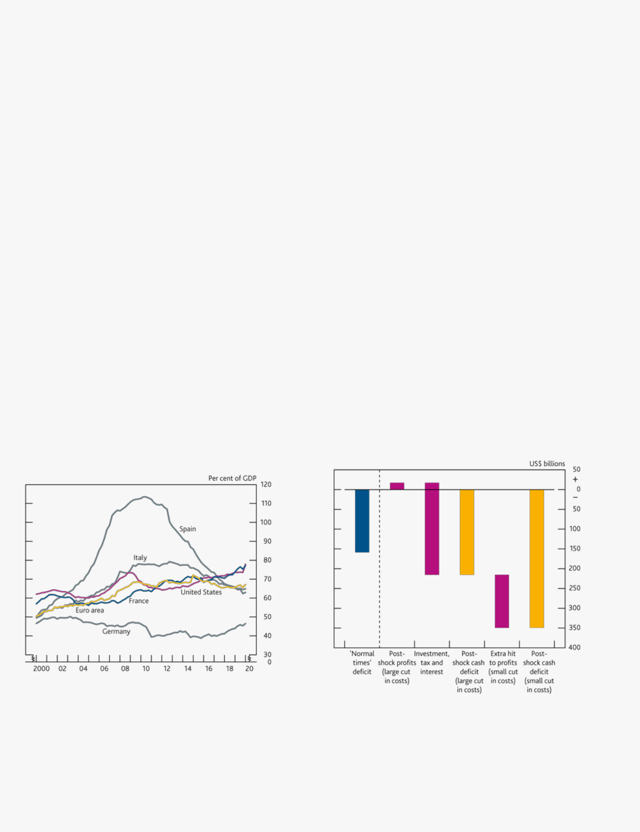

**Box 3**

**Covid-19 and corporate sector financing in the US and the euro area**

Using a similar approach to the analysis of cash flows on the UK corporate sector presented in this chapter, Bank staff have assessed the possible impact of Covid-19 on corporate sectors in the US and the euro area. Financial stress on companies in the US and euro area could affect UK financial stability directly, via its impact on the quality of loans and other financial claims on those companies held by UK financial institutions and also, indirectly, through the impact of slower economic growth in the UK’s trading partners on the UK economy.

Corporate debt levels in the US and France were already high before the Covid-19 outbreak (**Chart A**). The outbreak will significantly reduce cash flows for businesses, pushing some firms into cash deficits. The scope for financing these deficits will depend on the availability of finance from bank and market-based sources, as well as the extent of support from public policy. A series of Federal Reserve Board (FRB) [blog posts](https://www.chicagofed.org/publications/blogs/chicago-fed-insights/2020/financial-positions-part3) estimated that around a quarter of US publicly listed firms could run out of cash by 2020 Q3, and that the increase in borrowing to meet these cash

needs could double the share of highly leveraged firms.1 The European Commission [estimated](https://ec.europa.eu/info/sites/info/files/economy-finance/assessment_of_economic_and_investment_needs.pdf) a liquidity shortfall for the euro-area corporate sector of €350–€500 billion under its Spring forecast.

Since these estimates were prepared, more up to date indicators for economic activity in the US and euro area are available. Bank staff have used forecasts from the [August *Monetary Policy Report*](https://www.bankofengland.co.uk/report/2020/monetary-policy-report-financial-stability-report-august-2020) to construct estimates of cash-flow deficits in the US and the euro-area corporate sectors. Reflecting limited data availability and the sensitivity of results to different assumptions, there is even more uncertainty around these estimates than there is for the estimates for the UK. The assumptions made regarding variation across sectors are the same as for the UK analysis.

|  |  |  |  |  |
| --- | --- | --- | --- | --- |
|  |  |  |  |  |
| **Chart A** Corporate debt was already high in the US and |  | **Chart B** Cash-flow deficits in US firms could rise sharply |  |  |
| France before the Covid-19 outbreak |  | Components of cash deficit of US firms(a) |  |  |
| Private non-financial corporate debt to GDP(a) |  |  |  |  |
|  |  |  |  |
|  |  |  |  |  |

Sources: Eikon from Refinitiv, Eurostat and Bank calculations.

(a) Debt is net of inter-company loans.  Sources: Bank of England, S&P Capital IQ and Bank calculations.

(a) Aggregate negative cash flows, before dividend distributions and share buybacks, of

companies in the sample.

Depending on assumptions about how firms’ costs are affected by the outbreak, applying these falls in turnover to firm-level accounting data leads to estimates of an overall cash-flow deficit over the next year for listed non-financial firms in the US of between US$215 billion and US$350 billion (**Chart B**), around 2% of turnover of all

firms in the sample.2 Around 60% of firms in the US sample, accounting for around a third of turnover, record a



1. The FRB analyses used the fall in US share prices in February and March 2020 instead of a macroeconomic scenario to project the earnings of US listed companies.
2. The analysis is based on firm-level data from Capital IQ. The cash-flow deficit estimate is the sum of the deficits of each firm that is estimated to run a deficit. The estimate does not take account of the surpluses of firms that are expected to continue to run a cash-flow surplus.

Financial Stability Report August 2020 The UK corporate sector and Covid-19 38

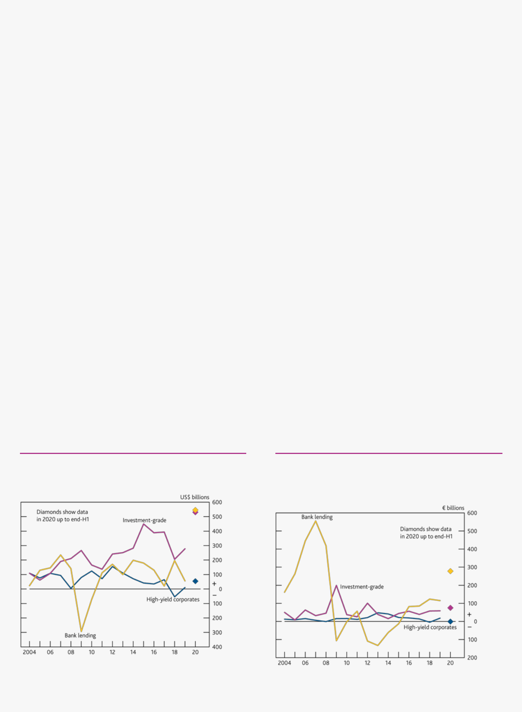

cash-flow deficit in the scenario. This compares with a ‘normal times’ deficit of around US$160 billion, where less than half the firms, accounting for just 10% of turnover, run deficits. The firms that are expected to run deficits typically have higher levels of leverage and lower interest coverage ratios than other firms.

Performing similar analysis for companies in the euro area is more difficult due to more limited data availability. Around half of a sample of large non-financial corporates in Germany, France, Italy and Spain, accounting for around a quarter of turnover in the sample, are projected to run cash-flow deficits in 2020, with deficits coming to around 2% of turnover of firms in the sample.3 Simply scaling up these figures to the corporate sector for the whole euro area would lead to an estimated cash-flow deficit of around €230 billion–€400 billion.

These estimates do not take account of government policy measures, such as support for subsidised short-time working and furloughing schemes in the euro area or the Paycheck Protection Program (PPP) in the US. These programmes are large (spending of more than US$520 billion has been approved under the PPP) but their effectiveness will depend on how much government support reaches the firms that need it most. Unfortunately, limitations of the firm-level data used in the simulations make it difficult to estimate the effects of these policies on individual firms’ cash deficits either in the euro area or in the US.

Firms are likely to require access to finance from a number of sources to meet at least some of the cash deficits they face. Before the Covid-19 outbreak, firms in the US sample raised around two-thirds of their credit from the corporate bond market. Although bond issuance in the US stalled in the early part of the pandemic, it has since picked up sharply on the back of support from central bank policies (**Chart C**). Recent levels of net issuance in the US appear large relative to estimates of corporates’ cash-flow deficits. However, there are signs that issuance is concentrated in higher-rated firms and in firms in sectors, like technology, which are less affected by Covid-19, raising the possibility that firms in the most affected sectors may still face financing difficulties. Bank lending in the US also picked up sharply as firms drew on existing credit lines. Firms in the euro area rely less on bond finance and net bond issuance by euro-area firms has shown less of an increase than in the US. Bank lending has increased sharply in the euro area — in contrast to the fall in lending in 2009 during the global financial crisis (**Chart D**). As in the UK, regulators in the US and the euro area have encouraged banks to use their available capital buffers and many governments have made guarantees available in order to support lending and economic activity. In the August *MPR* forecast, economic activity gradually recovers as the impact of Covid-19 and lockdown measures eases. However, even if corporate profits recover to near their levels prior to the Covid-19 shock, the crisis will leave a legacy in the form of higher corporate debt and an increase in the proportion of highly indebted firms.

**Chart C** Both US net bond issuance and bank lending rose sharply in the first half of 2020

**Chart D** Euro-area corporates have relied more on banks and less on bond finance

|  |  |  |  |
| --- | --- | --- | --- |
| US net bond issuance(a) and bank lending to the corporate sector(b) |  | Euro-area net bond issuance(a) and bank lending to the corporate |  |
|  |  | sector(b) |  |
|  |  |
|  |  |  |  |
|  |  |  |  |

Source: Federal Reserve, Refinitiv — Deals Business Intelligence and Bank calculations.

1. Net bond issuance by non-financial corporates.
2. Change in stock of commercial and industrial loans by US commercial banks.

Sources: ECB, Refinitiv — Deals Business Intelligence and Bank calculations.

1. Net bond issuance by non-financial corporates.
2. Net flow of loans by euro-area banks to euro-area non-financial corporations.



3 For a comparable sample of UK listed firms, estimated cash deficits are similar at around 2% of turnover, or 4% for the full sample.

Financial Stability Report August 2020 The UK corporate sector and Covid-19 39



**Box 4**

**The supply of finance for productive investment**

*Productive finance is important for both long-term growth and productivity, and for financial stability.*

Since 2015, HM Treasury has included a recommendation as part of the FPC’s annual remit and recommendations letter that the FPC consider, subject to meeting its primary objective in relation to financial stability, how the UK financial system might best be able to intermediate the supply of finance for productive investment. In 2020, HM Treasury further recommended that the FPC consider how financial regulation and changes to the financial system’s structure may have affected the balance between financial stability and the supply of productive finance in all regions and nations of the UK.

Productive investment is defined as spending by businesses that has the potential to expand the productive capacity of the economy, while also generating marginal returns to society that exceed the marginal cost of that investment to society (see [Bank of England Discussion Paper (2016))](https://www.bankofengland.co.uk/paper/2016/understanding-and-measuring-finance-for-productive-investment). Such investments include plant and equipment (which can help businesses achieve scale), research and development (which improves the knowledge economy), technologies (for example, green technology) and infrastructure.

Productive finance refers to the way that businesses fund this productive investment — for example, from profits, cash injections from owners, loans from banks, and external investors, often intermediated by the financial system. It encompasses long-term and short-term financing. In principle, a wide range of financial instruments can support productive finance including both liquid instruments (eg primary issuance of listed equity) and less illiquid instruments (such as private equity investments).

*One type of productive finance that requires particular attention in the UK at present is investments that are longer-term, less liquid and more equity like than other types of instruments.*

Addressing issues related to productive finance is part of the FPC’s secondary objective, but can also improve financial stability outcomes, in line with the FPC’s primary objective. Longer-term investments (typically less liquid than other investments) and more equity-like investments, can increase growth in a more sustainable way than short-term, more liquid investments or debt often can. Equity-like investments also reduce leverage. An increasingly leveraged economy poses a risk to UK financial stability due to limited risk sharing and fragile corporate balance sheets (see [Brazier (2020))](https://www.bankofengland.co.uk/speech/2020/alex-brazier-keynote-dialogue-at-the-cfo-agenda). Addressing distortions to support equity investments can improve the redistribution of risk in a way that is less concentrated in specific parts of the economy, and larger equity buffers can make the corporate sector more resilient to a shock.

The Covid-19 shock has brought the supply of productive finance into sharper focus, given the need for longer-term financing options to support the corporate sector. Additional debt may not be the most appropriate form of finance

for some companies (see main text of the chapter).1 In addition, increased leverage may constrain some companies’ future growth. Therefore additional equity or equity-like finance, particularly for unlisted companies, could support recovery and reduce liquidations in the medium term.

*Previous work has highlighted barriers to the provision of long-term productive finance in the UK.*

In 2017, HM Treasury’s [‘Patient Capital Review’](https://www.gov.uk/government/publications/patient-capital-review) identified barriers to the provision of longer-term capital for smaller, innovative businesses to achieve scale. It noted that a significantly lower proportion of research and development in the UK is performed by younger companies than in the US. The review’s focus on longer-term productive finance reflects that successfully expanding the production frontier of the economy — be that via scaling-up young businesses or building new infrastructure — often involves relatively long time horizons.

In response to this review, HM Treasury and the UK regulators have taken, and continue to take, action to support patient capital in the UK. Measures by HM Government included the launch of British Patient Capital, a subsidiary of the British Business Bank, which received a capital injection from HM Government to be co-invested with private



1. This has also been discussed elsewhere — see, for example, [The City UK’s recent report.](https://www.thecityuk.com/assets/2020/Reports/fc19b9c385/Supporting-UK-economic-recovery-recapitalising-businesses-post-Covid-19.pdf)

Financial Stability Report August 2020 The UK corporate sector and Covid-19 40

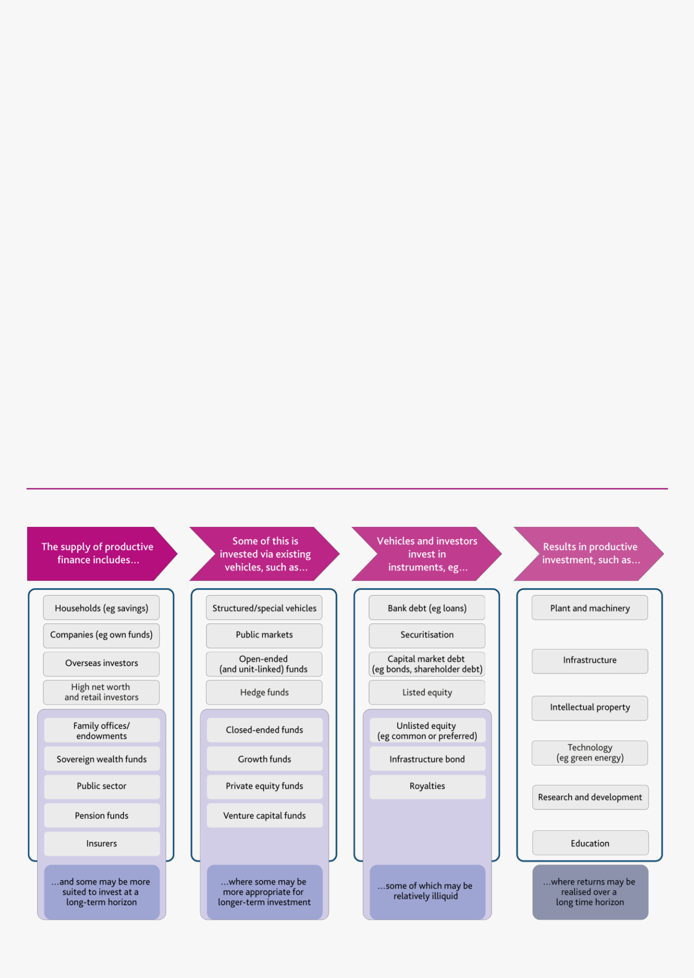

sector capital and invested in small and medium-sized enterprises (SMEs), and changes to tax-advantaged trusts (see [HM Treasury (2018))](https://assets.publishing.service.gov.uk/government/uploads/system/uploads/attachment_data/file/769428/Financing_growth_in_innovative_firms_one-year_on.pdf). The Financial Conduct Authority (FCA) updated its permitted links rules for unit-linked funds (which apply to Defined Contribution (DC) schemes where individual policyholders bear the investment risk) to ‘address any unjustified barriers to retail investors investing in a broader range of long-term assets in unit-linked funds, whilst maintaining an appropriate degree of investor protection’ (see [FCA (2020))](https://www.fca.org.uk/publications/policy-statements/ps20-4-amendment-cobs-21-3-permitted-link-rules). And The Pensions Regulator updated guidance to clarify that DC pension funds may invest in illiquid assets as part of an appropriately diversified portfolio (see [The Pensions Regulator (2018))](https://www.thepensionsregulator.gov.uk/en/trustees/managing-dc-benefits/investment-guide-for-dc-pension-schemes-).

As part of separate work in response to the [2019 Future of Finance report,](https://www.bankofengland.co.uk/report/2019/future-of-finance) the Bank is working to develop further the concept of a portable SME credit file. This would help SMEs access a more diverse and competitive range of financing by augmenting credit history and financial data with tax data (see [Bank of England (2019))](https://www.bankofengland.co.uk/research/future-finance).

*The FPC will focus on examining possible distortions to the supply and intermediation of longer-term productive finance, including into illiquid investments.*

The productive finance ecosystem is complex (**Figure A**). The FPC is considering two specific issues within it: the degree to which certain regulatory or structural factors may discourage investors who might otherwise be willing and able to invest in long-term or illiquid productive investments; and whether existing structures for intermediating long-term productive finance are appropriate.

Reforms to regulations alone are unlikely to transform levels of productive investment in the UK. Other factors also play a role — such as investors’ expected return relative to the risk undertaken, investors’ expertise, and even the national savings rate. And obstacles to businesses demanding non-debt financing may persist. For example, small business owners are often reluctant to accept the reduction in autonomy and control associated with external equity investments. One key factor relevant to both supply of and demand for productive finance will be the tax treatment of investments for investors and businesses respectively.

**Figure A** The financial ecosystem supporting the supply of productive finance is complex

Stylised illustration of the various components of the supply, intermediation, investment and use of long-term productive finance

Financial Stability Report August 2020 The UK corporate sector and Covid-19 41



*Regulatory and other structural factors may influence the supply of productive finance into longer-term illiquid assets.*

Banks, with their short-term fixed value liabilities (such as deposits) may not always be suited to investing in longer-term or illiquid investments. The non-bank sector, including pension funds, insurers and investment funds, may be more apt to provide such types of productive finance. However, Bank staff estimate that UK insurance companies and pension funds allocate only around 3% of their assets to unlisted equity. And UK collective investment funds (in which insurance firms and pension funds also invest) allocate only 2% of their assets to unlisted equities. Such investments require careful risk management; regulatory requirements, market structures and practices also affect investment in these types of assets.

Industry reports and consultations suggest DC pension schemes in particular could invest more in illiquid assets but

several factors may have discouraged this.2 The UK pensions market has a large number of small DC pension schemes which do not necessarily have the scale and in-house expertise to invest in illiquid assets. Daily trading and pricing is also common practice for DC schemes, which is another constraint on investment in illiquid assets. This is not a regulatory requirement and has been highlighted as a hurdle by industry (including the [Investment](https://www.theia.org/sites/default/files/2019-05/20180621-puttinginvestmentattheheartofdcpensions.pdf) [Association (2019),](https://www.theia.org/sites/default/files/2019-05/20180621-puttinginvestmentattheheartofdcpensions.pdf) [Defined Contribution Investment Forum (2017)](https://dcif.co.uk/wp-content/uploads/2017/06/2017-barriers-to-innovation-final-web-version.pdf) and the [Law Commission (2017))](http://www.lawcom.gov.uk/app/uploads/2017/06/Summary-Pension-Funds-and-Social-....pdf). Drawing upon existing reports and consultations in this area, the FPC will assess the extent to which DC pension funds’ practices and the environment in which they operate may discourage investment in longer-term illiquid assets.

Insurers are subject to Solvency II regulatory requirements, which are underpinned by a whole balance sheet approach to regulatory solvency and a focus on good governance and risk management. Insurers invest in various types of longer-term and illiquid assets, and investment in certain types of illiquid assets has grown in recent years, such as non-unit-linked life insurers’ investment in mortgages and property. UK insurers, however, only invest a small share of assets in unlisted equities, less than many European peers. In the UK, unit-linked portfolios account for over half of insurance assets. Unlisted equities represent less than 1% of unit-linked equities investment, and such funds will be restricted by investment mandates. Non-linked life insurers, meanwhile, are less likely to invest in equities, given the need for fixed cash flows to back their annuity liabilities.

The Government has announced a review of Solvency II to begin in autumn 2020, and the PRA welcomes stakeholder views on regulatory reforms that allow it to deliver its statutory objectives. The FPC will also contribute to this review by considering the macroprudential implications, including for investment in illiquid longer-term investments.

*Investors need the right structures and platforms to invest in longer-term illiquid assets in a way that is consistent with financial stability…*

Illiquid investments may be associated with a higher level of risk, because the investor cannot easily exit, but in theory this should be paired with a higher expected return to compensate for that risk. One of the factors investors consider is the trade-off between achieving this higher return and a preference for liquidity. Some open-ended funds have sought to reduce this trade-off by offering access to less liquid investments while also offering daily liquidity. When investors exit, the price the fund pays them is based on the fund’s net asset value (NAV). When such funds also offer little pricing adjustment alongside daily liquidity, they may crowd out investment opportunities via alternative fund structures and contribute to increased risk of liquidity mismatches in open-ended funds.

Undertakings for the Collective Investment in Transferable Securities (UCITS), which comprise the largest share of open-ended funds marketed to UK investors by assets under management, are currently limited to only investing in certain categories of investment that meet certain conditions. Where a UCITS invests in transferable securities,

those securities must generally meet minimum liquidity criteria.3 The other main type of UK open-ended fund,



2

3

These include the [industry panel response to HM Treasury’s patient capital review;](https://assets.publishing.service.gov.uk/government/uploads/system/uploads/attachment_data/file/661397/PCR_Industry_panel_response.pdf) the [All-Party Parliamentary Group on Alternative Investment Management’s](https://www.aima.org/uploads/assets/uploaded/45ebb41a-8f88-4ee5-845de88dd72b2c7d.pdf) [February 2019 report;](https://www.aima.org/uploads/assets/uploaded/45ebb41a-8f88-4ee5-845de88dd72b2c7d.pdf) [The Investment Association’s June 2018 position paper;](https://www.theia.org/sites/default/files/2019-05/20180621-puttinginvestmentattheheartofdcpensions.pdf) and the [British Business Bank and Oliver Wyman’s September 2019 report.](https://www.british-business-bank.co.uk/wp-content/uploads/2019/09/Oliver-Wyman-British-Business-Bank-The-Future-of-Defined-Contribution-Pensions.pdf)

For example, a transferable security can meet these liquidity criteria if it is listed on a market which meets certain conditions. However, up to 10% of the fund’s assets can be invested in transferable securities that do not meet these liquidity criteria. Transferable securities include shares, bonds and gilts. For further information see the rules in the Collective Investment Schemes sourcebook (COLL), in particular, the rules in COLL 5.2 (General investment powers and limits for UCITS schemes).

Financial Stability Report August 2020 The UK corporate sector and Covid-19 42



(Non-UCITS Retail Schemes, or ‘NURS’) can invest in illiquid assets to a greater degree, for example property. However, if the funds also offer short — even daily — redemption periods, these structures may be ill-suited to holding large quantities of illiquid assets as this results in a liquidity mismatch. In the face of large redemptions, this can lead to forced asset sales and potentially fund suspensions that could disrupt the provision of long-term finance provided through these vehicles.

As part of the ongoing Bank of England and FCA review of open-ended funds, the FPC has established that there should be greater consistency between the liquidity of a fund’s assets and its redemption terms. The FPC’s third principle from its [progress review in 2019](https://www.bankofengland.co.uk/-/media/boe/files/financial-stability-report/2019/december-2019.pdf) was that redemption notice periods should reflect the time needed to sell the required portion of a fund’s assets without discounts beyond those captured in the price received by redeeming investors. This could contribute to reducing liquidity mismatch and better aligning investor incentives. In particular, notice periods may facilitate existing structures, such as NURS, to hold larger quantities of inherently illiquid assets (subject to regulatory limits) — for example, because fund managers, faced with lower risk of a high volume of redemptions and even suspensions, may judge they are more able to invest in fewer cash-like instruments to account for that risk.

The FCA is currently consulting on whether authorised open-ended retail-oriented property funds could transition to a structure where redemption terms (ie the terms under which investors can get their capital out of the fund)

are better aligned with the liquidity of fund assets.4 This consultation is a first step in addressing liquidity mismatch in open-ended funds. The FPC welcomes the FCA seeking views on whether existing frameworks limit access to capital markets for some types of companies, particularly the smaller ones as they seek to recapitalise after the Covid-19 shock, and willing investors [(Woolard (2020))](https://www.fca.org.uk/news/speeches/role-investment-managers-post-covid-19-recovery).

*…and other structures, such as closed-ended funds, may be more appropriate vehicles for investing in certain illiquid assets.*

Closed-ended funds are collective investment vehicles that issue a fixed number of shares, which can be listed on a stock exchange. The London Stock Exchange estimates that, between 2015 and 2019, over 70% of newly launched closed-ended funds had a non-listed equity focus, investing in a range of asset classes including private equity, real

estate and infrastructure.5 Typically investors can neither subscribe to additional shares nor redeem existing ones on demand after the initial purchase of those shares. Relative to open-ended funds, closed-ended funds face a lower risk of having to liquidate asset holdings earlier than planned to help meet redemptions — potentially

making them a more suitable vehicle for certain illiquid investments. 6

Investors in closed-ended funds may be able to exit the fund by selling their shares on the secondary market. Depending on the balance between demand and supply at the time of the transaction, they face a risk of receiving less than the fund’s NAV. In the UK, around 70% of assets in listed closed-ended funds are in funds that were trading at a discount to NAV in 2019; such discounts may weigh on returns for the initial investors. To support the liquidity of their shares, all closed-ended funds listed on the London Stock Exchange, for instance, have at least one designated market maker.

Closed-ended funds may also have characteristics that make them more closely resemble open-ended funds

— often known as ‘hybrid closed-ended funds’. Two such characteristics are: periodically offering to buy shares back from investors and operating in a way that permits the redemption and issuance of shares. Where hybrid closed-ended funds offer such options, they are typically limited in their availability and subject to certain conditions. And some closed-ended funds also benefit from tax incentives, such as Venture Capital Trusts in the UK, which invest in small, early-stage companies.



1. See FCA [CP20/15.](https://www.fca.org.uk/publications/consultation-papers/cp20-15-liquidity-mismatch-authorised-open-ended-property-funds) The FCA consultation sets out the consequences of introducing notice periods, including the interaction with: current suspension rules; SIPP provider capital rules; unit-linked insurance providers; intermediaries and distributors; and ISA eligibility.
2. These funds can still hold listed equities, but their investment strategy is not targeted at such investments.
3. That risk however still exists for closed-ended funds, for example if there was a need to extend the fund’s life beyond the initial horizon. In that case, the funds might need to sell holdings if some investors want their invested capital back at the agreed time horizon.

Financial Stability Report August 2020 The UK corporate sector and Covid-19 43



There have also been additional proposals developed for alternative fund structures that aim to better support the intermediation of long-term finance, for example the Investment Association’s (IA) proposed Long-Term Asset Fund (see [IA UK Funds Regime Working Group (2020));](https://www.theia.org/sites/default/files/2020-04/20200330-ukfrwgfinalreport.pdf) and the British Business Bank’s proposal for a Pooled Investment Vehicle (see [British Business Bank and Oliver Wyman (2019))](https://www.british-business-bank.co.uk/wp-content/uploads/2019/09/Oliver-Wyman-British-Business-Bank-The-Future-of-Defined-Contribution-Pensions.pdf).

*The FPC will examine the extent to which these factors are materially affecting the supply and intermediation of productive finance.*

The Committee intends to undertake further work to better understand how the factors detailed above may be influencing the supply of longer-term, and potentially illiquid productive finance. In particular:

The FPC will examine the causes of DC pension funds in the UK investing only a small proportion of their

assets in illiquid investments.

The FPC will engage with aspects of the review of Solvency II relevant to its remit, alongside the Prudential Regulation Committee. Specifically, the FPC intends to consider whether any disincentives to investing in longer-term and illiquid instruments can be removed without reducing insurers’ safety and soundness or

policyholder protection.

The FPC will continue to engage with the joint Bank of England and FCA review of liquidity mismatch in open-ended funds, and in particular seek to address distortions that discourage the use of funds with longer redemption notice periods or closed-ended funds. These may be more appropriate vehicles for investing in certain illiquid assets.

Financial Stability Report August 2020 The resilience of the UK banking sector 44

The resilience of the UK banking sector



The Financial Policy Committee (FPC) has co-ordinated with the Prudential Regulation Committee (PRC) closely in preparing the analysis contained in this chapter. The PRC is responsible for the safety and soundness of individual banks within the aggregate picture presented in this chapter.

The major UK banks and building societies (‘banks’) have a crucial role to play in supplying credit to the UK corporate sector and thus supporting activity and limiting longer‐term economic damage to output and employment.

Banks will incur losses if businesses struggle to weather the disruption related to the outbreak of Covid-19 and unemployment rises. In the first half of 2020, banks have reported an additional £18 billion of credit losses on their outstanding loans.

In May, the FPC judged that banks had buffers of capital that were more than sufficient to absorb the cumulative losses under the illustrative economic scenario set out in the [May 2020 *Monetary Policy Report* (*MPR*)](https://www.bankofengland.co.uk/report/2020/monetary-policy-report-financial-stability-report-may-2020) which, under prudent assumptions, generated credit losses of just over £80 billion.

As set out in the Monetary Policy Committee’s (MPC’s) central projection in the [August 2020 *MPR*,](https://www.bankofengland.co.uk/report/2020/monetary-policy-report-financial-stability-report-august-2020) economic output is expected to have fallen substantially, but the cumulative loss of output resulting from the pandemic is projected to be somewhat smaller than in the illustrative economic scenario in the May *MPR*.

The FPC judges that the MPC’s central projection would be consistent with credit losses of less than £80 billion and therefore continues to judge that banks’ capital buffers are more than sufficient to absorb the losses that are likely to arise under the MPC’s central projection. Taking into account the Government’s lending guarantee schemes, banks have the capacity to continue to provide credit to support the UK economy.

As set out in the August *MPR*, there is a material level of uncertainty around the economic outlook. It is important that banks are able to continue to serve the economy in a range of possible economic outcomes.

The banking system cannot be resilient to all possible outcomes ― there are inevitably very severe economic outcomes that would challenge banks’ ability to lend. However, the FPC recognises that, having entered a period of stress, there are costs to banks taking defensive actions, such as cutting lending, in order to try to widen the range of possible outcomes to which they would be resilient. By restricting lending, those actions could make the central outlook materially worse.

Financial Stability Report August 2020 The resilience of the UK banking sector 45

The FPC therefore takes an explicitly countercyclical approach to stress testing banks; building up their resilience outside stress periods so that buffers of capital can then be used in a stress to continue to lend. Defensive actions may be necessary in stress but only if there is a material probability of the economy following a path so severe that it might jeopardise banks’ resilience and challenge their ability to absorb losses and continue to lend.

The FPC has carried out a ‘reverse stress test’ to analyse how much worse than the

central projection the economic outcome would need to be in order to deplete

regulatory capital buffers, using as a reference point the 2019 stress test of banks.1

In that exercise, banks were tested against a depletion of their capital ratios of around

5 percentage points in aggregate.

To deplete capital ratios by around 5 percentage points, banks would need to incur credit impairments of around £120 billion. There is a range of scenarios that could generate that level of loss but in general, the cumulative loss of economic output associated with the outbreak of Covid-19 would need to be around twice as big as the MPC’s central projection, and accompanied by a significant rise in unemployment.

The exercise presents two illustrative ‘reverse stress-test’ paths for the UK and global economies that could generate £120 billion of credit impairments: a very slow recovery from the 2020 H1 shock and a double‐dip recession later in 2020. The second of these would require events to have an economic impact worse than that seen from March onwards.

Other risks could crystallise alongside the economic disruption related to Covid-19. For example, there could be an effect on economic activity if the UK and EU do not reach a free trade agreement and if this leads to material disruption at the border at the end of the transition period. These risks could, depending on their severity, reduce the extent of disruption related to the outbreak of Covid-19 that banks are able to absorb while continuing to lend.

Because banks actually have buffers of capital larger than they are required to hold as informed by previous stress tests, the £120 billion of losses in the ‘reverse stress test’ would, in aggregate, deplete around 60% of the buffers of capital which sit above banks’ minimum requirements. In aggregate, banks would be left with the ability to absorb a further £80 billion of losses arising from further shocks, in addition to the extremely severe paths in the ‘reverse stress test’.

Based on this exercise, the FPC judges banks to be resilient to a very wide range of possible outcomes. It would therefore be costly for them and for the wider economy to take defensive actions. It remains the FPC’s judgement that banks have the capacity, and



1. This chapter uses the term ‘reverse stress test’ in a macroprudential sense. A strict microprudential definition of ‘reverse stress testing’ is an exercise that involves exploring the size and nature of shocks that would render a bank’s business model unviable or its financial position fragile. It starts from an outcome of business failure and identifies circumstances where this might occur. For the purpose of this chapter, ‘reverse stress test’ does not have the same meaning as it does in the PRA Rulebook.

Financial Stability Report August 2020 The resilience of the UK banking sector 46

it is in the collective interest of the banking system, to continue to support businesses and households through this period.

The Committee will continue to monitor the risks to the economic outlook against the results of the ’reverse stress test’ and keep its judgement under review.

**The resilience of the UK banking system**

*Banks’ capital and liquidity positions have remained resilient through the shock so far.*

The global banking system entered into this shock in a much stronger position than the global financial crisis. Major UK banks and building societies (‘banks’), in aggregate had over three times their pre-crisis common equity Tier 1 (CET1) capital ratios at end-2019 (**Chart D.1**).2 In aggregate, despite reporting credit losses banks’ CET1 ratios increased by 0.5 percentage points in the first half of 2020, driven by the cancellation of outstanding 2019 dividends in line with the Bank’s guidance. CET1 ratios have also been supported by changes to IFRS 9 transitional arrangements, which limit the extent to which provisions for expected credit losses impact regulatory capital ratios.

|  |  |
| --- | --- |
| **Chart D.1** The aggregate CET1 ratio remains more than | **Chart D.2** Banks hold a significant buffer of liquid assets |
| three times higher than it was before the financial crisis | Aggregate LCRs of major UK banks(a) |
| Aggregate CET1 capital ratio of major UK banks(a)(b)(c) |  |

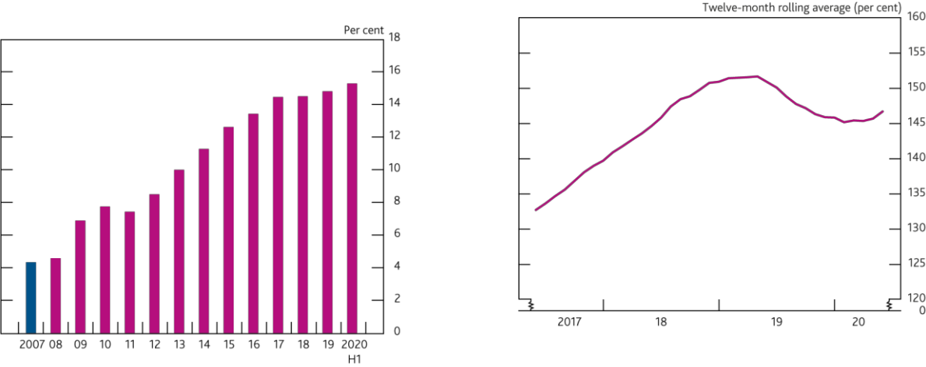

Sources: PRA regulatory returns, published accounts, Bank analysis and calculations.

1. The CET1 capital ratio is defined as CET1 capital expressed as a percentage of risk-weighted assets. Major UK banks are Barclays, HSBC, Lloyds Banking Group, Nationwide, Natwest Group, Santander UK and Standard Chartered. From 2011, data are CET1 capital ratios as reported by banks. Prior to 2011, data are Bank estimates of banks' CET1 ratios.
2. Capital figures are year-end, except 2020 H1.
3. 2020 H1 data reflect Q2 for those banks who had reported Q2 results by 3 August, and Q1 for those that had not.

Sources: PRA regulatory returns and Bank calculations.

1. Major UK banks are Barclays, HSBC, Lloyds, Nationwide, Natwest Group, Santander UK and Standard Chartered.

As outlined in the [May *Interim Report*,](https://www.bankofengland.co.uk/report/2020/monetary-policy-report-financial-stability-report-may-2020) banks also held a significant buffer of liquid assets entering into this stress. At the start of the year, banks in aggregate held around 1.5 times more liquid assets than the severe 30-day stressed outflows underlying the Liquidity Coverage Ratio (LCR) and they have maintained that ratio in the year to date (**Chart D.2**).

*Banks could face significant losses as a result of the economic shock associated with the outbreak of Covid-19.*

Banks have already reported an additional £18 billion of credit losses on their outstanding stock of lending in 2020 H1, compared with around £3 billion in 2019 H1. As the economic outlook in both the UK and global economies is uncertain, banks’ credit losses may well continue to increase as the shock progresses.

The current price to book ratio of banks’ equity is around 0.4 in aggregate. It is possible to back out the impairment charges implied by current market prices. Based on a simple framework that discounts projected pre-provision profits, current market pricing of UK banks’ equity is consistent with expectations that banks will incur around £45–£80 billion of impairments over the course 2020 and 2021. The expectation of future impairments is sensitive



2 The seven banks referred to in this chapter are Barclays, HSBC, Lloyds Banking Group, Nationwide, NatWest Group, Santander UK and Standard Chartered.

Financial Stability Report August 2020 The resilience of the UK banking sector 47

to the assumed cost of equity, which is likely to have increased as a result of the pandemic. The Bank has therefore used a range of plausible estimates of banks’ cost of equity. Analyst consensus expectations are that banks will incur around £45 billion of impairments over 2020 and 2021.

*The FPC judged in May that banks had sufficient capital to absorb this level of losses and continue to lend to businesses and households.*

In May 2020, the FPC (in close co-ordination with the PRC) carried out a desktop stress test, designed to explore the potential losses banks could incur under an illustrative economic scenario consistent with that set out in the May *MPR*. The exercise assessed that, under prudent assumptions, banks could incur impairments of around £80 billion in that scenario. The FPC judged that the usable buffers of capital built up by banks were more than sufficient to absorb these losses and continue lending to the UK economy.

The May *interim Report* also set out the importance of banks continuing to lend through the scenario underpinning the May desktop stress test. The FPC judged that continued lending by the banks, supported by government schemes, was essential to minimise longer-term economic damage. If banks were to withdraw from credit provision, more businesses would fail due to cash-flow deficits, triggering bigger losses for banks on existing corporate lending, and by pushing unemployment higher, bigger losses on existing household loans.

*The cumulative loss of output resulting from the pandemic in the central economic outlook in the August* MPR *is somewhat smaller than in the MPC’s illustrative economic scenario in the May* MPR*.*

As set out in the Monetary Policy Committee’s (MPC’s) central projection in the August *MPR*, economic output is expected to have fallen substantially, but the cumulative loss of output resulting from the pandemic is projected to be somewhat smaller than in the illustrative economic scenario in the May *MPR*.

The FPC judges that the MPC’s current central projection would be consistent with credit impairments of less than £80 billion. The Committee therefore continues to judge that the buffers of capital built up by banks are more than sufficient to absorb the cumulative losses that are likely to arise under the central projection and continue lending to UK households and companies.

**The FPC’s approach to monitoring UK banks’ resilience as the Covid-19 outbreak unfolds**

*As set out in the August* MPR*, there is material uncertainty around the central outlook.*

The MPC’s projections assume that uncertainty is elevated and risks to economic activity are skewed to the downside. As set out in the August *MPR*, both households’ and businesses’ uncertainty has weighed on the economy. In particular, three quarters of businesses responding to the Decision Maker Panel survey reported that uncertainty was high or very high in July, and survey indicators suggest that household confidence was well below its historical average in July.

However, spending in the UK has risen, and the recovery is projected to continue in the near term as households’ health concerns are assumed to fade gradually. Further out, activity is supported by the assumption that uncertainty around the economic outlook fades over time as the health and economic risks fade gradually over time. But if this does not occur then there could be a risk of a more protracted recovery from the 2020 H1 shock or a potential double-dip recession.

It is important that banks are able to continue to serve the needs of the economy in a range of potential outcomes for the economy. But the banking system cannot be infinitely resilient to all possible outcomes ― there are inevitably very severe economic outcomes that would challenge banks’ ability to lend.

*The FPC has conducted a ‘reverse stress test’ to allow it to monitor the probability that the banks’ ability to lend to the wider economy could become challenged.*

The Bank’s approach to stress testing is explicitly countercyclical: building banks’ resilience, in the form of buffers of capital, outside stress, which can be drawn on to support the economy in a stress.

The FPC recognises that, having entered a period of stress, there are costs to banks taking defensive actions, such as restricting lending to preserve or increase their capital buffers, in order to widen the range of possible outcomes to which they would be resilient. Taking such actions could make the central outlook materially worse and lead to higher impairments for banks. They may be necessary in stress only if there were a material probability of the

Financial Stability Report August 2020 The resilience of the UK banking sector 48

economy following a path so severe that it might jeopardise banks’ resilience and challenge their ability to absorb losses and continue to lend.

The FPC has conducted a ‘reverse stress test’. Unlike a standard stress test which starts with an economic scenario and finishes with a capital impact, in this exercise the FPC has taken a drawdown of capital that would deplete banks’ regulatory capital buffers and considered how much worse than the central outlook the paths for the economy would need to be in order to deplete banks’ capital by this amount. As the stress develops, the FPC can then compare the evolution of risks to the economy to the paths generated in the ‘reverse stress test’. The exercise has not drawn on modelled submissions from banks.

More details on how this approach fits in with the Bank’s countercyclical approach to stress testing can be found in **Box 5**.

**The ‘reverse stress test’**

*The ‘reverse stress test’ targeted a 5.2 percentage point reduction in the aggregate CET1 capital ratio, which would reduce banks’ aggregate capital buffers on top of regulatory capital minima by around 60%.*

As of end-2019 banks’ aggregate CET1 capital ratio was 14.8%. The ‘reverse stress test’ targeted a 5.2 percentage point reduction as a reference point, in line with the level of capital depletion banks were tested against in the 2019 stress test and which banks are capitalised to be able to continue lending in stress (**Chart D.3**).

**Chart D.3** The ‘reverse stress test’ targeted a

5.2 percentage point reduction in the banks’ aggregate CET1 capital ratio…

Impact of the ‘reverse stress test’, May desktop stress test, and 2019 stress test on banks’ aggregate CET1 capital ratio(a)(b)

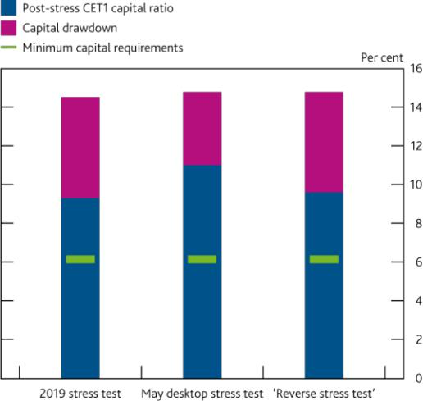

Sources: Participating banks’ STDF data submissions, published accounts, Bank analysis and calculations.

1. The CET1 capital ratio is defined as CET1 capital expressed as a percentage of risk-weighted assets (RWAs), where both terms are defined in line with CRR and the UK implementation of CRD IV via the PRA Rulebook.
2. The May desktop and ‘reverse stress test’s incorporates the effects of amendments to CRR applicable from 27 June 2020 to allow 100% relief of eligible IFRS 9 provisions until the end of 2021. This was not incorporated in the 2019 stress test.

**Table D.A** …and impairments are assumed to be the most material driver of capital depletion

Key drivers of the decrease in the aggregate CET1 capital ratio in the ‘reverse stress test’ and 2019 stress test(a)(b)(c)(d)

|  |  |  |
| --- | --- | --- |
|  | **2019** | **‘reverse** |
|  | **stress test** | **stress test’** |
| Start CET1 capital ratio | **14.5** | **14.8** |
| Impairments | -6.1 | -7.3 |
| *of which UK* | *-3.6* | *-4.4* |
| *of which mortgages* | *-1.0* | *-0.8* |
| *of which consumer credit* | *-1.2* | *-1.8* |
| *of which corporate* | *-1.4* | *-1.8* |
| *of which non-UK* | *-2.5* | *-2.8* |
| IFRS 9 transitional relief(e) | 0.9 | 1.5 |
| Growth in risk-weighted assets | -3.2 | -3.7 |
| Trading operations(f) | 0.6 | 1.9 |
| Cancelled dividends | 0.0 | 0.4 |
| Other(g) | 2.7 | 1.9 |
| **End CET1 capital ratio**(h) | **9.3** | **9.6** |

Sources: Participating banks’ STDF data submissions, Bank analysis and calculations.

1. The figures in this table set out the drivers of capital drawdown from the start of the respective projection. Previous publications have set out these figures on the basis of a stress to baseline scenario comparison.
2. The Start point for the ‘reverse stress test’ is end-2019. The 2019 stress test start point is end-2018. The CET1 capital low point for both scenarios is in year 2 of the projection.
3. The CET1 capital ratio is defined as CET1 capital expressed as a percentage of RWAs, where both terms are defined in line with CRR and the UK implementation of CRD IV via the PRA Rulebook.
4. To produce the aggregate results of the ‘reverse stress test’ in a single currency, the Bank has converted the results of US dollar reporters HSBC and SCB into sterling assuming exchange rates remain fixed at their 2020 Q1 level over 2020 and 2021. For comparison purposes, the 2019 stress test results in this table have also been presented on a constant exchange rate basis, except for the ‘End CET1 ratio’. This row alone has been calculated on a dynamic exchange rate basis ie based on the exchange rate paths specified in the 2019 stress test scenario.
5. The ‘reverse stress test’ incorporates the effect of amendments to Capital Requirements Regulation applicable from 27 June 2020 to allow 100% relief of eligible IFRS 9 provisions until the end of 2021. This was not incorporated in the 2019 stress test.
6. Trading operations comprise: market risk losses, counterparty credit risk losses, losses arising from changes in banks’ fair value adjustments, prudential valuation adjustments (PVA) and losses on fair value positions not held for trading. Investment banking income comprises the revenues and excludes costs.
7. ‘Other’ comprises other profit and loss and other capital movements. Other profit and loss includes misconduct, net interest income, expenses, fees and commission, other wholesale impairments, share of profit/loss in investments in associates, and other income. Other capital movements include pension assets devaluation, prudential filters, accumulated other comprehensive income, IRB shortfall of credit risk adjustment to expected losses, and actuarial gain/loss from defined benefit pension schemes.
8. The CET1 capital ratio at the end point is shown before the conversion of additional Tier 1 instruments.

Financial Stability Report August 2020 The resilience of the UK banking sector 49

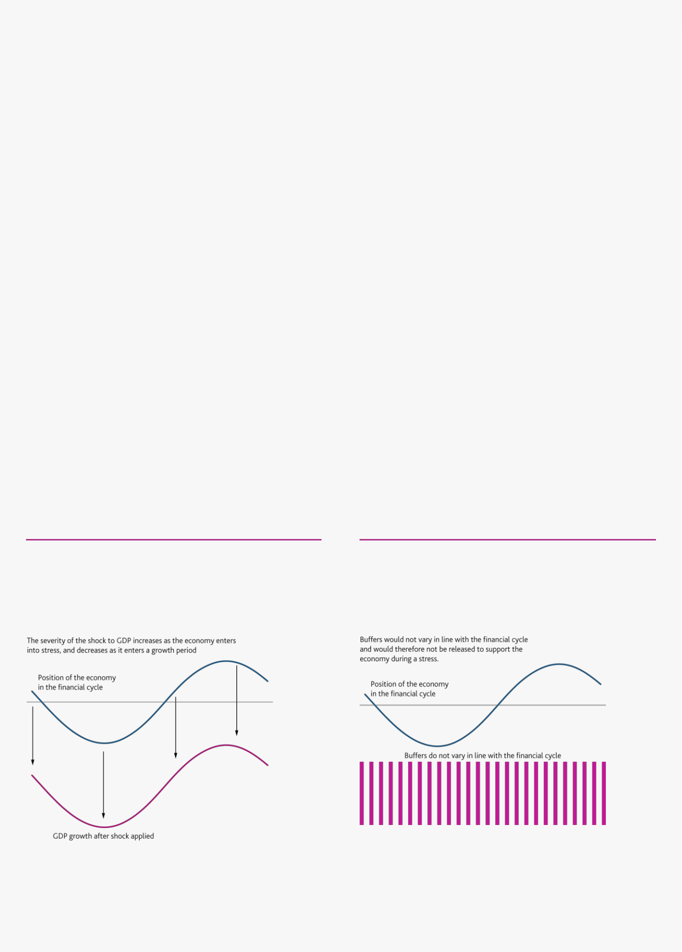

**Box 5**

**How ‘reverse stress testing’ fits into the Bank’s approach to stress testing**

*Each year, the Bank would usually carry out a stress test of the banks that incorporates a single severe but plausible adverse scenario.*

The Bank’s annual stress test — the [annual cyclical scenario (ACS)](https://www.bankofengland.co.uk/news/2015/october/boe-publishes-approach-to-stress-testing-the-uk-banking-system) ― seeks to stress major UK banks at the same

time against a single hypothetical adverse scenario, to assess how the scenario could impact the health of the

UK banking system. The stress applied under the ACS is not a forecast. Rather, it is a coherent scenario designed to

be severe and broad enough to assess the resilience of UK banks to a range of adverse shocks. The results of the

ACS are used by the FPC and PRC to inform the setting of banks’ capital buffers, to ensure that the banking system

as a whole, and individual banks within it, have sufficient capital to absorb losses and maintain the supply of credit

to households and businesses in a future stress.

The scenario used in the ACS is designed to be a low probability event in the long-run context of UK and global macroeconomic performance. For example, the shocks to UK real GDP and unemployment incorporated in previous stress-test scenarios are comparable to those seen in the most severe recessions the UK has faced since the 1850s.

*When the financial system enters a stress period, calibrating a stress test by layering stress on top of an already stressed outlook could damage the economy.*

The stress test is used to inform the setting of banks’ regulatory capital buffers. The setting of banks’ buffers is informed by how far banks’ capital ratios are drawn down in the test and are therefore directly related to the size of the stress in the test. If the Bank sought to apply the same shock in the ACS each year, irrespective of the current level of key macroeconomic indicators, banks’ regulatory capital buffer requirements would always stay constant (**Charts A** and **B**).

As the economy enters a stress period and banks start to take losses, they would need to take defensive actions to try to preserve their capital buffers. Banks may therefore withdraw from supporting the economy through meeting demand for credit at the point when it was needed the most, thereby deepening and prolonging the stress.

**Chart A** If the Bank moved the severity of the shock in line with the short-term economic outlook, the stress scenarios would become more severe as the economy entered into stress…

Procyclical GDP stresses applied over the course of the financial cycle

**Chart B** …buffers would not therefore vary in line with the financial cycle and could not be released to support the economy in times of stress

Indicative levels of banks capital buffers if the Bank adopted procyclical approach to stress testing

.

*To avoid this, the Bank’s approach to stress testing is explicitly countercyclical.*

In order to build up banks’ capital buffers outside stress so they can then be released to support the economy in a stress, the Bank has an explicitly countercyclical approach to stress testing. Its general approach is to set the severity of its stress tests ― in terms of the levels various economic indicators are assumed to reach ― in a

Financial Stability Report August 2020 The resilience of the UK banking sector 50

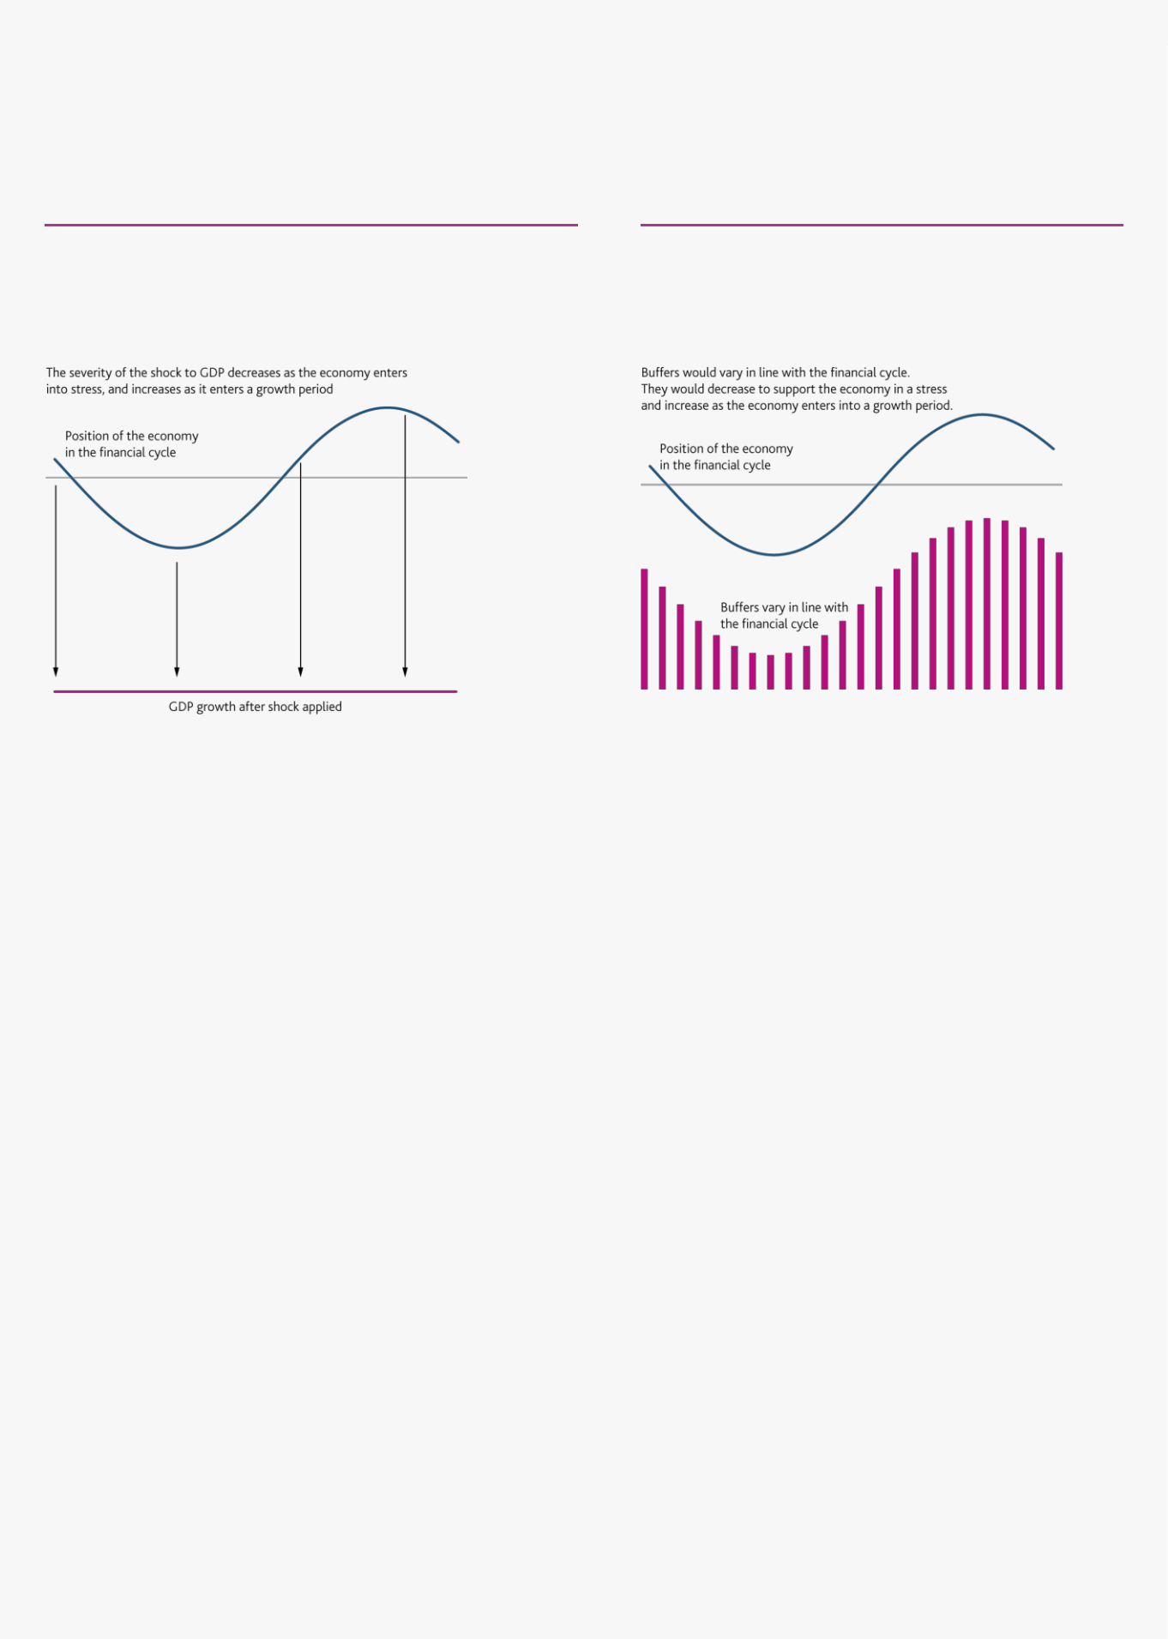

long-run context, independent of the short-term outlook. As the economy enters a stress, the levels to which output, employment and house prices are stressed remain unchanged (**Chart C**). The shocks applied therefore decrease as the economy enters into a stress. This ensures as banks incur losses, they are able to draw on the buffers of capital they have at the outset of the stress and can continue to support the economy by lending (**Chart D**).

**Chart C** The Bank therefore broadly targets the same stressed outcome in its stressed scenarios, unless underlying risks in the economy change…

GDP stresses applied over the course of the financial cycle

**Chart D** …this results in buffers which decrease as the economy enters in a stress and increase as it enters into a growth period

Changes to banks’ regulatory buffers through the financial cycle

implied by the Bank’s countercyclical approach to stress testing

The Bank is symmetric in this approach. During periods in which the economy is growing rapidly and the short-term outlook appears strong, it makes the stress scenario more severe, meaning that banks tend to need to build up their buffers of capital ready for the next stress.

To reinforce this countercyclical approach, outside stress the Bank increases the severity of the stress-test scenarios as debt levels increase relative to GDP. This reflects the empirical evidence that recessions following credit booms tend to be deeper than otherwise, regardless of what triggers a recession. The stress-test scenarios would therefore be most severe during a period of exuberance — for example, when credit and asset prices are growing rapidly and risk premia are compressed. This might well be the point when markets and financial institutions consider risks to be lowest, but banks are likely to need more capital to be able to absorb future potential losses.

*During periods of stress, the FPC needs a framework that explores what outcomes could deplete banks’ regulatory capital buffers and assesses how likely these outcomes are given the economic outlook.*

As the economy enters a stress period, it may become more likely that, in the short term, the economy follows a path that goes beyond the severity of the stress scenarios against which the banking system has previously been tested. Such paths could challenge the banking system, and its ability and willingness to lend to the wider economy.

It is important that banks are able to continue to serve the economy in a range of possible outcomes. There are costs to banks taking defensive actions in order to widen the range of outcomes that they are resilient to (since, by restricting lending, they can make the central outlook materially worse). Defensive actions may be necessary in stress only if there were a material probability of outcomes occurring that might jeopardise banks’ resilience and challenge their ability to absorb losses and continue to lend. In a stress period, the FPC therefore needs a way of assessing the likelihood of these outcomes given the current economic outlook so it can judge whether there is merit in increasing banks’ resilience to them, recognising the economic costs that doing so can have in making the central outlook for the economy worse.

The FPC can carry out a ‘reverse stress test’, to identify paths for the economy that generate the same capital impact on banks that they have been capitalised against in previous annual stress tests.

Financial Stability Report August 2020 The resilience of the UK banking sector 51



*The FPC has used this ‘reverse stress-testing’ approach to monitor the outbreak of Covid-19 and its impact on the banks.*

The outbreak of Covid-19 and the measures taken to limit its spread have been associated with a significant impact on UK and global economic growth and uncertainty around the path of the recovery (see Performance of the UK financial system during the Covid-19 pandemic chapter).

The FPC has carried out a ‘reverse stress test’ to generate a range of macroeconomic scenarios that would reduce banks’ capital buffers in aggregate by 5.2 percentage points. This reference point is the level of capital depletion that banks were tested against in the 2019 stress test and that would deplete banks’ regulatory capital buffers in the face of severe, but plausible, synchronised shocks to the UK and global economies.

The resulting paths for the economy are different in shape to the 2019 stress test because they are conditioned on the idiosyncratic shock related to the Covid-19 outbreak. They include a slow recovery from the 2020 H1 shock and a double-dip recession. They also incorporate a much smaller trading book shock than the 2019 stress test and assume a lower path for costs related to previous misconduct. The paths generated by the 'reverse stress test' are set out in more detail below.

The aggregate CET1 capital ratio is made up of regulatory minima, which banks are required to maintain at all times, and capital buffers which can and should be used in a stress to both absorb losses and promote banks’ ability to lend to households and companies. In turn, capital buffers are made up of regulatory capital buffers, which are set by regulators, and management buffers, which banks hold voluntarily over and above the regulatory buffers.

At the start of the ‘reverse stress test’, of the 14.8% aggregate CET1 capital ratio, just over half comprised buffers above minimum capital requirements. Depleting 5.2 percentage points of capital would use up around 60% of their capital buffers which sit above their minimum requirements.

But because banks’ buffers of capital are larger than they are required to hold as informed by previous stress tests, their aggregate CET1 capital ratios would remain above their minimum CET1 capital ratio requirements. In aggregate, banks would be left with the ability to absorb a further £80 billion of losses arising from further shocks, in addition to the extremely severe paths in the ‘reverse stress test’.

*A substantial level of credit impairments would be needed to deplete banks’ capital ratios by this amount.*

To deplete capital ratios by 5.2 percentage points in aggregate, banks are assumed to incur substantial losses of around £120 billion on UK and global credit exposures to the two-year capital low point of the reverse stress test. This reflects the nature of the shock related to the Covid-19 outbreak, which has placed significant pressure on both corporate and household income and is most likely to impact on banks’ capital through outstanding loans to these sectors (**Table D.A**).

The assumed credit impairments are also much larger than those banks incurred in the 2019 stress test, despite resulting in very similar level of capital depletion. This is driven by three key areas where the ‘reverse stress test’ incorporates different assumptions to the 2019 stress test:

The ‘reverse stress test’ has smaller losses on banks’ portfolios held for trading for a given path for the economy. In particular, banks’ losses on their holdings over government debt are modest as the value of these holdings is supported by the persistent low interest rates. The ‘reverse stress test’ also incorporates the recent strong investment banking performance, which has been driven by increased trading volumes due to heightened volatility in the financial markets.

Costs associated with past misconduct are lower than the 2019 stress test, reflecting in particular the anticipated reduction in costs associated with past payment protection insurance (PPI) mis-selling. In the first two years of the 2019 stress test, misconduct costs accounted for around £13 billion of banks’ losses.

Financial Stability Report August 2020 The resilience of the UK banking sector 52

Finally, as in the 2019 stress test, the ‘reverse stress test’ takes into account the transitional arrangements under International Financial Reporting Standard 9 (IFRS 9) which allow banks to ‘add-back’ a proportion of expected credit losses to their capital holdings. But the ‘reverse stress test’ also takes into account the impact of amendments to the Capital Requirements Regulation (CRR) applicable from 27 June 2020 to allow 100% relief of eligible IFRS 9 provisions until the end of 2021. Banks therefore benefit from a higher level of capital add-back for a given level of impairments in the ‘reverse stress test’ than they did under the 2019 stress test.

Further detail on both the credit and non-credit key drivers of the capital depletion underpinning the ‘reverse stress test’ are set out in **Box 6**.

**Sensitivity of the banks’ assumed credit losses to changes in macroeconomic shocks**

*The ‘reverse stress test’ converts assumed credit losses into a range of paths for the economy, using the relationships between losses and shocks to key macroeconomic variables observed historically and during previous stress tests.*

To generate paths for the economy that would result in the credit impairments set out above, the ‘reverse stress test’ starts with the historical relationships between banks’ impairments and shocks to key macroeconomic variables. The paths are then further refined based on the relationships observed during previous stress tests and the Bank’s suite of ‘in-house’ models, as well as supervisory judgement on how the quality of banks’ loan portfolios may evolve in a stress period.

The relationships differ depending on the type of lending activity carried out by a bank. For example, impairments on unsecured personal loans are particularly sensitive to changes in the severity of the shock to unemployment. As the peak level of unemployment in a scenario increases, households are more likely to enter into distress and may default on unsecured personal lending. Impairments on mortgage lending are less sensitive to changes in unemployment as households may prioritise paying their mortgage over other credit commitments. Impairments on corporate lending are broadly most sensitive to changes in the severity of the shock to GDP (**Table D.B**).

**Table D.B** Banks’ assumed impairments are sensitive to changes in the severity of macroeconomic shocks

Impact of a 1 percentage point marginal shock (averaged over six quarters and holding other variables constant) on banks’ impairments(a)(b)

|  |  |  |  |  |
| --- | --- | --- | --- | --- |
|  |  | **GDP** | **Unemployment** | **Residential property prices** |
|  |  |  |  |  |
| **UK** | **Retail** | £0.1 billion | £3.0 billion | £0.5 billion |
|  | **Wholesale** | £1.5 billion | £0.5 billion | – |
|  |  |  |  |  |
| **Non-UK** | **Retail** | £0.1 billion | £1.5 billion | £0.3 billion |
|  | **Wholesale** | £2.0 billion | £1.0 billion | – |

Sources: Participating banks STDF data submissions, Bank analysis and calculations.

1. These relationships are based on a range of simplifying assumptions and do not capture all the dynamics between macroeconomic variables and banks’ impairments.
2. Sensitivities that result in an increase of less than £0.05 billion of impairments are excluded.

Although these relationships are linear approximations of the scaling between the severity of macroeconomic shocks and the level of impairments banks incur on their exposures, the FPC has also considered the impact of non-linear relationships and included their effects when calibrating the ‘reverse stress test’. For example, the losses banks incur on mortgages that do default is determined by the severity of the shock to residential house prices. But increasing the severity of the shock only materially impacts on banks’ mortgage impairments when the additional shock pushes a material portion of their mortgage portfolio into negative equity (**Box 6**).

The FPC has also explored the sensitivity of credit losses to the persistence of shocks to the economy as well as the severity of the initial shocks. For example, the FPC has considered the impact of increasing the level of long-term economic scarring associated with a given shock by increasing the level of corporate defaults associated with it. This increases the sensitivity of banks' impairments on corporate lending to a given initial shock to GDP.

Financial Stability Report August 2020 The resilience of the UK banking sector 53

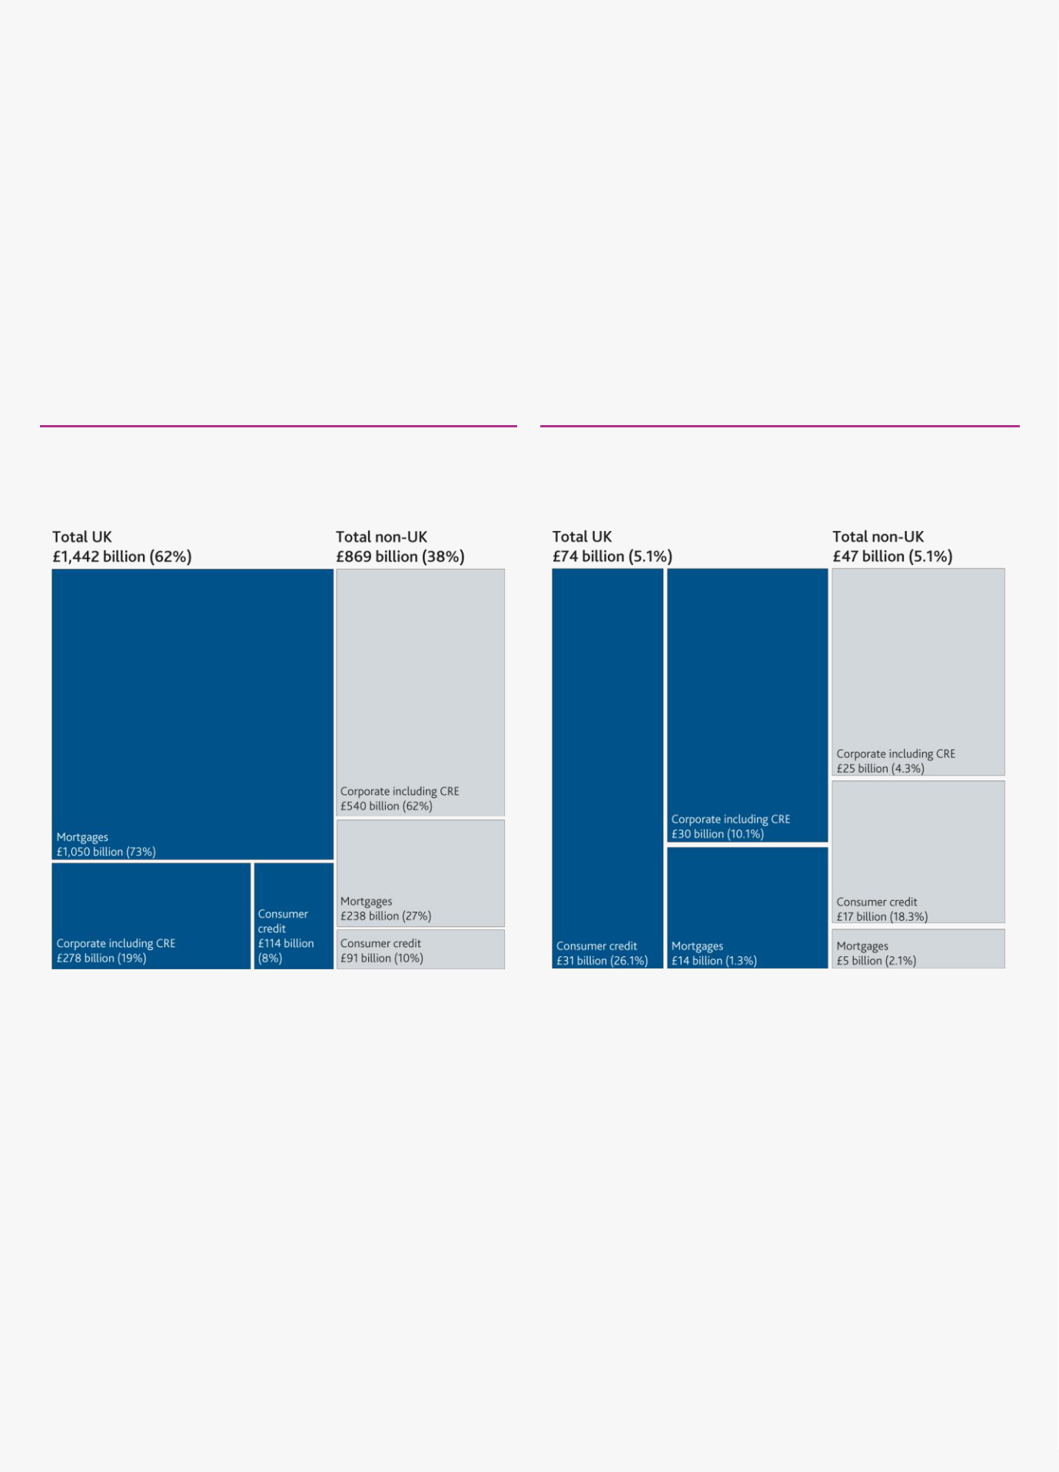

**Box 6**

**Key drivers of the assumed losses underpinning the ‘reverse stress test’**

*Based on the assumptions underpinning the ‘reverse stress test’, banks are assumed to incur impairments of around £120 billion on their outstanding loans, with around 60% of these being incurred on their exposures to UK borrowers.*

Impairments on banks’ loan portfolios are a key driver of losses in the ‘reverse stress test’. In total, banks are assumed to incur an impairment rate of 5.1% on their total outstanding loans to households and businesses by end-2021.

Sixty-two per cent of banks’ outstanding exposures are to UK borrowers and 38% to non-UK borrowers. Impairments on banks’ exposures follow a similar split, but are skewed more towards retail unsecured and corporate lending, reflecting the risker nature of these products (**Charts A** and **B**).

**Chart A** Banks’ exposures are more heavily weighted towards UK borrowers…

Aggregate drawn balances in the ‘reverse stress test’(a)(b)

**Chart B** …and their impairments are also more heavily weighted to their UK exposures

Assumed two-year aggregate cumulative impairment charges (and rates) in the ‘reverse stress test’(a)

Sources: Participating banks STDF data submissions, Bank analysis and calculations.

1. Based on end 2019-exposures.
2. Percentage figures in parentheses show proportion of total regional exposure.

Sources: Participating banks’ STDF data submissions, Bank analysis and calculations.

1. Cumulative impairment charge rates = (two-year total impairment charge)/(average gross on balance sheet exposure), the denominator is the simple average of the banks’ end-2019 and projections of their end-2020 exposures.

*£14 billion of the total assumed impairments are incurred on UK mortgage lending, driven by a severe shock to UK residential property prices.*

Banks are assumed to incur impairments on £14 billion of their outstanding mortgage lending, these are driven by:

Banks’ losses on defaulted UK mortgages are driven by the sharp and persistent decrease in UK residential property prices. This decrease pushes around 25% of UK mortgages into negative equity, meaning that banks are only able to recover a portion of the value of defaulted mortgages (**Chart C**);

Defaults on mortgages increase due to the assumed sharp increase in unemployment in the ‘reverse stress test’.

This is dampened by ‘payment holidays’, announced by the Financial Conduct Authority (FCA) and offered by lenders, providing a form of forbearance to support borrowers who may be experiencing financial difficulties by allowing a temporary freeze on mortgage and other loan repayments (see UK household indebtedness and Covid-19 chapter).

Financial Stability Report August 2020 The resilience of the UK banking sector 54

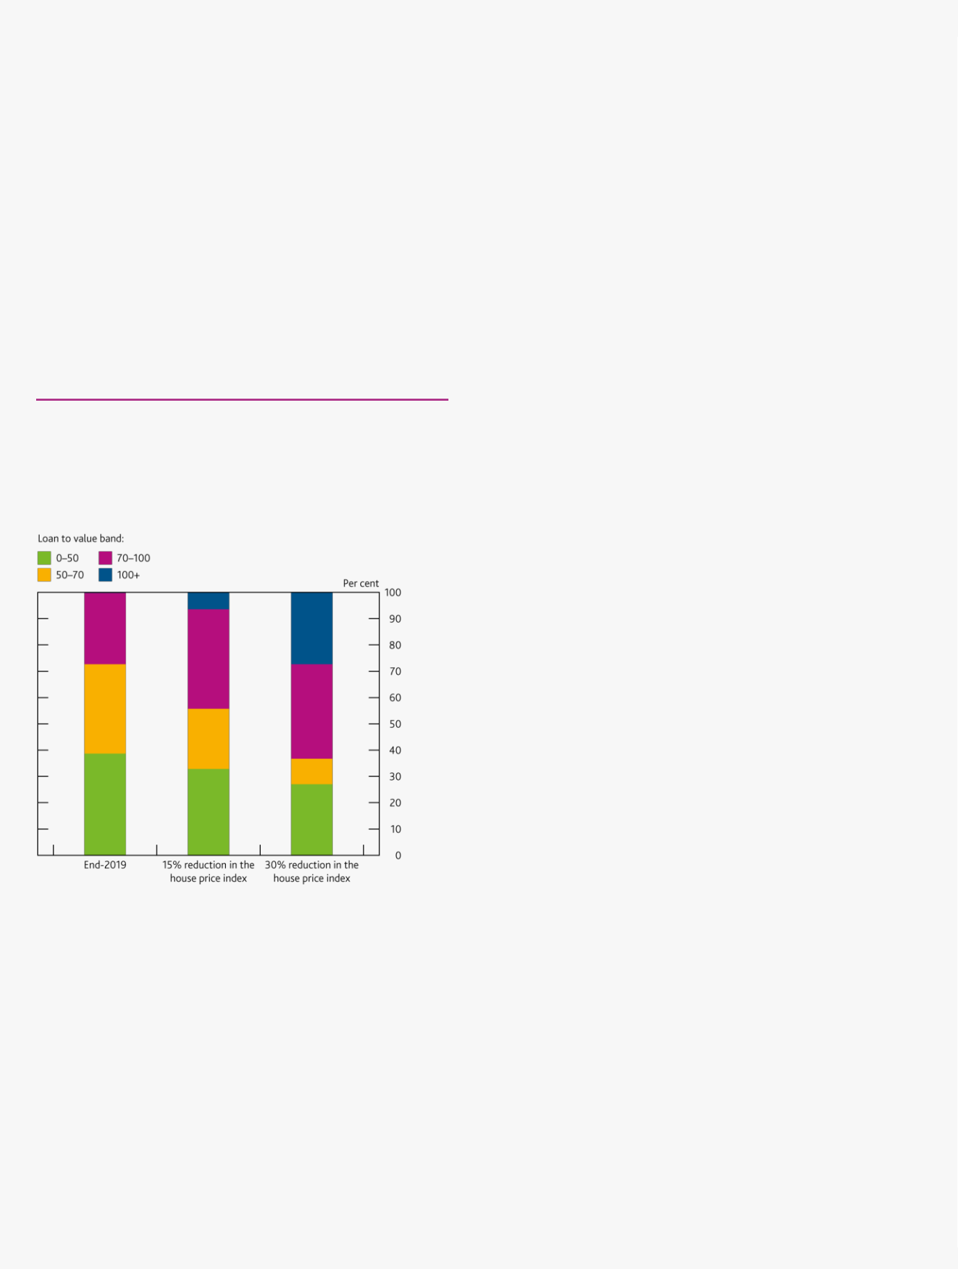

*£31 billion of the assumed impairments are on their UK consumer credit exposures, in line with the historical relationship between consumer credit write-offs and unemployment.*

Banks are assumed to incur £31 billion of impairments on their consumer credit exposures, largely driven by the peak level and persistence of unemployment in the paths generated by the ‘reverse stress test’. The level of consumer credit impairments in the ‘reverse stress test’ is consistent with the assumption of significant and prolonged increases in unemployment that underpinned the exercise. The impairment rate on banks’ UK consumer credit lending is 26.1% and the peak level of unemployment is in the region of 15% in the ‘reverse stress test’, compared to a consumer credit loan impairment rate of 16% and a peak unemployment level of 8.4% during the global financial

crisis.3

There has been a strong historical relationship between unemployment and consumer credit loss rates. The level of consumer credit impairments in the ‘reverse stress test’ is also consistent with the assumption of significant and prolonged increases in unemployment that underpinned the ‘reverse stress test’ (see UK household indebtedness and Covid-19 chapter).

**Chart C** The shock to residential property prices pushes

around 25% of banks’ UK mortgage portfolios into

negative equity

Index of loan to value ratios at end-2019, after a 15% decrease in

residential property prices and a shock consistent with those in the

paths generated by the ‘reverse stress test’(a)(b)

Sources: Participating banks’ Portfolio Quality Review data submissions, Bank analysis and

calculations.

1. Applies a house price shock to end-2019 LTV distribution of participating banks’ UK mortgage exposures.
2. The 15% decrease in the house price index is consistent with that incorporated in the May desktop stress test scenario.

*The remaining £30 billion of banks’ impairments on UK lending are incurred on lending to companies.*

As set out in The UK corporate sector and Covid-19 chapter, the shock associated with the Covid-19 outbreak has already resulted in a significant decrease in corporate revenues, which has led many UK companies to face significant financing deficits that they need to fill to avoid default. In addition to these liquidity pressures, the deeper contraction in revenue in the paths generated by the ‘reverse stress test’ leads to solvency and viability issues, particularly in vulnerable sectors.

Companies facing a cash-flow deficit can either seek to finance it by raising additional financing through bank credit or equity raises, or by reducing their productive capacity such as by laying off employees and delaying investment. The banking system has already provided around £45 billion of financing to the UK corporate sector in 2020 H1



3 For comparison, global financial crisis impairment rates have been adjusted to reflect the impact of the introduction of IFRS 9.

Financial Stability Report August 2020 The resilience of the UK banking sector 55



(compared with around £13 billion in 2019 H1), and is assumed to continue to meet the demand for credit by viable businesses throughout the stress. But additional financing cannot address solvency issues.

In the paths generated by the ‘reverse stress test’, a broad range of companies are assumed to enter into insolvency. The ‘reverse stress test’ further assumes that businesses operating in particularly vulnerable corporate sectors face protracted pressure on their revenues leading to heightened defaults. This particularly affects mid-cap businesses and small and medium-sized enterprises (SMEs) as they: (a) typically have less diversified business models, including a more concentrated base of customers and suppliers, and are therefore more vulnerable to a shock affecting one of their revenue streams; and (b) are typically less able to access sources of bridge financing, and Government support schemes are assumed to wind down in 2020 Q3.

Therefore of the £30 billion of impairments banks are assumed to incur on their exposures to UK companies, around 70% are on exposures to mid-cap and SMEs. The Bank has also analysed banks’ exposures to leveraged lending. Using the prudent assumptions from the 2019 stress test, leveraged lending makes up just under 1% of banks’

UK corporate lending and assumed losses on these books total around £2 billion, or just under 2% of banks’ assumed total credit impairments.

*Impairments on exposures to non-UK borrowers account for around £47 billion of banks’ assumed total impairments in the ‘reverse stress test’.*

Banks are assumed to incur an impairment rate of 5.1% on their exposures to non-UK borrowers, roughly equal to the impairment rate on their UK lending.

But the loss rate on non-UK corporate lending is lower than for the UK because banks’ non-UK corporate exposures are made up of loans to large companies, which are assumed to be less at risk of default. Conversely, banks incur a higher rate of impairments on their non-UK mortgage lending relative to their UK exposure. This reflects an assumption of a sharp unemployment shock in key non-UK jurisdictions, as well as some idiosyncratic risks associated with banks’ non-UK mortgage exposures.

*A range of other assumptions deliver the drawdown in capital in the ‘reverse stress test’.*

As the shock associated with Covid-19 primarily affects banks’ capital positions through their outstanding loans to households and companies, the ‘reverse stress test’ focused on generating losses through impairments on banks’ lending. The additional assumptions are set out below (**Table 1**).

Financial Stability Report August 2020 The resilience of the UK banking sector 56



**Table 1** The ‘reverse stress test’ incorporates a range of assumptions around the non-credit drivers of the capital drawdown

Assumptions underpinning the drivers of non-credit drivers of the capital drawdown

|  |  |  |  |  |
| --- | --- | --- | --- | --- |
|  | **Driver** | **Assumption** |  |  |
|  |  |  |  |  |
|  | IFRS 9 transitional | The assumed losses in the ‘reverse stress test’ take into account the transitional arrangements under IFRS 9 which |  |  |
|  | relief | allow banks to ‘add-back’ a proportion of expected credit losses to their capital holdings. The ‘reverse stress test’ also |  |  |
|  |  | takes into account the impact of amendments to the CRR applicable from 27 June 2020 to allow 100% relief of |  |  |
|  |  | eligible IFRS 9 provisions until the end of 2021. |  |  |
|  |  |  |  |  |
|  | Increases in banks’ | Increases in banks’ RWAs account for an assumed 3.7 percentage point reduction in the banks’ aggregate CET1 |  |  |
|  | RWAs | capital ratio. This increase in RWAs is primarily driven by increases to risk weights on banks’ existing exposures as |  |  |
|  |  | credit quality decreases, rather than banks expanding lending. |  |  |
|  |  |  |  |  |
|  | Investment bank | The ‘reverse stress test’ incorporates the impact of increased volatility supporting trading volumes and boosting |  |  |
|  | income | banks’ investment banking revenue. |  |  |
|  |  |  |  |  |
|  | Losses on portfolios | The assumed loss on banks’ trading portfolios is relatively modest at around £4 billion. Losses are dampened by |  |  |
|  | held for trading | interest rates remaining low throughout the ‘reverse stress test’, supporting prices on government bonds, which in |  |  |
|  |  | turn supports the value of banks’ holdings of government bonds. |  |  |
|  |  |  |  |  |
|  | Costs related to | Reflecting banks settling past misconduct issues, the ‘reverse stress test’ incorporates an assumption that costs |  |  |
|  | historical past | related to past misconduct issues remain relatively low. This reflects in particular the anticipated reduction in costs |  |  |
|  | misconduct issues | associated with past PPI mis-selling following last year’s FCA time bar for claims. |  |  |
|  |  |  |  |  |
|  | Net interest income | The lower path of interest rates also leads to an assumption of squeezed interest margin on banks’ assets reducing |  |  |
|  | (NII) | the NII they earn. Banks are assumed to earn approximately £11 billion less NII in 2020 and 2021 than they would |  |  |
|  |  | have if margins had stayed at 2019 levels. The Bank’s introduction of the Term Funding scheme with additional |  |  |
|  |  | incentives for Small and Medium-sized Enterprises is assumed to help offset some of this squeeze on banks’ margins |  |  |
|  |  | by providing them with long-term funding at a lower interest rate than some other potential sources of funding. |  |  |
|  |  |  |  |  |
|  | Distributions | Banks are assumed to retain earnings rather than distribute them through dividends, variable remuneration or |  |  |
|  |  | coupons on their additional Tier 1 (AT1) instruments. In 2020, banks cancelled payment of any outstanding 2019 |  |  |
|  |  | dividends, and, in line with the Bank’s [guidance,](https://www.bankofengland.co.uk/prudential-regulation/publication/2020/pra-statement-on-deposit-takers-approach-to-dividend-payments-share-buybacks-and-cash-bonuses.) the ‘reverse stress test’ assumes they pay no dividends in 2020 and |  |  |
|  |  | 2021 as they are assumed to be loss making in aggregate. It has also been assumed that variable remuneration is |  |  |
|  |  | reduced and banks cut coupons on their AT1 instruments where required. |  |  |
|  |  |  |  |  |
|  |  |  |  |  |

Informed by these sensitivities, the FPC has generated paths for the economy that it estimates would result in the targeted £120 billion of credit losses. **Box 6** sets out further detail on banks’ credit impairments and the non-credit drivers of the capital loss targeted in the ‘reverse stress test’ and the assumptions underpinning these drivers.

**Paths for the economy generated by the ‘reverse stress test’**

*The paths for the economy that could generate the required level of capital depletion are very severe.*

Informed by the sensitivities described above, the FPC has ‘reversed out’ two paths for the economy that, following the sharp fall in real GDP over the first two quarters of 2020, could generate the assumed £120 billion of credit impairments.

The two paths correspond to two broad economic outlooks that could arise as the Covid-19 outbreak develops. In the first, ‘slow recovery’ path, UK GDP falls sharply in 2020 H1 and slowly recovers over the remainder of the path. In the second, ‘double-dip’ path, there is some recovery in 2020 Q3 followed by a renewed fall in output in 2020 Q4 (**Chart D.4**).

The key difference between the two paths is the speed of recovery from the initial shocks. In the slow recovery path, the economy gradually returns to growth and continues to grow after the initial shock has passed. In the double-dip path, the economy re-enters into a downturn in 2020 Q4 but then recovers more quickly.

Cumulative GDP losses over the course of the three years from end-2019 are significant, at around £610 billion (29% of 2019 annual GDP) in both paths (**Chart D.5)**. Given the similar loss in output, the paths deliver the same level of capital depletion despite being different in shape.

Financial Stability Report August 2020 The resilience of the UK banking sector 57

**Chart D.4** GDP falls sharply in the paths generated by the ‘reverse stress test’…

UK real GDP in the paths generated by the ‘reverse stress test’ and the *MPR* central projection

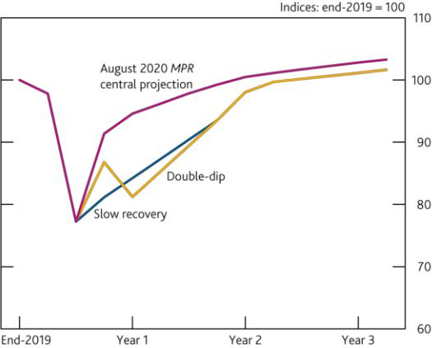

**Chart D.5** …and they imply cumulative GDP losses of around £610 billion

Cumulative GDP losses in the paths generated by the ‘reverse stress test’ and the *MPR* central projection(a)

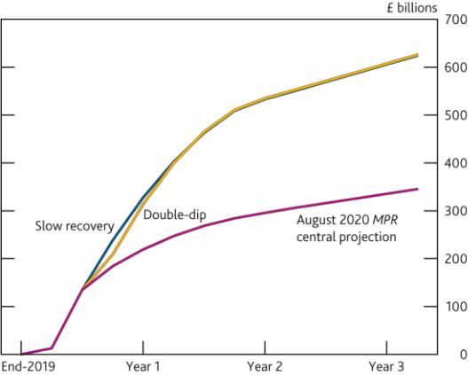

Sources: Bank analysis and calculations.

Sources: Bank analysis and calculations.

1. Cumulative GDP loss is calculated as the sum of quarterly differences between baseline and stressed GDP scenarios. The baseline for *MPR* scenarios is taken from the January 2020 *MPR*.

In both cases, the UK unemployment rate needed to generate the targeted degree of credit impairment rises very sharply, to around 15%, and it averages around 9% over the three-year horizon in the paths generated by the ‘reverse stress test’ **(Chart D.6).** In addition, residential property prices fall by around 30%, remaining around 12% below their starting level by the end of the three-year paths. Commercial real estate prices fall by around 40% and remain around 11% below their starting level at the end of the three-year paths. Bank Rate remains around its current historical low point throughout the projection period and 10-year gilt yields remain at around 0.3%.

**Chart D.6** The shocks to unemployment in the paths generated by the reverse stress paths are severe

Unemployment in the paths generated by the ‘reverse stress test’ and the August *MPR* central projection

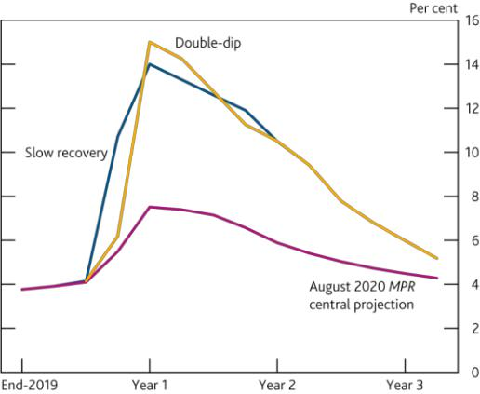

**Chart D.7** Many different combinations of GDP and unemployment shocks could result in the same level of capital depletion

Shocks to GDP and unemployment that could result in the same level of capital depletion as in the ‘reverse stress test’(a)

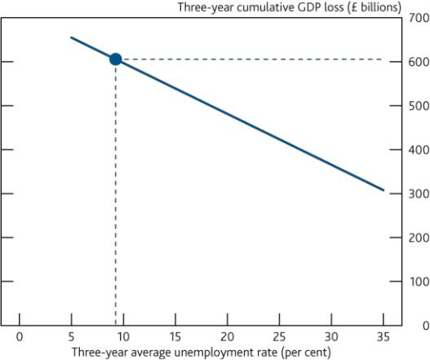

Sources: Bank analysis and calculations.

Sources: Bank analysis and calculations.

(a) Cumulative GDP loss is calculated as the sum of quarterly differences between baseline and

stressed GDP scenarios. The baseline for *MPR* scenarios is taken from the January 2020 *MPR*.

*Both paths generated by the ‘reverse stress test’ also incorporate severe shocks to key macroeconomic variables outside the UK.*

The paths generated by the ‘reverse stress test’ also incorporate deep downturns in non-UK jurisdictions. For example over the three-year horizon in the ‘reverse stress test’, cumulative losses on world GDP are around 30% of the 2019 level. Although the precise paths differ across countries, the cumulative loss of GDP in each country is similar to that in the path for the UK, as is the average level of unemployment over three years in major jurisdictions. Despite the shocks being broadly similar in severity to those in the UK, banks incur a lower rate of

Financial Stability Report August 2020 The resilience of the UK banking sector 58

impairments on their non-UK corporate lending. This is because a large proportion of banks’ non-UK corporate exposures are to large companies, which are assumed to be less likely to default than smaller companies when faced with a given shock (**Box 6**).

*More severe macroeconomic shocks than the 2019 stress-test scenario are needed to deliver the same level of capital depletion.*

The paths for the economy generated by the ‘reverse stress test’ incorporate more severe macroeconomic shocks than the 2019 stress test. In general, the 2019 stress-test scenario was broad in coverage and severity. As set out above, the different assumptions underpinning the ‘reverse stress test’ mean that it requires a higher level of credit losses to generate the same level of capital drawdown as the 2019 stress. Additionally, two other key differences mean the macroeconomic shocks to key variables need to be more severe in the ‘reverse stress test’ to generate the same level of credit losses:

The ‘reverse stress test’ incorporates persistent low interest rates. The low level of interest rates helps support both businesses’ and households’ ability to meet their obligations. A sharper fall in GDP and rise in unemployment are therefore needed to generate the same degree of credit impairment. In contrast, the 2019 stress test incorporated a spike in interest rates.

The ‘reverse stress test’ incorporates the impact of the package of fiscal support undertaken by both UK and global authorities in the paths for the economy. For example, the government lending support schemes materially reduce the losses banks are assumed to incur on their lending carried out under them, and they also dampen the increase in RWAs that would be associated with this lending.

*Many different combinations of shocks could result in the same level of capital depletion and be in line with the broad shapes of the paths for the economy generated by the ‘reverse stress test’.*

The paths for the UK and global economies generated by the ‘reverse stress test’ are specific combinations of macroeconomic shocks that result in the targeted level of credit impairments and capital depletion. There are numerous combinations of shocks to key macroeconomic variables could result in the same level of capital depletion.

The paths presented here are underpinned by assumptions around the relationship between key macroeconomic variables. For example, the severity of the shocks to GDP, unemployment, and residential property prices are assumed to be interlinked. As the severity of the shock to GDP increases, more companies are assumed to enter into insolvency, laying off their employees, which in turn results in more households entering into distress. As this happens, more households begin to default on their mortgages and increasing uncertainty also pushes down on activity in the housing market, thereby reducing residential property prices.

But if the link between shocks to GDP and unemployment was altered, then different combinations of shocks could result in the same capital impact. For example, if a given shock to GDP resulted in a smaller increase in the severity and persistence of the shock to unemployment, then the scenario would require a larger GDP shock to compensate for the relatively weaker increase in unemployment. **Chart D.7** sets out a frontier of possible combinations of shocks to GDP and unemployment that would result in the level of capital drawdown targeted by the ‘reverse stress test’, absent the effect of any non-linearities in the relationship between these variables and banks’ impairments.

The paths for the economy described in this chapter represent the FPC’s view of a coherent combination of macroeconomic variables that results in a reduction in the banks’ aggregate CET1 capital ratio equal to that banks were tested against in the 2019 stress test and that could deplete banks’ regulatory capital buffers.

**The ‘reverse stress-test’ paths for the economy in context**

*The shocks incorporated in the paths generated by the ‘reverse stress test’ are very severe, when compared with the historical performance of the UK economy back to the 1850s…*

The FPC has considered the experience of previous recessions the UK has faced over a very long run time horizon to place the current shock related to the Covid-19 outbreak and the paths generated by the ‘reverse stress test’ in a historical context. Although the paths incorporated an unprecedented shock, the FPC notes that even in the

Financial Stability Report August 2020 The resilience of the UK banking sector 59

context of extreme shocks the UK economy has faced previously, the paths generated by the ‘reverse stress test’ are extremely severe.

For example, on a calendar-year basis, UK real GDP falls by around 14.5% in the paths generated by the ‘reverse stress test’, which is unprecedented compared to recessions faced by the UK since 1850 (**Chart D.8**). Additionally, the peak yearly average level of unemployment in the paths is around 12%, a higher level than at any point since the early 1930s, and the annual average increase in unemployment is larger than any seen since the 1920s (**Chart D.9**).

**Chart D.8** The shock to UK GDP in the paths generated by the ‘reverse stress test’ is unprecedented…

Annual growth of UK real GDP in the ‘reverse stress test’ and historical GDP growth since the 1850s

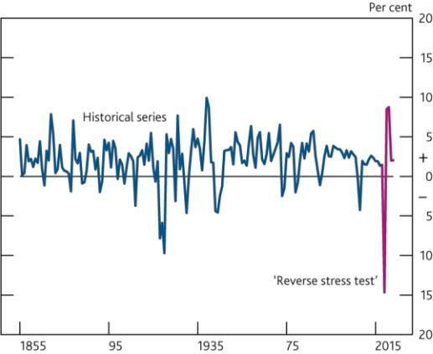

**Chart D.9**…and the peak average level of unemployment is the highest it has been since the 1930s

Annual average level of unemployment in the paths generated

by the ‘reverse stress test’ and historical unemployment since

the 1850s

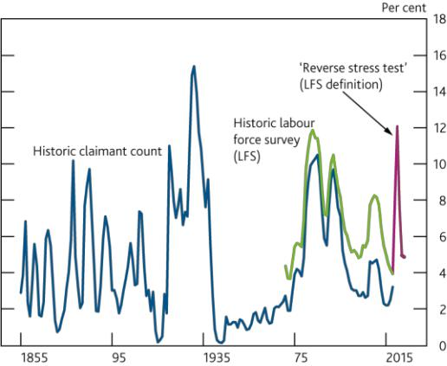

Sources: ONS, Bank analysis and calculations.

Sources: ONS, Bank analysis and calculations.

*…and the paths generated by the ‘reverse stress test’ incorporate shocks which are substantially more severe than those incorporated in the central projection set out in the MPR.*

The FPC has also considered the severity of the paths generated by the ‘reverse stress test’ against the central projection set out in the August *MPR* (**Table D.C**). The paths incorporated shocks that were substantially more severe than the MPC’s central projection. Broadly, the cumulative loss of economic output associated with the outbreak of Covid-19 would need to be around twice as big as the MPC’s central projection and incorporate a significant increase in unemployment before it would be at a similar level of severity to the paths generated by the ‘reverse stress test’.

Other risks could crystallise alongside the economic disruption related to Covid-19. For example, there could be an effect on economic activity if the UK and EU do not reach a free trade agreement and if this leads to material disruption at the border at the end of the transition period.

These risks could, depending on their severity, reduce the extent of disruption related to the outbreak of Covid-19 that banks were able to absorb while remaining within a 5.2 percentage point reduction in capital used to calculate the ‘reverse stress-test’ paths. But because the paths generated by the ‘reverse stress test’ would only deplete around 60% of banks’ capital buffers which sit above their minimum requirements, banks have space to absorb further shocks in addition to the extremely severe paths in the ‘reverse stress test’ before depleting all of their capital buffers.

**The importance of banks continuing to supply credit to the UK corporate sector**

*The FPC continues to judge that it is in the collective interest of the banking system to continue to lend to businesses and households…*

Given the combination of shocks to the UK and global GDP, unemployment, and house prices incorporated in the paths generated by the ‘reverse stress test’, the FPC judges the banks to be resilient to a very wide range of possible outcomes.

Financial Stability Report August 2020 The resilience of the UK banking sector 60

It would therefore be costly to them and to the wider economy for them take defensive actions. It remains FPC’s judgement that banks have capacity, and it is in the collective interest of the banking system, to continue to support businesses and households through this period.

**Table D.C** The paths generated by the ‘reverse stress test’ incorporate shocks to key macroeconomic variables roughly twice as severe as the August *MPR* central projection

Shocks incorporated in the paths generated by the ‘reverse stress test’ and the August *MPR* central projection

**Reverse stress test** **August *MPR***

UK GDP (cumulative three-year loss)(a)

UK unemployment (three-year average)

World GDP (cumulative three-year loss)(a)

|  |  |
| --- | --- |
| 29% | 16% |
| 9.3% | 5.6% |
| 30% | 15% |

Sources: Bank analysis and calculations.

1. Three-year cumulative GDP loss is calculated as the sum of quarterly differences between baseline and stressed GDP scenarios and expressed as a percentage of 2019 annual GDP. The baseline for *MPR* scenarios is taken from the January 2020 *MPR*.

The FPC therefore judges that lending by the banks is essential to mitigate deeper and longer-lasting economic damage. If banks withdrew credit provision, more companies could fail due to cash-flow deficits, resulting in banks incurring a higher-level of impairments on their existing corporate lending and, by pushing unemployment higher, larger losses on existing lending to households too.

*…this applies also to the refinancing of corporate loans due to mature over the coming year.*

In addition to needing a continued flow of new credit to finance cash-flow deficits, UK companies have around £275 billion of debt that is due to mature this year, much of which will need to be refinanced (see The UK corporate sector and Covid-19 chapter).

In the short term, it may appear to be in banks’ interests to cut lending, as a company that was in a strong position when it originally took out financing from a bank may be in a weaker position when it comes to refinance. The extent of Government support for refinancing is also more limited relative to that available for new lending, meaning banks will bear more risk.

However, the majority of loans in need of refinancing are to companies that, if they are able to bridge any cash-flow deficit, are likely to be able in future to continue to service debts. This applies even in the economic paths generated by the ‘reverse stress test’, in which the probability of corporate default is likely to rise.

If banks do not extend refinancing to these companies, the economic outlook could worsen materially. If companies are unable to refinance their debt, they could enter into distress as that debt matures. They may need to enter into insolvency and lay off their employees, which would result in an increase in unemployment and in turn place additional strain on household finances and result in more defaults on mortgages and consumer credit.

As corporate insolvencies increase and employees are laid off, households become more uncertain about future prospects and housing market activity is likely to shrink, resulting in downward pressure on house prices, which would probably increase the losses banks face on mortgages that have been defaulted on.

These spillover effects can be very large and in the paths generated by the ‘reverse stress-test’ outweigh the direct benefits to banks of cutting lending. The FPC therefore judges that it is also in the collective interest of banking system to refinance outstanding loans to otherwise viable companies facing cash-flow disruption.

*Banks should therefore be prepared to use their capital buffers to support lending to UK corporates.*

Although it remains in banks’ interests to continue supporting the UK economy through lending to corporates, doing so may require banks to draw down their regulatory capital buffers. The FPC reiterates that all elements of the substantial capital buffers that have been built up by banks can be used as necessary to support the economy in times of stress. And the PRA published a [Q&A](https://www.bankofengland.co.uk/prudential-regulation/publication/2020/buffer-usability-qanda) document in April explaining that buffers are designed to be used. The Basel Committee on Banking Supervision has reinforced this with a public statement in June.

Financial Stability Report August 2020 The resilience of the UK banking sector 61

Banks may be reluctant to use their buffers, perhaps if there is any prevailing fear about the supervisory reaction, market stigma, or the implications for distributions associated with ratios falling below levels at which automatic distribution restrictions apply. This could lead to a risk that banks deleverage in order to preserve capital and avoid using buffers. Restricting lending to viable businesses in need of temporary support would come at a heavy cost to the wider economy ― and ultimately to the banking system.

The Basel Committee has committed to monitoring risks and vulnerabilities to the global banking system from Covid-19 and to pursue additional measures if required. The Bank believes that concerns around distribution restrictions may be best addressed by temporary changes to the buffer framework, either by making fixed parts of the combined buffer releasable, or by changing the automatic consequences for distributions of using buffers. Any such changes might prudently be accompanied by system-wide capital conservation measures. The Bank will continue to monitor the situation and assess the extent to which temporary changes to the framework may be necessary.

**The resilience of other UK lenders and insurers**

*The FPC and PRC continue to monitor the resilience of small banks not captured in the ‘reverse stress test’.*

The ‘reverse stress test’ was designed to test the resilience of the major UK banks and building societies, which account for the vast majority of lending to the UK real economy. These banks have a diverse range of business models and some operate in a broad range of international markets.

The large number of non-systemic UK deposit-takers supervised by the Bank have a wide range of business models at different stages of development and will therefore be impacted by Covid-19 in different ways. Non-systemic firms are held to robust capital standards and typically capitalised to maintain adequate capital resources through idiosyncratic scenarios of equivalent severity to the 2019 stress test — although they are not required to be capitalised to ensure they can maintain credit supply through stress scenarios. Non-systemic firms have an aggregate CET1 ratio of around 17% and an aggregate Liquidity Coverage Ratio of over 200% which leaves them well placed to absorb the near-term risks arising from the current uncertain outlook. The impact of the stress on smaller firms’ balance sheets and business plans continues to be assessed by Bank supervisors. If necessary, the Bank has mechanisms for ensuring that stresses in this sector would not be systemic.

*The FPC and PRC also continue to monitor the risks facing insurance firms, and the PRA has carried out a separate stress test of these firms.*

The shock related to the outbreak of Covid-19 also has significant implications for the outlook of insurers’ balance sheets. The solvency coverage ratios from the largest PRA-regulated general and life insurers indicate that they were around 50% higher than their Solvency II capital requirements in 2020 Q1, with a relatively modest reduction in aggregate capital coverage ratios of around 10 percentage points from end-2019.

In order to assess the resilience of the insurance sector against severe but plausible shocks that could arise as the Covid-19 outbreak unfolds, the PRA has carried out a separate stress test of the largest life and general insurance firms, the aggregate findings of which were published in June 2020. The stress scenario underpinning the test used the economic scenario outlined in the May *MPR,* and further severe asset and insurance shocks tailored to stress the different risks to which different types of insurance firm are exposed. The stress test on insurance firms showed that the sector is robust to downside stresses, with the highest uncertainty centred on certain general insurers’ liabilities — particularly those arising from Business Interruption claims.

*Therefore, the stress on general insurers focused on their Business Interruption policy contracts…*

General insurers’ business models are typically sensitivity to liability stresses. In particular, in the context of the outbreak of Covid-19, there have been differences in interpretation around the wording of firms’ Business Interruption policy contracts between the insuring firm and the policyholder. The FCA is seeking a court declaration on a number of test cases to provide clarity for policyholders and firms as to how these Business Interruption wordings should be interpreted. The PRA welcomes the FCA initiative, which aims to provide clarity for firms and policyholders, and is co-ordinating with it to understand the potential financial impact of the court case on Bank-regulated insurers.

Financial Stability Report August 2020 The resilience of the UK banking sector 62

Therefore, in addition to stressing assets, the general insurance stress scenario focused on firms’ assumptions around the robustness of their Business Interruption policies. The liability scenarios have also considered a number of severe but plausible stresses, including a severe hurricane season, uncertainty around external reinsurance responses, stresses on revenues and earnings due to premium holidays, and an increase in bad debts; as well as further Covid-19 related losses (non-UK Business Interruption).

*…while the stress test on life insurers focused on the impact of credit downgrades on their Matching Adjustment portfolios.*

The stress scenario for life insurers aimed to capture the impact of credit downgrades as a key risk to their Matching Adjustment portfolios. Credit downgrades affect both the value of risky assets life insurers hold and (on the other side of the balance sheet) the level of Matching Adjustment benefit firms can claim, the net effect of which can have a significant impact on life insurers’ solvency ratios.

The scenario tested a 50% downgrade of assets by one credit quality step broadly equivalent to the worst one-year experience in history, felt during the Great Depression in 1932. The results showed that most firms are sensitive to a severe downgrade stress of this kind, but firms have a range of management actions available to help mitigate losses, particularly if the losses arise over a reasonable timeframe.4

*To ensure that the sector remains robust the PRA expects firms to take actions to manage their capital positions, and some firms withheld final dividend payments.*

The PRA expects firms to maintain close monitoring of the evolving situation, to update their risk and capital assessments and to take appropriate management actions to manage the impact on their balance sheets. A number of insurers announced actions to withhold or amend final 2019 dividend payments in light of the potential for further claims stresses; the PRA welcomed these actions.



4 The insurance stress test does not include the impact of management actions the firms could take to defend their capital position.

Financial Stability Report August 2020 Building the resilience of market-based finance 63

Building the resilience of market-based finance



Companies and financial institutions ― including banks and non-banks ― rely on the smooth functioning of a set of important markets, such as corporate debt and equity markets to raise finance, and government bond and repo markets to meet their cash-flow needs.

The behaviour of a range of intermediaries, investors and infrastructure collectively determine how smoothly markets function. Market disruption can arise when individual market participants do not take into account that their actions could result in adverse outcomes for the system as a whole, for example if many investors seek to sell assets at the same time and there are no other investors willing to buy them, leading to market illiquidity. When important markets fail to function, it imposes costs on the wider system and economy. Ultimately, if companies or investors are unable to access financing, they may be unable to meet their obligations, threatening their solvency. These dynamics can amplify shocks, making a downturn worse.

In times of severe stress, central banks have a role to play in providing a liquidity backstop to support the functioning of markets where dysfunction would otherwise create disruption in the wider financial system and harm economic activity. Such central bank interventions were necessary in March, when the Covid-19 shock exposed underlying vulnerabilities in market-based finance that disrupted even normally highly liquid government bond and repo markets during a ‘dash for cash’.

Although central bank interventions to provide liquidity at scale were both necessary and effective in restoring market functioning, they have costs. Central bank interventions pose risks to public funds and can adversely affect the incentives of market participants, for example by encouraging excessive risk taking. Appropriate regulatory requirements and oversight can mitigate these risks but also carry costs themselves.

There is evidence that in recent years market-based finance has become more prone to liquidity shocks, raising the possibility of further disruption in the future, absent action. There must be an appropriate balance between private sector resilience and reliance on extraordinary central bank liquidity support. That balance varies by market, depending on the costs that disruption in that market would pose to the market-based financial system and hence the economy. While the recent shock was exceptionally severe, the reliance on central bank support to address dysfunction in key markets suggests there is a need to **review the resilience of investors and markets under stress.**

**Recognising the global nature of markets, this work needs to be internationally co-ordinated. The Financial Policy Committee (FPC) welcomes** [**the work by the**](https://www.fsb.org/2020/07/fsb-sets-out-action-to-maintain-financial-stability-during-covid/)

Financial Stability Report August 2020 Building the resilience of market-based finance 64

[**Financial Stability Board (FSB)**](https://www.fsb.org/2020/07/fsb-sets-out-action-to-maintain-financial-stability-during-covid/) **to undertake a comprehensive review of the provision of market-based finance in light of the Covid-19 shock.** This analysis will take account of interconnections across different parts of the financial system, and will provide a basis for the analysis of whether policy action is needed to enhance the resilience of market-based finance while preserving its benefits. The Bank will actively participate in the work of the FSB with other authorities to take this forward domestically and internationally.

In line with its responsibilities to identify, monitor and take action to mitigate risks to protect and enhance the resilience of the UK financial system ― including those arising from beyond the core banking sector ― the FPC has identified areas for further work domestically and internationally based on initial lessons from the ‘dash for cash’, which should include:

Examining the procyclicality of margin calls and the resilience of non-bank liquidity management when faced with margin calls in stress. Large margin calls in March resulted in a sudden and sharp redistribution of liquidity around the financial system;

Understanding factors that might have limited dealer capacity to intermediate and finding ways to enhance that capacity without reducing the resilience of the financial system;

Assessing the role of leveraged non-bank investors in the functioning of core markets, and the impact of the unwinding of leveraged positions on conditions in the

US Treasury and other markets, including the gilt market;

Examining risks related to money market funds (MMFs), including how a run on these funds may affect short-term funding markets and the potential impact of these funds suspending given some market participants rely on MMFs as cash-like assets;

Continuing the joint Bank and Financial Conduct Authority (FCA) review into risks associated with the mismatch between redemption terms and the liquidity of some open-ended funds’ assets. In aggregate, open-ended funds behaved more procyclically than other investors in the UK corporate bond market, contributing to selling pressures; and

Continuing to work with the FSB and other authorities to develop measures of the linkages and exposures between different parts of the financial system. This could help identify interdependencies that could spread problems across markets and amplify them, as demonstrated in the recent stress.

Building on this *Report* and other relevant work, the FPC will publish a more detailed assessment of the risk oversight and mitigation systems for the non-bank financial sector as requested in HM Treasury’s 2020 remit letter to the Committee. Where appropriate, the assessment will identify gaps in resilience in the non-bank financial sector and the potential measures that may be taken to increase resilience.

Financial Stability Report August 2020 Building the resilience of market-based finance 65

**Building the resilience of market-based finance**

*There was an exceptionally severe shock in March, which had impacts across the financial system. Many key parts of the system functioned well through the market stresses.*

In March 2020 financial markets reacted to the expected effect on economic activity of Covid-19 and the public health measures to contain it. A ‘flight to safety’ in financial markets became a self-reinforcing abrupt and extreme ‘dash for cash’ in which investors sold off even safe assets such as long-term government bonds in order to obtain short-term highly liquid assets.

Many parts of the system, including banks and financial market infrastructure, were resilient to the shock (see Performance of the UK financial system during the Covid-19 pandemic chapter). The core banking system remained resilient, largely due to reforms introduced in the decade after the global financial crisis, which have significantly improved the ability of UK and other banking systems to absorb losses while continuing to lend to the real economy. The central clearing of derivatives and daily margining of positions ensured that market participants were protected from counterparty credit risk despite very sharp price moves.

*But the episode caused severe disruption in market-based finance, which has become crucially important for the provision of financial services to the real economy in recent years.*

The ‘dash for cash’ in March disrupted the smooth functioning of market-based finance. Market-based finance is the system of markets, financial institutions (including both banks and other types of financial institutions) and financial market infrastructure that provide funding and other financial services to the wider economy.1

Following the global financial crisis, when banks were rebuilding their resilience, the non-bank share of market-based finance provided to UK businesses continued to grow, helping to support the economy. The non-bank sector now accounts for around half of financial sector assets, both in the UK and globally (**Chart E.1**). As a result, UK businesses now have more access to a wider range of options to manage their risks and raise finance. And a greater share of economic risk is held by investors who bear losses directly, and are generally less leveraged than banks.

**Chart E.1** The non-bank financial system has grown over the past decade

Share of UK financial sector assets by subsector(a)(b)(c)

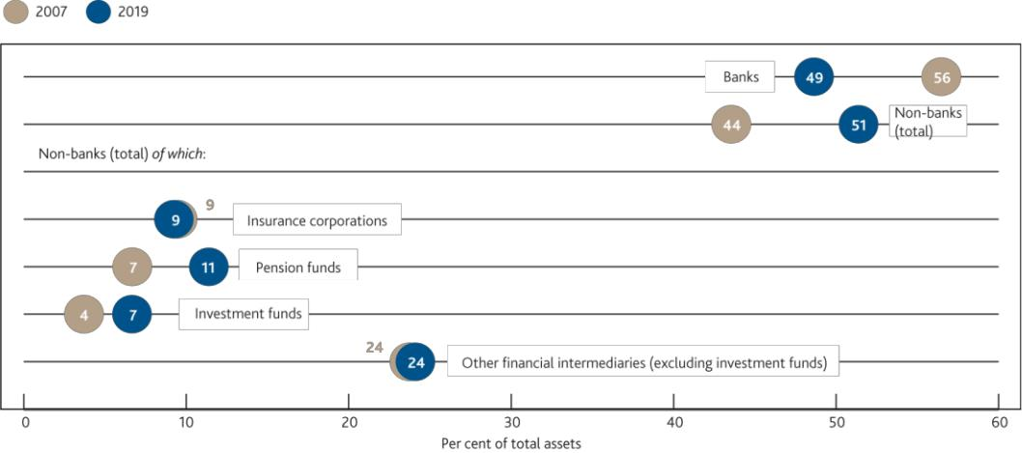

Sources: AFME, Bank of England, Bloomberg Finance L.P., company accounts, FCA, Morningstar, ONS and Bank calculations.

1. Investment funds also includes money market funds, hedge funds and real estate investment trusts.
2. Other financial intermediaries consists of broker-dealers, holding companies, structured finance vehicles, non-bank mortgage lenders, central counterparties (CCPs), finance companies and financial auxiliaries.
3. Where 2019 data were unavailable, the latest available data were used. For 2007, where unavailable 2008 data were used.

The resilience of market-based finance has therefore become increasingly important to the reliable provision of financial services to the real economy. For example, businesses rely on primary corporate bond and equity markets to raise funding and meet cash-flow needs. A lack of willing buyers in these markets can increase the cost of raising finance. Market functioning, in turn, relies on buyers having confidence to invest in markets, including through an



1. Banks and their affiliated dealers are important participants in the market-based financial system. Part of their funding is market-based, and they are critical providers of market liquidity in key markets. The core banking system part of the market-based system remained resilient through the market stresses.

Financial Stability Report August 2020 Building the resilience of market-based finance 66

expectation of liquidity in secondary markets to liquidate or de-risk their portfolios. Poor secondary market liquidity does not only undermine new issuance of securities but can spill over to other secondary markets; for example, if market participants seek to sell different assets instead.

*The financial system is reliant on government bond and repo markets remaining liquid in stress. In March, these markets were threatened…*

As in most countries, in the UK, government bonds ― ‘gilts’ ― are critical for the functioning of the economy: they provide a benchmark for other borrowing rates for the UK Government, households and businesses; they are vital to the transmission of monetary policy; and they are essential to the smooth functioning of the financial system.

Government bonds are among the highest-quality liquid assets that banks can hold to meet regulatory liquidity requirements and account for the vast majority of the primary liquidity resources of non-bank institutions.

Following a negative economic shock, investor appetite usually shifts from risky to safer, more liquid, assets which increases demand in the government bond market. This occurred at the outset of the Covid-19 episode. However, as conditions became more severe, markets became characterised by exceptionally high demand for cash and near-cash, short-dated assets.2 The functioning of markets such as the US Treasury and gilt markets, among the deepest and most liquid in the world, deteriorated quickly.

*…exposing a number of vulnerabilities in market-based finance…*

The FPC has previously highlighted a number of potential vulnerabilities in market-based finance, including: fragilities to liquidity in some markets; risks to liquidity from dependencies on US dollar funding; and the potential for abrupt redistribution of liquidity across the system caused by large margin calls on derivatives. Arguably, each of these liquidity vulnerabilities contributed to the exceptionally high demand for cash and the deterioration in liquidity in government bond markets (see Performance of the UK financial system during the Covid-19 pandemic chapter). Further work to assess the vulnerabilities exposed in the ‘dash for cash’, as summarised in **Figure E.1**, should include:

Examining the procyclicality of margin calls and the resilience of non-bank liquidity management when faced with large **margin calls** in stress. Margin calls on both cleared and uncleared derivatives resulted in a sudden and sharp redistribution of liquidity around the financial system. Initial analysis of transaction data and market intelligence suggests that, to raise cash to meet such calls, some UK pension funds and insurers had to sell or borrow against gilts or sell short-term corporate bonds, adding pressure to these markets.

Understanding which factors might have limited **dealer capacity** to intermediate and finding ways to enhance that capacity without reducing the overall resilience of the financial system. While dealers did not immediately step back as the demand for liquidity surged, evidence suggests their capacity was constrained, including in the US Treasury and gilt markets ― so the cost of trading spiked and market illiquidity intensified just as market participants were seeking the cash to meet those margin calls.

Assessing the role of **leveraged non-bank investors** in the functioning of core markets under stress. Leveraged investors ― predominantly hedge funds ― seeking to unwind large US Treasury market bonds and futures positions that suddenly became loss-making contributed to unusual price movements in that market. In the days that followed, the ‘dash for cash’ spread across the global financial system.

Examining vulnerabilities in **money market funds** (MMFs), which investors rely on for cash management. MMFs experienced large outflows, raising the possibility of suspensions as MMFs sought to sell commercial paper and certificates of deposit to meet redemptions and build cash buffers, but were inhibited by a lack of liquidity in those markets (see Box 8). Demand for bank-issued short-term debt instruments remained constrained even in the aftermath of the shock, contributing to elevated Libor rates (see Box 10).

With the FCA, continuing the review into risks from liquidity mismatch in some **open-ended funds.** Market participants sold a range of assets and redeemed from open-ended funds in March. There may have been



1. ‘Cash or near-cash short-dated assets’ refers to assets that are redeemable at par or can be liquidated on demand without price impact, such as reserves, sight deposits and assets traded/borrowed against in highly deep and liquid markets.

Financial Stability Report August 2020 Building the resilience of market-based finance 67

potential incentives to redeem from some of these funds before other investors did so and, in aggregate, investors in these funds behaved more procyclically (selling when asset prices were falling) in the UK corporate bond market than other market participants, contributing to selling pressures.

With the FSB and other authorities, continuing to develop the ability to **measure the flow of funds and**

**interconnected exposures across different parts of the financial system**. The March ‘dash for cash’ demonstrated how the withdrawal or hoarding of liquidity by one set of participants, or decisions about how to raise finance by others, can affect the entire chain that facilitates the provision of finance. All of these actions were probably rational and desirable from the point of view of the individual institutions concerned. However, given the interconnections between them, they could have resulted in systemic consequences. So it is important to assess the entire system, which is interconnected globally.

**Figure E.1:** The Covid-19 shock has underlined the need to review the resilience of investors and markets under stress

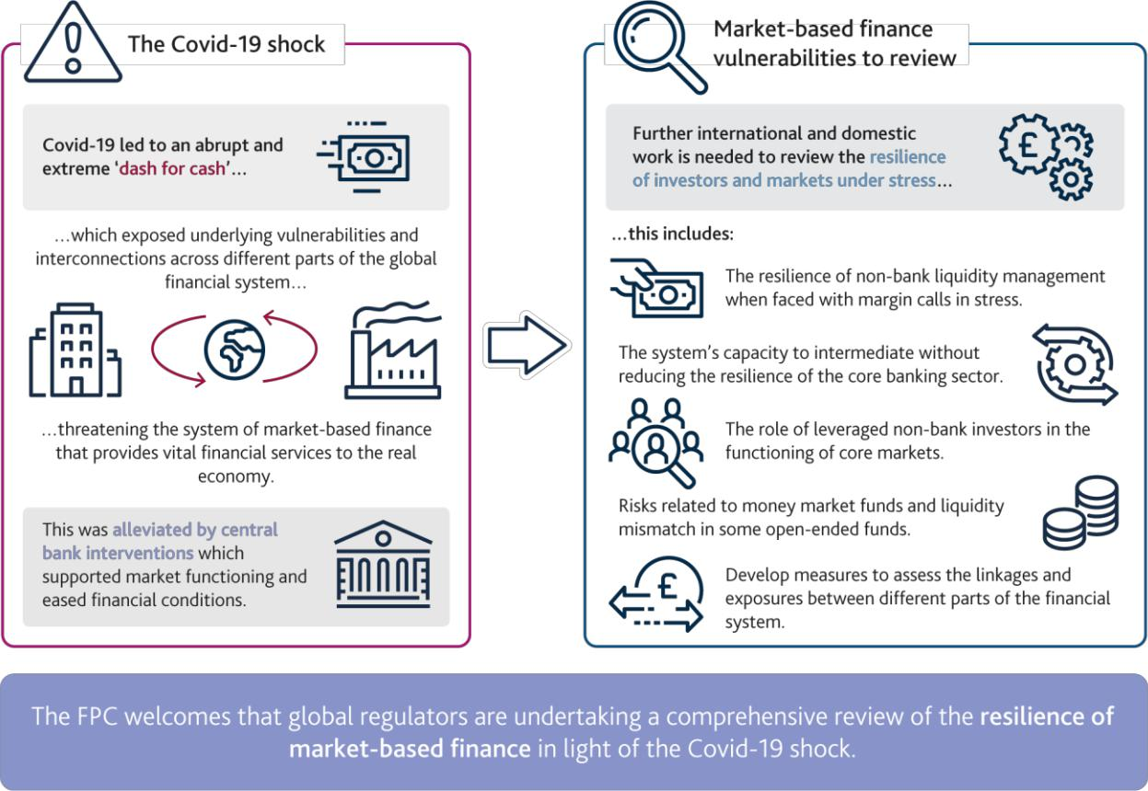

…*with the potential to ripple through the system with severe consequences for the wider economy.* Unchecked, these factors could have interacted with each other and other elements of the financial system to a damaging effect, with a range of corporates and financial institutions being unable to meet their obligations which could threaten their solvency.

Wider bid-ask spreads, higher volatility and larger liquidity risk premia would have led to further difficulties in raising cash for financial institutions, including pension funds that hold the savings of UK citizens. With MMFs already experiencing outflows, further stress would have also raised the possibility of suspensions, which could have directly impacted the ability of some large companies and other investors to access cash.3 Losses at leveraged hedge funds may have prompted more deleveraging, amplifying stress in government bond and repo markets further.4 Pressures in US dollar funding markets may have intensified given the extensive reliance on US dollar liquidity in global capital markets (see Box 9). Meanwhile, redemptions from open-ended funds would probably have increased further, triggering further selling and making it more difficult for governments and businesses to



1. Outflows from MMFs amounted to £25 billion in just over a week for sterling funds, equivalent to 11% of assets under management, and $125 billion for prime US dollar funds from February 2020 to March 2020 (see US Securities and Exchange Commission [statistical release)](https://www.sec.gov/files/mmf-statistics-2020-03.pdf).
2. For example, contacts have suggested relative value trading losses could have amounted to around 13% of hedge funds’ capital on those trades.

Financial Stability Report August 2020 Building the resilience of market-based finance 68

access finance. Had this affected bank funding, credit conditions would have further tightened for households and those small businesses that rely on bank lending.

*Central bank interventions were necessary and effective in avoiding wider economic damage in March.*

Financial stability is not the same as market stability. Volatility in asset prices and even the insolvency of market participants can be expected through periods of adjustment or heightened uncertainty — indeed it is important that asset prices are able to adjust to developments in order to send the right signals to the broader system.

But in times of severe stress, central banks have a role to play in providing a liquidity backstop to support the functioning of markets that would otherwise create disruption in the wider financial system and harm economic activity (see Box 7).

In March, such interventions were necessary and effective in stabilising the financial system, avoiding wider economic damage than that associated with the Covid-19 shock itself. Central banks acted quickly, in unprecedented scale and in a co-ordinated fashion in response to the crisis. All major central banks eased monetary policy, cutting interest rates and expanding their asset purchase programmes. They also extended their provision of dollar liquidity and extended credit in various forms to the corporate sector. Central banks also activated, and in many cases enhanced, their domestic currency liquidity insurance facilities (see Performance of the UK financial system during the Covid-19 pandemic chapter).

*But central bank interventions also carry costs and can adversely affect the incentives of market participants.*

While necessary in extreme stress, central bank interventions come with potentially adverse consequences. They can pose risks to public funds and create incentives for market participants to become overly dependent on central bank backstops, which can lead to excessive risk taking. Appropriate regulatory requirements and oversight can mitigate these risks and vulnerabilities in market-based finance. But those interventions also carry costs.

*The recent shock underlines the need to review the resilience of investors and markets under stress.*

It is first and foremost for private market participants to manage the liquidity risks they face. But it is not realistic or efficient to expect financial intermediaries to self‐insure against every conceivable shock or stress. There must be an appropriate balance between private sector resilience and reliance on extraordinary central bank liquidity support. That balance varies by market, depending on the costs that disruption in that market would pose to the system of market-based finance and the economy. While the recent shock was exceptionally severe, the reliance on central bank support to address dysfunction in key markets suggests the need to review the resilience of market functioning under stress. Macroprudential policy has an important role to play in addressing the risk that the market-based system amplifies shocks and therefore worsens economic outcomes.

There have been some indications that the financial system has become more prone to ‘jumps’ to illiquidity ― such as the period of volatility in the US dollar repo market in September 2019. Absent action, this raises the possibility of further disruption in the future.

*The FPC is in close contact with other authorities, in the UK and internationally, to take this work forward.*

As set out in the recent letter from the Chair of the FSB to the G20, and recognising the global nature of the market-based system, work to reinforce the resilience of market-based finance needs to be internationally co-ordinated [(FSB (2020))](https://www.fsb.org/2020/07/fsb-sets-out-action-to-maintain-financial-stability-during-covid/). The FPC welcomes the comprehensive review of the provision of market-based finance in light of the Covid-19 shock being undertaken by the FSB, due to be delivered by November 2020. This analysis will take account of interconnections across different parts of the financial system, and will help to identify areas in which policy responses may be needed to improve the resilience of market-based finance while preserving its benefits. The Bank will actively participate in this work with other authorities to take this forward domestically and internationally.

Relatedly, the FPC welcomes that the FSB has begun a mapping exercise of the critical connections in non-bank sectors in a cross-border setting, with the Bank and FCA represented in this workstream. It is important to develop measures to assess the linkages and exposures between different parts of the financial system. This could help identify interdependencies and vulnerabilities that could spread problems across markets and amplify them.

Financial Stability Report August 2020 Building the resilience of market-based finance 69



**Box 7**

**The role of central banks in a financial market liquidity stress**

The Covid-19 shock exposed underlying vulnerabilities in market-based finance that disrupted even normally highly-liquid government bond and repo markets during a ‘dash for cash’. Central bank interventions to provide liquidity at scale were both necessary and effective in restoring market functioning. That raises important questions for policymakers: what is their tolerance for disruption in different markets? What is the appropriate balance between private sector resilience and reliance on extraordinary central bank liquidity support? As set out in this chapter, the primary focus of the FPC and other authorities, including via the FSB, is on understanding and addressing underlying vulnerabilities in market-based finance. This box instead focuses on the role central banks can play in backstopping market liquidity, and the risks of such interventions.

In normal times, financial markets help ensure that market participants can access liquidity ― cash and highly liquid assets ― when needed. Continuous access to liquidity underpins the stability of many important financial markets. However, as the recent episode has demonstrated, access to liquidity via markets may be reduced or disrupted during times of stress or market dysfunction. While it is first and foremost for market participants to manage the liquidity risks they face, it is not realistic or efficient to expect them to self-insure against every conceivable shock or stress. So, in times of severe stress, central banks have a role to play in providing a liquidity backstop to support the functioning of markets that would otherwise create disruption in the wider financial system and harm economic activity.

Central banks have traditionally focused on providing liquidity insurance primarily to the core of the banking system. Since the financial crisis of 2008-09 many central banks, including the Bank of England, have improved and broadened their frameworks for liquidity provision to banks. Key changes seen globally include: broadening the range of collateral accepted in central bank operations beyond only the most liquid assets; extending the maturity of those operations, in some cases quite materially; and reducing the cost of borrowing. In light of the progressive shift of intermediation away from banks towards non-banks, some central banks have also broadened access to their operations. For example, following the 2012 [Winters Review,](https://www.bankofengland.co.uk/-/media/boe/files/news/2012/november/the-banks-framework-for-providing-liquidity-to-the-banking) the Bank of England broadened eligibility for many of its liquidity support operations to include smaller banks and building societies, as well as some central counterparties and broker-dealers.

It has become increasingly apparent that, as financial systems evolve, certain liquidity shocks could also necessitate action by central banks to backstop liquidity and market functioning in key markets where disruption might otherwise have wider economic consequences. Central bank actions in this regard have previously included lending operations, changes in collateral policy (including the range of eligible assets and the haircuts applied), and acting

as ‘market maker of last resort’ (MMLR) ― that is, intervening directly to buy and sell assets.5 Large scale asset purchases, while typically used as a monetary policy tool, can also improve market liquidity and functioning in stressed conditions by providing buying interest and reducing the risks facing intermediaries.

Central bank toolkits were put to the test in March as they acted quickly, at unprecedented scale and in a co-ordinated fashion, to respond to the economic shock of Covid-19 and stabilise markets (see Performance of the UK financial system during the Covid-19 pandemic chapter). Those actions, which involved a combination of lending (primarily to banks) and large-scale asset purchases (ultimately mainly from non-banks), proved effective in stabilising markets (**Chart A**).

However central bank interventions also carry costs and risks. For example, when central banks lend to banks or other financial services firms, and especially when they purchase assets, public money is inevitably put at risk. More broadly, central bank interventions can affect the incentives facing market participants in ways that may be detrimental to financial stability in future ― for example, by reducing the incentive for them to ‘self-insure’ and



1. The Bank of England has previously acted as MMLR, for example the Corporate Bond Secondary Market Scheme launched in 2009. The central bank’s role in providing emergency support to securities markets is explored in more detail in [King *et al,* 2017.](https://www.imf.org/~/media/Files/Publications/WP/2017/wp17152.ashx)

Financial Stability Report August 2020 Building the resilience of market-based finance 70

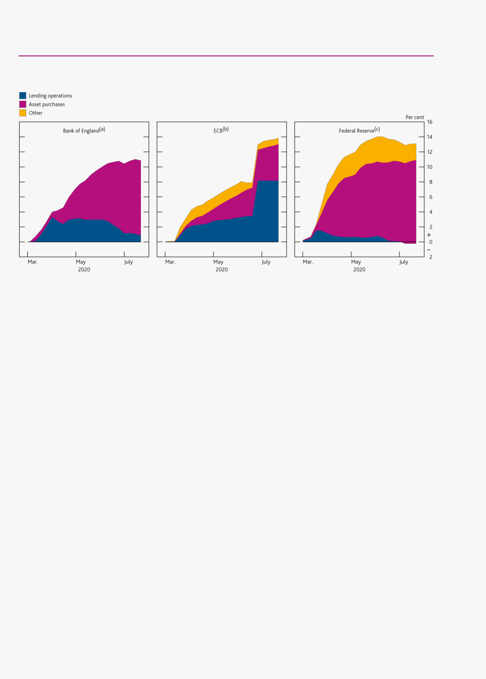

thus encouraging excessive risk taking (creating ‘moral hazard’). Appropriate regulatory requirements and oversight can mitigate these risks, but also carry costs themselves.

**Chart A** Central banks responded to the Covid-19 shock with large increases in lending and asset purchases

Changes in components of central banks’ balance sheets since the end of February 2020 as a proportion of 2019 nominal GDP in their home jurisdictions

Sources: Bank of England, Bureau of Economic Analysis, European Central Bank, Eurostat, Federal Reserve Board, ONS and Bank calculations.

1. Bank of England lending operations shown here: Indexed long-term repo, Contingent term repo facility, US dollar repo operations, Liquidity Facility in Euros, Term Funding Scheme and Term

Funding Scheme with additional incentives for SMEs. Bank of England asset purchases shown here: Asset Purchase Facility and Covid Corporate Financing Facility.

1. ECB lending operations: Lending to euro-area credit institutions related to monetary policy operations denominated in euro. ECB asset purchases: Securities held for monetary policy purposes.
2. Federal Reserve lending operations: Repurchase agreements, Loans and Net portfolio holdings of TALF II LLC (less TALF II LLC Treasury contributions and other assets). Federal Reserve asset

purchases: Securities held outright.

Developments in March may provide a helpful lens through which to reflect on central banks’ role. An overarching question is whether, in light of the growth of market-based finance relative to dealer intermediation capacity, central banks have the right tools to ensure they can continue to meet their objectives in an effective and efficient way. In which markets and securities, and when, should central banks stand ready to intervene to support liquidity? Can they be clearer about the principles that might guide interventions including MMLR? And how can the potential risks of interventions in markets ― financial and moral hazard ― best be managed, through a combination of regulation and oversight of firms that benefit, central bank policies on access to facilities and collateral eligibility, and the pricing of those facilities to set the right incentives?

The FPC supports further work on these issues alongside the work underway internationally to review the resilience of market-based finance. However, it is important to recognise that central bank interventions cannot be a substitute for reforms that mitigate the vulnerabilities in financial markets giving rise to liquidity stresses in the first place.

Financial Stability Report August 2020 Building the resilience of market-based finance 71

**Areas for further work based on initial lessons from the ‘dash for cash’**

The FPC has a responsibility to identify, assess and take action to mitigate risks in order to protect and enhance the resilience of the UK financial system, both now and in the future. This includes risks from the non-bank financial sector, as set out in HM Treasury’s latest [remit letter.](https://www.bankofengland.co.uk/letter/2020/response-to-the-remit-letter-for-the-fpc-2020) In line with this, the FPC has identified areas for further work domestically and internationally based on initial lessons from the ‘dash for cash’.

**Examine the procyclicality of margin calls and the extent to which non-banks are able to anticipate and meet margin calls in stress**

*Margin calls reduced counterparty credit risk during the recent stress…*

The collection of margin on derivative contracts is a crucial safeguard in financial markets. By ensuring that derivatives exposures are adequately collateralised as market prices change and volatility rises, margin reduces the risk that the failure of one counterparty causes concerns around the solvency of other counterparties ― which could otherwise lead to panic that can impair market functioning. In March, despite the very large asset price moves, margin calls were largely met and concerns around counterparty credit risk were contained.

*…but margin calls also have implications for the distribution of liquidity within the financial system.*

Derivatives margin requirements have two components. ‘Initial margin’ is posted at the beginning of a transaction to cover at least 99% of the expected loss to protect clearing members and clients in the event of a counterparty default, and is recalculated on a regular basis. ‘Variation margin’ is exchanged daily to cover actual changes in the market value of the contract and ensures losses or gains in a contract are distributed promptly.

Where market participants have large directional positions (even if for hedging) their losses or gains on derivative products can be large and they can consequently face large variation margin calls. Because variation margin reflects the new market price of a product, gains by market participants on one side of the trade are always equal to the losses incurred by other market participants. This means that, in aggregate, variation margin does not remove liquidity from the system, it redistributes it. But problems arise when the cash received by gaining counterparties is not recycled back towards loss-making counterparties in the system that need to pay it (**Figure E.2**), for example, because dealers are unable or unwilling to intermediate (see intermediation section below). In periods of extreme volatility, the prospect of future variation margin calls may also encourage market participants to hoard cash to ensure that they have sufficient buffers to meet them. Alternatively, they may need to sell other assets or borrow cash against them, which could amplify market moves and add strains to funding markets.

**Figure E.2** Margin calls redistribute cash but not necessarily towards where it is most needed

Illustrative diagram of variation margin flows

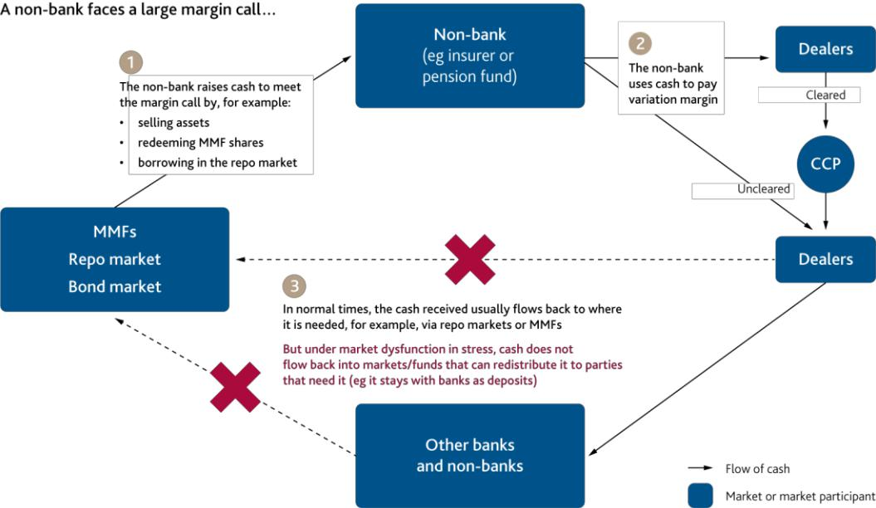

Source: Bank of England.

Financial Stability Report August 2020 Building the resilience of market-based finance 72

Initial margin requirements tend to rise in stress, reflecting increases in expected losses. This ensures that counterparty risk is properly mitigated, but may also create a procyclical effect by requiring counterparties who post margin to find additional liquid assets at precisely the time when it is most difficult for them to do so. Moreover, low initial margin requirements in the upswing may encourage users to take larger positions, making any liquidations and amplification of price moves in the downswing larger than otherwise. International standards require central counterparties (CCPs) to seek to mitigate procyclicality in initial margin requirements to the fullest extent possible while ensuring they remain resilient to counterparty risk. Initial margin requirements on uncleared derivatives are commonly based on the International Swaps and Derivatives Association (ISDA) Standard IM Model (SIMM)TM, that is calibrated using data from historical periods of market stress in order to provide conservative coverage and avoid procyclical increases in margin when market conditions deteriorate.

*More complete and consistent data are necessary to monitor liquidity risks for the system as a whole.*

The FPC assessed the capacity of non-banks in the UK to cover the posting of variation margin on over-the-counter (OTC) interest rate derivatives in 2018.6,7 This was based on transaction-level trade repository (TR) data. While useful, this analysis was necessarily partial, focusing on a subset of derivative positions on a particular day. More complete and consistent data are necessary to monitor liquidity risks for the system as a whole. Authorities also lack a global view of derivatives markets — at the moment, many authorities can only access data in local TRs and no work is underway to decide how a cross-border data aggregation mechanism should work in practice.

*The Covid-19 stress provides lessons on how non-bank derivative users managed liquidity risks.*

New analysis since the May *interim Report* shows the periods during March when the UK non-bank sector was paying larger volumes of margin than it was receiving (**Chart E.2**). Over the ‘dash for cash’ period (9 to 23 March), variation margin paid by a subset of non-banks on some cleared and uncleared derivative positions is estimated to have totalled £33 billion, while they only received £25 billion over that period. UK pension funds and insurers were particularly large payers of margin on interest rate and FX positions. In part, this reflected that they had hedged the currency risk associated with holding US dollar-denominated assets such as corporate bonds and these hedges implied large margin calls when sterling depreciated sharply against the dollar.

To assess the implications of these flows for financial stability requires understanding what actions these non-banks had to take to meet margin payments. For example, market intelligence suggests some insurers sought to sell corporate bonds and sell or borrow against gilts, while some pension funds relied on redeeming holdings in MMFs to meet margin calls. These actions may have contributed to selling pressures in those markets and the large withdrawals from MMFs in mid-March.

Market intelligence also suggests that some derivatives users were better prepared for the increase in margin than others. For example, some pension funds were constrained by only being willing to collateralise their hedges with cash or gilts, rather than to pay the extra cost to enable them to post corporate bonds as securities, while others reported that required liquidity was, in part, held within sterling MMFs. But with many pension funds’ liquidity needs moving in the same direction, the calls on some MMFs threatened to overwhelm their ability to meet redemption calls (see Box 8). Initial supervisory work on insurers suggests many firms utilised previous stress tests to assess their liquidity risk and liquidity coverage ratios during the Covid-19 shock, though there may have been limitations to this approach. For example, previous stress tests did not consider the combined nature of the recent shock, which affected market liquidity as well as business profitability.

*The FPC supports further work into whether there are mitigants that could reduce the pressure from margin calls in stress without compromising the benefits from greater collateralisation.*

The FPC supports further international work to explore whether there are mitigants that could reduce pressure from margin calls in stress without reducing protection against counterparty credit risk. Given the high degree of interconnectedness in the system, this work should follow a holistic approach, which could include:

Examining the extent to which non-bank users of derivatives are able to anticipate margin calls on cleared and uncleared derivatives as part of their liquidity risk management, especially in stressed market conditions, in light



1. See The FPC’s assessment of the risks from leverage in the non-bank financial system chapter, [November 2018 *Financial Stability Report*.](https://www.bankofengland.co.uk/-/media/boe/files/financial-stability-report/2018/november-2018.pdf)
2. Since that review, the PRA has published a [supervisory statement](https://www.bankofengland.co.uk/prudential-regulation/publication/2019/liquidity-risk-management-for-insurers-ss) on insurers’ management of liquidity risks in 2019.

Financial Stability Report August 2020 Building the resilience of market-based finance 73

of lessons from the Covid-19 episode. Non-banks typically access CCPs as clients of clearing members, and the clearing member retains some discretion over how and when margin is collected. Meanwhile, margin calls on uncleared derivatives are determined by the counterparties to the trade and may be subject to dispute ― supervisory intelligence suggests major UK banks saw up to a six-fold rise in disputes in March and April 2020 relative to earlier in the year, driven largely by an increased volume of margin calls amidst high market volatility.

Reviewing whether margining practices could take better account of the system-wide impact of large margin calls in stress, while providing adequate protection against counterparty credit risk. Different practices apply for cleared and uncleared derivatives, such as the timing of margin calls and the assets that can be used to fulfil them. The extent to which CCP margining practices affect non-banks is also partly determined by clearing members’ approach to risk managing client exposures, including whether they fund intraday margin calls on behalf of clients. These and other considerations can inform discussion of whether expanding central clearing to more markets and counterparties would make the non-bank system more resilient to liquidity risks.

Reviewing the effectiveness of existing measures to limit initial margin procyclicality in stress. As set out in the European Market Infrastructure Regulation (EMIR), UK and EU CCPs are required to take specific measures to mitigate procyclicality ― in practice this prevents margin requirements from falling to low levels when market volatility is subdued by historical standards. Relative to other global CCPs, CCPs subject to EMIR generally reported smaller increases in aggregate initial margin requirements during 2020 Q1, although this may partly reflect differences in the growth of cleared positions at different CCPs and differences in the mix of asset classes cleared at each CCP. Initial margin increases were also in general more pronounced for cleared exchange-traded derivatives (ETD) than cleared OTC derivatives (**Chart E.3**). Further analysis could seek to better understand these differences and explore whether higher initial margin requirements in normal times could help to reduce the build-up of leverage and therefore the need for procyclical increases in stress, without making hedging using derivatives prohibitively expensive.

**Chart E.2** UK insurers and pension funds faced large margin calls on their derivative contracts

Total estimated variation margin payments on some interest rate and FX derivatives for some UK non-banks, by sector and payment direction(a)

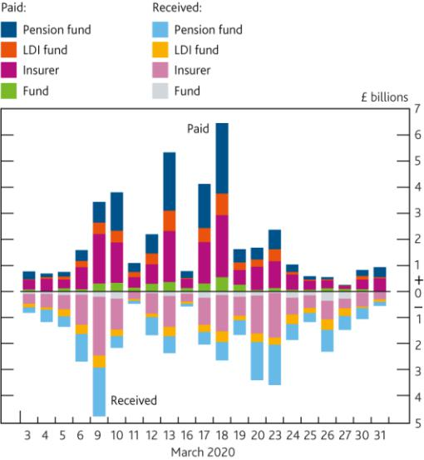

**Chart E.3** Initial margin increases have been less pronounced for CCPs subject to EMIR and for OTC derivatives

Quarterly change in total initial margin received at CCP and service level, size of the bubble denotes total initial margin in 2020 Q1(a)(b)

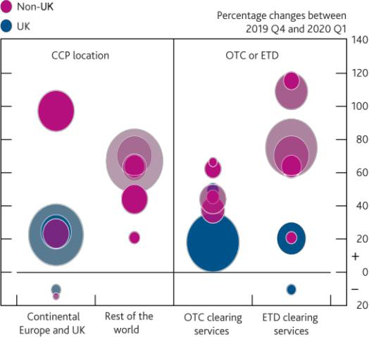

Sources: Trade Repositories ― DTCC Derivatives Repository plc, ICE Trade Vault Europe Ltd, Regis-TR S.A and UnaVista Limited Trade Repositories; Bloomberg Finance L.P. and Bank calculations.

1. Variation margin calls estimated using position-level trade repository data on sterling interest rate swaps and forward rate agreements, and on GBPUSD, EURUSD, JPYUSD, USDGBP, USDEUR and USDJPY FX forwards. Covers over 400 UK pension funds, insurers, liability driven investment funds and other open-ended funds. Variation margin estimations based on methodology used in Bardoscia M *et al* (2019), [‘Simulating liquidity stress in the derivatives](https://www.bankofengland.co.uk/working-paper/2019/simulating-liquidity-stress-in-the-derivatives-market) [market’](https://www.bankofengland.co.uk/working-paper/2019/simulating-liquidity-stress-in-the-derivatives-market) and in the FPC’s 2018 assessment of risks from leverage in the non-bank financial system set out in the [November 2018 *Report*.](https://www.bankofengland.co.uk/financial-stability-report/2018/november-2018)

Sources: CCP disclosures and Bank calculations.

1. The left panel of the chart demonstrates the percentage change in aggregate initial margin of 12 representative CCPs during 2020 Q1. Six out of the twelve CCPs are domiciled in continental Europe and UK, and the other six are domiciled in non-EU jurisdictions. Bubble size represents the total initial margin requirement of each CCP in 2020 Q1. The right panel represents the percentage change in aggregate initial margin of representative CCP services of cleared OTC derivatives, and ETD. OTC derivative services include cleared interest rate swaps and cleared credit default swaps. The exchange-traded derivative services focus on futures and options. Bubble size represents the total IM requirement of each CCP in 2020 Q1.
2. CCPs include: ICEU, LCH, LMEC, Eurex, LCH Sa, ECC, CME, ICE US, OCC, ICC, SGX, JSCC.

Financial Stability Report August 2020 Building the resilience of market-based finance 74

**Understand factors that might limit dealer capacity to intermediate and find ways to enhance that capacity without reducing the resilience of the financial system**

Dealers can alleviate market stresses by extending repo financing, absorbing sales and building up an inventory of securities. Conversely, as the FPC has highlighted in the past, when dealers are unable or unwilling to intermediate, this can contribute to deteriorating liquidity, even in usually liquid markets.8

*Although dealers did not immediately step back as the demand for liquidity surged in March, evidence suggests their supply of intermediation became constrained quickly, reflecting a number of factors.*

During the Covid-19 episode, dealers initially absorbed large amounts of US Treasuries and gilts sold by market participants to generate cash. But as the ‘dash for cash’ intensified, the speed and size of sales overwhelmed dealers’ capacity to intermediate further. In response, dealers widened bid-offer spreads, increasing the cost of trading.

In part, this may have reflected that markets may have grown much more than the capacity of dealers to intermediate in them using their own balance sheets. Since the global financial crisis, the size of the US Treasury and gilt markets have grown significantly relative to dealer balance sheets (**Chart E.4**). Since the outbreak of Covid-19, key financial centres moving to remote working arrangements may have added operational challenges.

Internal risk controls and regulation to safeguard the core banking system may have also played a part in constraining capacity. For example, during March, some firms cited internal risk limits as constraining activity due to increased market volatility.9 However, maintaining robust standards is crucial to supporting financial stability. In that context, the FPC emphasises that dealers are able to draw down usable regulatory buffers for both capital and liquidity to support market functioning through the cycle, as well as in stress. Buffers allow intermediaries to continue to provide market-making services when they are most needed and where withdrawal of those services would risk amplifying the effect of shocks on credit conditions and the real economy.

Another factor that may have influenced markets’ intermediation capacity is the behaviour of algorithmic and automated strategies. The role of algorithmic trading and how that may have affected intraday market functioning needs to be examined further, but initial work does suggest intraday dislocations in the gilt futures market.

*There may be merit in assessing ways to enhance the financial system’s ability to supply intermediation in stress, without reducing overall resilience.*

Further work could explore the extent to which risk controls and regulations contributed to constraining dealer capacity in March and whether adjustments to dealers’ market practice could alleviate some of the impact on market liquidity during stress without reducing the resilience of the banking system. For example, there is some evidence that netting arrangements have supported functioning in the gilt repo market in recent years, minimising the impact of repo trades on dealers’ balance sheets, and therefore their capital requirements. Analysis of changes in the price and volume of repo activity suggests that nettable transactions show less price sensitivity in response to changes in demand, although netting arrangements could be more difficult to use in a stress.

There may also be merit in considering broader market structure reforms that could free up dealers’ balance sheets. For example, [Duffie (2020)](https://www.brookings.edu/wp-content/uploads/2020/05/WP62_Duffie_v2.pdf) has proposed a study of the costs and benefits of mandating the central clearing of US Treasury transactions of all firms that are active in the market.

**Assess the role of leveraged non-bank investors in the functioning of core markets**

Since the global financial crisis, leveraged investors have played a bigger role in some government bond markets arbitraging small differences in the value of cash bonds, swaps and futures ― known as relative value trading. These trades, typically conducted at thin margins and high rates of leverage, can help to stabilise market prices. But they can also amplify market moves in stress through the unwinding of positions, particularly where those positions are concentrated in a particular market or correlated with those of other market participants. In March, hedge funds seeking to unwind large bond and futures positions in the US Treasuries market contributed to a short period



8

9

See Resilience of market-based finance chapter in the [December 2019 *Financial Stability Report*.](https://www.bankofengland.co.uk/financial-stability-report/2019/december-2019)

Prior to the Covid-19 shock, some research had found that some dealers reduced the supply of intermediation in the UK repo market after the announcement and implementation of leverage ratio requirements. See Bicu, A, Chen, L and Elliot, D (2017), ‘The leverage ratio and liquidity in the gilt repo markets’,

[*Bank of England Staff Working Paper No. 690*](https://www.bankofengland.co.uk/working-paper/2017/the-leverage-ratio-and-liquidity-in-the-gilt-and-repo-markets) and Kotidis, A and van Horen, N (2018), ‘Repo market functioning: the role of capital regulation’,[*Bank of England Staff Working Paper No.746*.](https://www.bankofengland.co.uk/working-paper/2018/repo-market-functioning-the-role-of-capital-regulation)

Financial Stability Report August 2020 Building the resilience of market-based finance 75

of extreme illiquidity in that market. The direct impact of hedge fund behaviour on the gilt market in March is less clear. Initial analysis of transaction data suggests much less trading of differences between bonds and futures by hedge funds in the gilt market than in the US Treasury markets (see Performance of the UK financial system during the Covid-19 pandemic chapter).

Authorities have better visibility of leveraged investor activity in core markets than in the past. For example, transaction-level data show hedge fund activity in the gilt repo market (**Chart A.7**). And, as set out in the December 2019 *Report*, the FPC noted that the Bank’s Hedge Fund As Counterparty Survey showed that cash borrowing by hedge funds in repo markets globally had increased by 41% in the six months to April 2019. This trend can also be seen in data reported by hedge funds to the FCA (**Chart E.5**). However, on their own, these data are insufficient to assess the risks from a build-up in leverage. Data collections are infrequent and jurisdictions may not have data covering all relevant leveraged non-banks. Moreover, further measures are needed to help inform the potential for liquidity demands and losses generated by leverage.

**Chart E.4** The stock of marketable Treasuries and gilts has grown significantly relative to dealer balance sheets

Stock of government securities and estimated dealer banks’ balance sheets

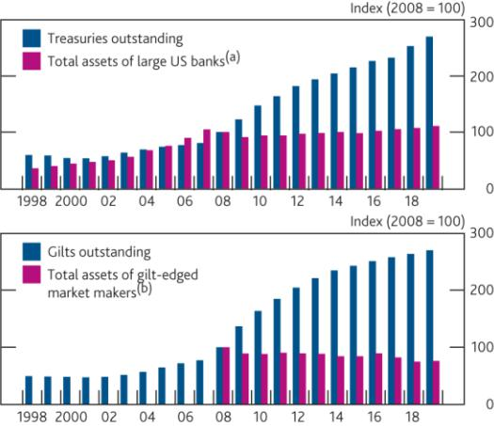

**Chart E.5** Total cash borrowing of hedge funds had been increasing in recent years

Total cash borrowing of hedge funds reporting to the FCA by borrowing type, per cent of net asset value (NAV)(a)

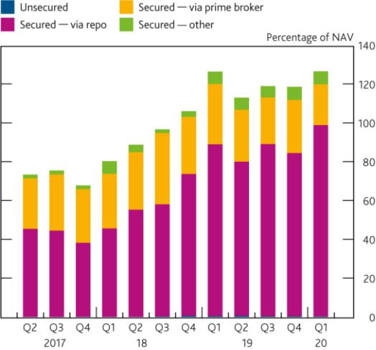

Sources: [Duffie, D (2020), ‘Still the world's safe haven?’ Redesigning the U.S Treasury market after](https://www.brookings.edu/wp-content/uploads/2020/05/WP62_Duffie_v2.pdf) [the Covid-19 crisis, *Hutchins Center Working Paper No. 62*;](https://www.brookings.edu/wp-content/uploads/2020/05/WP62_Duffie_v2.pdf) UK Debt Management Office; Bank of England Regulatory Returns and Bank calculations.

1. Assets of large US banks cover total assets for the holding companies of Bank of America, Bear Sterns, Citigroup, Goldman Sachs, JP Morgan Chase, Lehman Brothers, Merrill Lynch, Morgan Stanley and Wells Fargo.
2. Gilt-edged market makers’ total assets are based on quarterly averages available from 2008 and exclude assets of banking entities that are authorised to operate in the UK through branches. Amount of gilt outstanding is based on financial year-to-date as of end-March.

Sources: FCA Alternative Investment Fund Managers Directive (AIFMD) data and Bank calculations.

(a) Covers hedge reporting quarterly to the FCA under AIFMD.

The FPC supports further work on the role of leveraged investors in the government bond markets, particularly to assess the potential benefits they provide in supporting market functioning relative to potential costs they can pose if there is widespread deleveraging in stress. The Bank intends to discuss its findings in international fora to ensure a co-ordinated approach. As set out above, higher minimum margins on derivative positions could help reduce the build-up of leverage, thereby reducing the extent of deleveraging during stress. Higher and more standardised haircuts to securities financing transactions may also help in a similar manner, but would require more oversight of how market participants price repo, for example through repo clearing.

**Continue the Bank and FCA review of risks from open-ended funds**

Open-ended funds play an increasingly important role in the provision of finance, both globally and in the UK. Currently, open-ended funds that offer daily redemptions account for over 95% of UK open-ended funds’ assets. However, some of these funds take liquidity risks by investing in assets that take longer to liquidate in an orderly way, especially during a period of market stress, such as property or corporate bonds. As the Bank and FCA have previously explained, this means there is a potential advantage to investors who redeem ahead of others in a stress, which could lead to large redemptions and could force funds to sell assets, amplifying asset price moves and transmitting stress to other parts of the system (see [December 2019 *Report*)](http://www.google.com/search?q=december+2019+fsr&sourceid=ie7&rls=com.microsoft:en-GB:IE-Address&ie=&oe=). This has the potential to become a systemic risk.

Financial Stability Report August 2020 Building the resilience of market-based finance 76

*In order to manage their liquidity needs during the Covid-19 shock, open-ended funds focusing on UK assets built cash buffers, used swing pricing and, in the case of some property funds, suspensions.*

Open-ended funds invested in sterling corporate bond markets saw large outflows in March, but have stabilised since (**Chart E.6**). Funds used a range of strategies to cope with outflows. Fixed-income funds reported that they used cash buffers and sold more liquid and shorter-dated bonds, while those funds invested in less liquid assets, such as high-yield bonds, increased their allocations to cash (or cash-like) assets in March. Consistent with this, the *Bank of America Fund Manager Survey* found that the average amount of cash held by funds responding to the survey rose to 5.1% of assets under management (AUM) in March, and to 5.9% in April, relative to a 10-year average of 4.5%.

Some funds adjusted pricing to reflect the potential dilution effects of redemptions for remaining investors (known as ‘swing pricing’), which could address the potential advantage to investors who redeem ahead of others. Individual funds have their own methodology for calculating swing factors. While swing pricing may have helped in some cases, there is evidence that it was applied inconsistently across different funds, which may have prompted greater outflows from some funds. In some cases the remaining investors may have been penalised relative to exiting investors due to swing factors not being set high enough to reflect market conditions.

Exchange-traded funds (ETFs), which offer immediate liquidity on secondary markets, became one of the key mechanisms for price discovery during the Covid-19 shock. During this period there were some large differences between ETF end-of-day share prices and the measured end-of-day value of their assets. This suggested ETF prices contained information about future changes in underlying asset values, reflecting more accurately the liquidity and the cost of selling the underlying assets (see [May 2020 *interim Report)*](https://www.bankofengland.co.uk/-/media/boe/files/financial-stability-report/2020/may-2020.pdf). Some funds therefore considered ETF discounts when applying swing factors. However, ETF prices will have included other information, such as selling pressure from the increased usage of ETFs as hedges to other positions and as a source of liquidity. Though ETFs sold fewer bonds than open-ended funds, outflows from ETFs measured as a percentage of AUM were similar or larger during the stress (**Chart E.7**). ETF volumes were high during March. For example, US fixed-income ETF traded volumes reached an average of $33.5 billion per day in March, more than three times the 2019 daily average [(Blackrock (2020))](https://www.blackrock.com/corporate/literature/whitepaper/viewpoint-lessons-from-covid-19-etfs-as-a-source-of-stability-july-2020.pdf).The difference between the ETF share price and the end-of-day value of their underlying assets have narrowed since March, supported by interventions by the Federal Reserve Board.

**Chart E.6** Open-ended funds invested in sterling corporate bonds saw large outflows in March

Cumulative flows as a share of assets under management (AUM)(a)

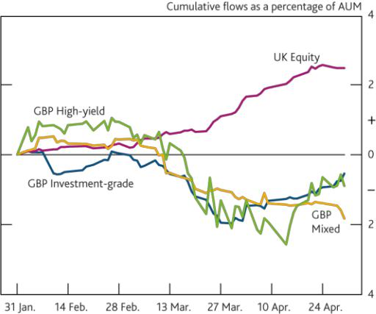

**Chart E.7** Global ETFs experienced more severe outflows than open-ended funds during the shock

Outflow from global ETFs and open-ended funds (OEF) as share of AUM(a)

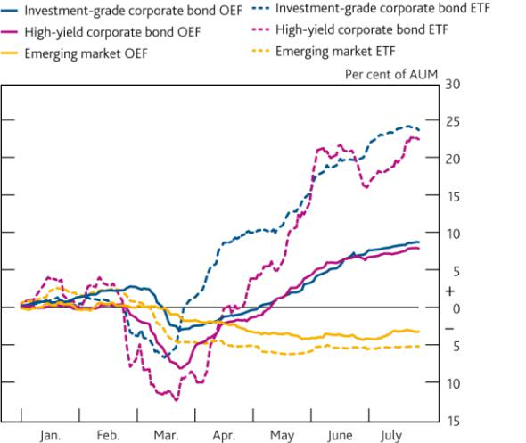

Sources: Morningstar and Bank calculations.

1. Asset classes are determined by the markets in which funds primarily invest, based on the underlying securities held in their portfolio.

Sources: Bloomberg Finance L.P., Morningstar and Bank calculations.

(a) Percentage outflows for largest 50 ETFs and OEFs by asset type globally, based on AUM at end-

2019. Asset classes determined by Morningstar categorisations.

*In aggregate, open-ended funds acted more procyclically than other market participants in the UK corporate bond market.*

In aggregate, open-ended funds behaved more procyclically (selling when risky asset prices were falling) in sterling corporate bond markets than other market participants (see **Chart A.6**). Analysis also suggests funds investing in

Financial Stability Report August 2020 Building the resilience of market-based finance 77

sterling corporate bonds were more likely to sell higher-rated bonds, particularly those rated AAA. Such actions could leave bond funds with lower-rated and less liquid asset profiles, which could make them more vulnerable to further shocks. Some funds also reduced their portfolio allocation to distressed sectors, such as energy and leisure, potentially adding further strain. In contrast, asset managers, including funds, were generally buyers of UK equities on the days of the largest price falls. UK equity funds received large inflows throughout March and April. These inflows were mainly received by funds which invest in large corporates, whereas funds that invest in small and medium-sized corporate equities saw net outflows, which could indirectly impact the terms of finance available to small companies relative to large ones.

*The Bank and FCA will resume work on the open-ended funds review.*

In July 2019, the Bank and FCA announced that they would undertake a joint review into vulnerabilities associated with liquidity mismatch in open-ended funds. In December 2019, the FPC considered the data needs for the review, noting that the initial data collection would take the form of a survey.

In light of the Covid-19 shock, the Bank and FCA had agreed to postpone the survey. But, as set out above, data and market intelligence from the stress indicates that some of the risks they had identified had probably been key drivers of funds’ response to the shock. The Bank and FCA will, therefore, resume the review and launch the survey capturing information relevant to the Covid-19 shock as part of the work.

The FCA is currently consulting on whether authorised open-ended retail-oriented property funds could transition to a structure where redemption terms (ie the terms under which investors can get their capital out of the fund) are better aligned with the liquidity of fund assets.10 This consultation is a first step in addressing liquidity mismatch in open-ended funds.

The FPC recognises the importance of addressing liquidity mismatches in open-ended funds internationally, given the global nature of asset management and the UK’s role in it. The Bank will continue to engage with the FSB and the International Organisation of Securities Commissions (IOSCO), as well as other authorities, on this topic.

**The episode raised a range of other important questions that the FPC will continue to work on**

This will include further work to fill data gaps to build a better understanding of the market-based system, which will be an important part of the FPC’s assessment of the risk oversight and mitigation related to the non-bank financial system as requested in the [HM Treasury 2020 remit letter](https://www.bankofengland.co.uk/letter/2020/remit-for-the-fpc-2020) to the Committee.

*The FPC plans to work with other authorities to improve data coverage, and build a better understanding of the risks posed by the market-based financial system.*

As set out above, the UK financial system may have become more prone to disruption due to liquidity risk. As a result, it has become more important to improve the coverage and quality of data available for risk monitoring, assessment and mitigation. There are currently significant data gaps in relation to these liquidity risks, and in relation to financial market participants’ ability to cope with these.

*The FPC looks at the whole range of entities which make up the market-based financial system and their activities, aiming to ensure appropriate oversight and risk mitigation.*

The interconnected nature of market-based finance poses challenges to establishing system-wide indicators of resilience. This, along with the issues around the limited quality and coverage of the data, make it challenging to form a view on the resilience of the system using broad indicators. However, as illustrated in this and previous *Reports*, the FPC looks at a broad range of data sets and indicators to inform its assessment of the risks frommarket-based finance. The Bank works domestically and internationally alongside other authorities to enhance its understanding of non-bank financial intermediation.11 As set out in the [FPC’s response](https://www.bankofengland.co.uk/letter/2020/response-to-the-remit-letter-for-the-fpc-2020) to the remit letter, the Committee will publish a more detailed assessment of the oversight and mitigation of systemic risks from the non-bank financial sector.



1. See FCA [CP20/15.](https://www.fca.org.uk/publications/consultation-papers/cp20-15-liquidity-mismatch-authorised-open-ended-property-funds) The FCA consultation sets out the consequences of introducing notice periods, including the interaction with: current suspension rules; SIPP provider capital rules; unit-linked insurance providers; intermediaries and distributors; and ISA eligibility.
2. For example, in recent years, the Bank has worked, and continues to work, with the FCA on a number projects related to issues discussed in this chapter. The Bank is also working with the Office for National Statistics to improve the quality, coverage and granularity of the UK Financial Accounts as part of the ‘flow of funds’ initiative. Internationally, the Bank and the FCA contribute to the FSB’s annual monitoring exercise to assess global trends and risks from non-bank financial intermediation, as well as current work in light of Covid-19.

Financial Stability Report August 2020 Building the resilience of market-based finance 78



**Box 8**

**Vulnerabilities in money market funds**

*Money market funds (MMFs) are funds that invest in short-term debt instruments issued by financial institutions, larger companies and governments. They are used by a wide variety of investors, who often consider MMFs as a ‘cash-equivalent’.*

MMFs are funds that invest in short-term money market instruments. Public debt MMFs invest in government securities, such as government bonds. On the other hand, prime MMFs invest largely in non-government assets such as commercial paper (CP) and certificates of deposits (CD). Globally, MMFs had over US$7 trillion of assets under management (AUM) as of March 2020, more than half of which held by funds that are domiciled in the US. AUM of sterling-denominated MMFs have more than doubled since the global financial crisis, and amounted to over £260 billion as of July 2020. Among UK investors, MMFs are predominantly used by pension funds, other financial institutions and funds including open-ended funds, corporates and local authorities.

Many investors use MMFs as part of their cash management strategies because MMFs offer ‘same-day’ liquidity ― meaning investors can generally expect to redeem their full principal at any time ― while offering more attractive yields than bank current accounts that similarly allow instant access to cash. Despite offering ‘same-day’ liquidity, MMFs can provide a yield by investing in assets with a maturity longer than a day, for example CP and CD that have a maturity of three months or six months. Banks can face costs in accepting deposits due to capital and liquidity requirements and therefore may be less willing to offer similar rates on current accounts. MMFs also allow investors to reduce counterparty credit risk (relative to a bank account) through diversified portfolios at minimal operational cost.

*During the March ‘dash for cash’ episode, prime MMFs faced significant outflows and found their ability to generate additional liquidity constrained, exposing the risk of a run on these funds.*

Although many investors regard their MMF holdings as cash-like assets and generally redeemable on demand, they are subject to risk of losses. Some of the instruments held by MMFs may become illiquid under stressed market conditions, while others ― such as CP and CD ― trade infrequently in secondary markets even in normal times. This can affect MMFs’ ability to sell these assets to meet redemptions or maintain sufficient cash buffers. Because of this liquidity mismatch, in stress early redeemers from the fund are more likely to receive their principal in full and on time. This incentivises investors to redeem quickly, which can introduce the risk of a run on the MMF and the possibility of the MMF needing to suspend redemptions.

In March, prime MMFs saw large outflows globally (see [May 2020 *interim Report*)](https://www.bankofengland.co.uk/report/2020/monetary-policy-report-financial-stability-report-may-2020). Sterling-denominated MMFs, which are mostly prime, saw outflows amounting to £25 billion in just over a week, equivalent to 11% of assets under management (AUM) (**Chart A**). This was largely driven by investors that use derivatives seeking to meet margin calls by redeeming their investments in MMFs. Euro-denominated MMFs saw similar trends, while outflows from prime US dollar-denominated funds (including those domiciled in Europe) were accompanied by large inflows

to MMFs investing in short-term government debt.1

Prime MMFs found their ability to generate additional liquidity to meet daily redemptions constrained, as some of the assets they held ― particularly CP and CD ― could not be sold under strained market conditions. This exposed the liquidity mismatch. A number of rating agencies downgraded the outlook for the MMF sector given market volatility. Some funds saw particularly large outflows, raising the possibility of suspensions.

*If MMFs had suspended in March, this could have had potentially severe implications for UK financial stability and the economy. These were avoided as central bank interventions alleviated demand for liquidity across the financial system.*

MMF suspensions can have a direct adverse impact on the economy — corporates and local authorities would be unable to access their holdings to pay creditors, taxes or wages. Suspensions could pose a threat to UK financial



1. In the US, prime US dollar MMF outflows amounted to $125 billion from February 2020 to March 2020 (see US Securities and Exchange Commission [statistical](https://www.sec.gov/files/mmf-statistics-2020-03.pdf) [release)](https://www.sec.gov/files/mmf-statistics-2020-03.pdf).

Financial Stability Report August 2020 Building the resilience of market-based finance 79



stability too, due to the interlinkages with other institutions that rely on MMFs to manage short-term liquidity. For example, financial institutions that cannot access their funds in MMFs may be unable to meet margin calls, with repercussions for the liquidity positions of their counterparties. And other investment funds, including open-ended funds and some exchange-traded funds, would be more vulnerable to their own liquidity mismatches due to their use of MMFs to manage their own cash buffers.

Suspensions could have knock-on impacts in markets where MMFs and their investors are market participants. For example, MMFs are a material supplier of repo funding in the overnight markets. Short-dated reverse repo may account for as much as 15% of assets for sterling-denominated MMFs. US MMFs are a source of US dollar repo funding and MMFs also supply short-term funding to banks.

Had there been MMF suspensions in March, repercussions for UK financial stability and the economy could have emerged. Instead, central bank interventions supported financial system functioning and eased financial conditions. In the US, the Federal Reserve Board established a liquidity facility for MMFs. Central bank interventions alleviated the sudden demand for liquidity, which benefited MMFs. While these interventions were necessary and effective, they also carry costs and risks (see Box 7).

*MMFs underwent a series of reforms to address issues that surfaced during the global financial crisis...*

MMFs were reformed internationally in the wake of the global financial crisis, when the run risk crystallised. Before the crisis, prime MMFs were constant net asset value (CNAV) funds ― these are funds that aim to return the full value of the principal by seeking to maintain a constant unit price. At that time, if the amortised value of a CNAV portfolio of a US MMF varied by more than 50 basis points from its market value, the MMF was required to price its assets at market value, known as ‘breaking the buck’. The failure of Lehman Brothers in 2008 contributed to the Reserve Primary MMF ‘breaking the buck’. As investors realised there was a risk they may not receive their original investment in full as they would have expected, or their holdings in the MMF may be suspended, a run on other US prime MMFs followed.

In response, the International Organization of Securities Commissions (IOSCO) published in 2012 international policy recommendations for the regulation and management of MMFs across jurisdictions. In the US, the Securities and Exchange Commission implemented rules in 2016 which required some MMFs to convert to floating or variable net asset value (VNAV) funds ― whose sales and redemptions are based on the current market value of the assets held within their portfolio. They also provided prime MMFs with tools to manage redemptions during periods of

stress should a fund’s ‘weekly liquidity buffer’ fall below 30% of total assets.2

In the EU, regulation since 2018 has permitted three types of MMF: public debt CNAV, low volatility NAV (LVNAV)

and VNAV (**Table 1**). LVNAV funds offer a constant unit price as long as the fund’s net asset value remains

within 20 basis points of market value. If this is exceeded, the fund is required to switch from constant to variable

pricing.3 Most sterling-denominated MMFs are prime funds, which are authorised as LVNAV. EU rules also require that funds maintain a weekly liquidity buffer. For LVNAV and public debt CNAV funds, if their weekly liquidity buffer falls below 30% of total fund assets and daily net redemptions are more than 10% of assets, the fund’s manager must decide whether to suspend or limit redemptions temporarily, apply liquidity fees or take no action. Liquidity fees or suspensions are mandatory if their weekly liquidity buffer falls below 10% of total fund assets.

*…but the recent episode demonstrates that MMFs are still vulnerable to risks.*

Even under these revised rules, MMFs have accentuated the stress in March. The prospect of suspensions as some MMFs' cash buffers approached the threshold requirements may have created incentives for investors to redeem early, and may have affected the extent to which MMFs felt they could draw down on liquid asset holdings

[(Li *et al* (2020))](https://papers.ssrn.com/sol3/papers.cfm?abstract_id=3607593). In order to meet redemptions and avoid falling below the 30% liquidity threshold, funds sought to



2

3

The ‘weekly liquidity buffer’ is defined as the share of assets that mature within seven days relative to the fund’s total assets. Under certain conditions, some other assets such as high-quality government securities can also be included in the calculation of weekly liquid assets.

For LVNAV, the fund’s net asset value, measured on an amortised cost basis needs to remain within 20 basis points of the net asset value measured on a mark-to-market basis. If that is exceeded they may need to switch to variable pricing depending on whether other steps need to be taken.

Financial Stability Report August 2020 Building the resilience of market-based finance 80

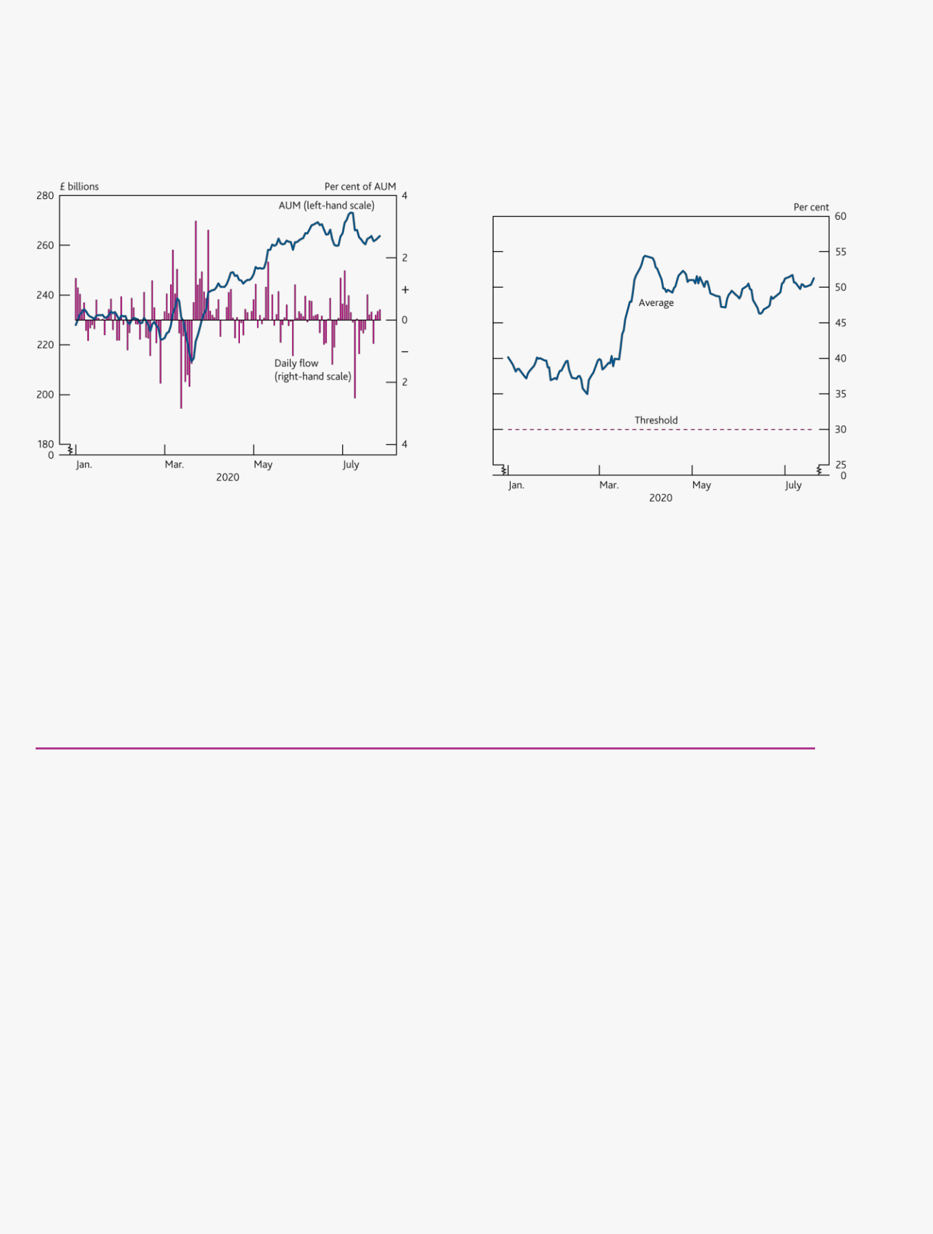

build up their buffers by selling illiquid CP and CD, compounding liquidity issues in these markets (**Chart B**). In turn, liquidity strains in these unsecured bank-funding markets put upward pressure on Libor rates (see Box 10).

|  |  |  |  |  |
| --- | --- | --- | --- | --- |
|  |  |  |  |  |
| **Chart A** Sterling-denominated MMFs saw large outflows |  | **Chart B** MMFs have significantly increased their liquidity | |  |
| during the ‘dash for cash’ |  | buffers to meet redemptions and avoid breaching the | |  |
| Sterling MMFs AUM and daily flows(a) |  | 30% liquidity threshold | |  |
|  |  | Weekly liquid assets of sterling-denominated LVNAV MMFs(a)(b) | |  |
|  |  |
|  |  |  |  |  |
|  |  |  |  |  |
|  |  |  |  |  |
|  |  |  |  |  |

Sources: Crane data and Bank calculations.

(a) Over 95% of the sample are prime (by AUM) and the remainder are public debt CNAVs.

Sources: Crane data, fund websites and Bank calculations.

1. Shows a sample of 11 LVNAV funds, which cover 59% of sterling-denominated MMFs.
2. For LVNAV and public debt CNAV MMFs, if weekly liquid assets fall below 30%, the MMF can only purchase assets that qualify as weekly liquid assets.

As volatility increased and outflows intensified, a number of EU-domiciled prime LVNAV MMFs came close to the 20 basis point threshold at which they would have to switch to variable pricing. Investors redeeming from these

funds might not have received their original investment in full as they would have expected.4 Although investors should be aware of this risk, in practice it may incentivise further withdrawals (for example if some investors have a

strong preference for the value to be stable).5

**Table 1** EU regulation since 2018 has permitted three types of MMF: public debt CNAV, LVNAV and VNAV

Features of European MMF structures

|  |  |  |  |  |
| --- | --- | --- | --- | --- |
|  | **Public debt CNAV** | **LVNAV** | **VNAV** |  |
| Pricing(a) | Constant | Constant if the amortised | Variable |  |
|  |  | NAV remains within |  |  |
|  |  | 20 basis points of the |  |  |
|  |  | mark-to-market or marked- |  |  |
|  |  | to-model NAV. Must convert |  |  |
|  |  | to variable if this limit is |  |  |
|  |  | exceeded. |  |  |
| Minimum daily/weekly | 10%/30% | 10%/30% | 7.5%/15% |  |
| liquidity requirements as |  |  |  |  |
| a percentage of assets |  |  |  |  |
|  |  |  |  |  |
| Liquidity tools, including | Must be considered if | Must be considered if | No requirement under EU |  |
| fees, gates or | weekly liquidity <30% of | weekly liquidity <30% of | MMF Regulation. Can apply |  |
| suspensions | assets and outflows >10% of | assets and outflows >10% of | as set out in the fund’s |  |
|  | assets in one day. | assets in one day. | prospectus and instrument, |  |
|  | Mandatory if weekly | Mandatory if weekly | and subject to requirements |  |
|  | liquidity <10% of assets. | liquidity <10% of assets. | in national law. |  |
|  |  |  |  |  |

Source: EU Money Market Fund Regulation (MMFR) (Regulation (EU No 2017/1131)).

(a) For Public debt CNAV and LVNAV funds the share price can be rounded to the nearest percentage point, or currency equivalent, eg £1.00 per unit, subject to the condition above for LVNAV funds. For VNAV funds, the share price can be rounded to the nearest basis point, or currency equivalent, eg £1.0000 per unit.



1. Investors may also receive more than they invested depending on market conditions.
2. Market participants invest their own cash or cash-like assets with MMFs precisely to avoid an internal cash management operation, and their accounting treatment of the investment relies on MMF values to be stable.

Financial Stability Report August 2020 Building the resilience of market-based finance 81



*The FPC therefore supports reviewing vulnerabilities posed by MMFs as part of the international post-Covid-19 reform agenda.*

The recent episode has highlighted the need to examine vulnerabilities from MMFs, particularly given investors’ reliance on MMFs and the potential UK financial stability implications from widespread fund suspensions.

Importantly, reform needs to be considered at the international level. While most investors in sterling-denominated MMFs are UK-based, the funds are largely domiciled in Ireland and Luxembourg. The Financial Stability Board alongside other regulatory authorities are carrying out a comprehensive review of resilience of the market-based financial system in the wake of the Covid-19 episode [(FSB (2020))](https://www.fsb.org/2020/07/fsb-sets-out-action-to-maintain-financial-stability-during-covid/). And the European Commission is due to review adequacy of existing regulation by July 2022. The Bank will continue to work with other authorities domestically and internationally to address vulnerabilities posed by MMFs and develop proposals for reform.

MMF units, as investment products, may be subject to losses or delays in repayment if risks crystallise. The EU rules for MMFs ― building on IOSCO recommendations of 2012 ― require fund managers to report on a number of metrics, including the maturity breakdown of the MMF’s portfolio, to all their investors at least weekly. In addition, any documents used for marketing must include a statement that the risk of loss of the principal is to be borne by the investor. More transparency around the conditions under which the risk can crystallise and disclosure to investors could enable investors to better assess the risks they are exposed to, via their investments in MMFs.

Any international review should include evaluating the effectiveness of post financial crisis reforms, including whether some aspects of those reforms may create undesirable incentives. For example, breaking the link between liquidity buffers and the prospect of boards applying liquidity tools, including suspensions, may help MMFs manage large redemptions in stress. And the uncertainty created by the possibility that LVNAV funds may switch to variable pricing should be looked at further. New proposals should be considered to the extent they can provide benefits, such as mitigating risks to financial stability, while taking into account costs, feasibility and ease of implementation.

There are also broader questions around the liquidity of some of the instruments that MMFs hold, especially given market participants’ expectations that MMF units are cash-like and generally redeemable on demand. Further analysis is needed on the CD and CP markets, given MMFs’ reliance on these instruments and the difficulties encountered in selling them during the March stress.

Financial Stability Report August 2020 Building the resilience of market-based finance 82

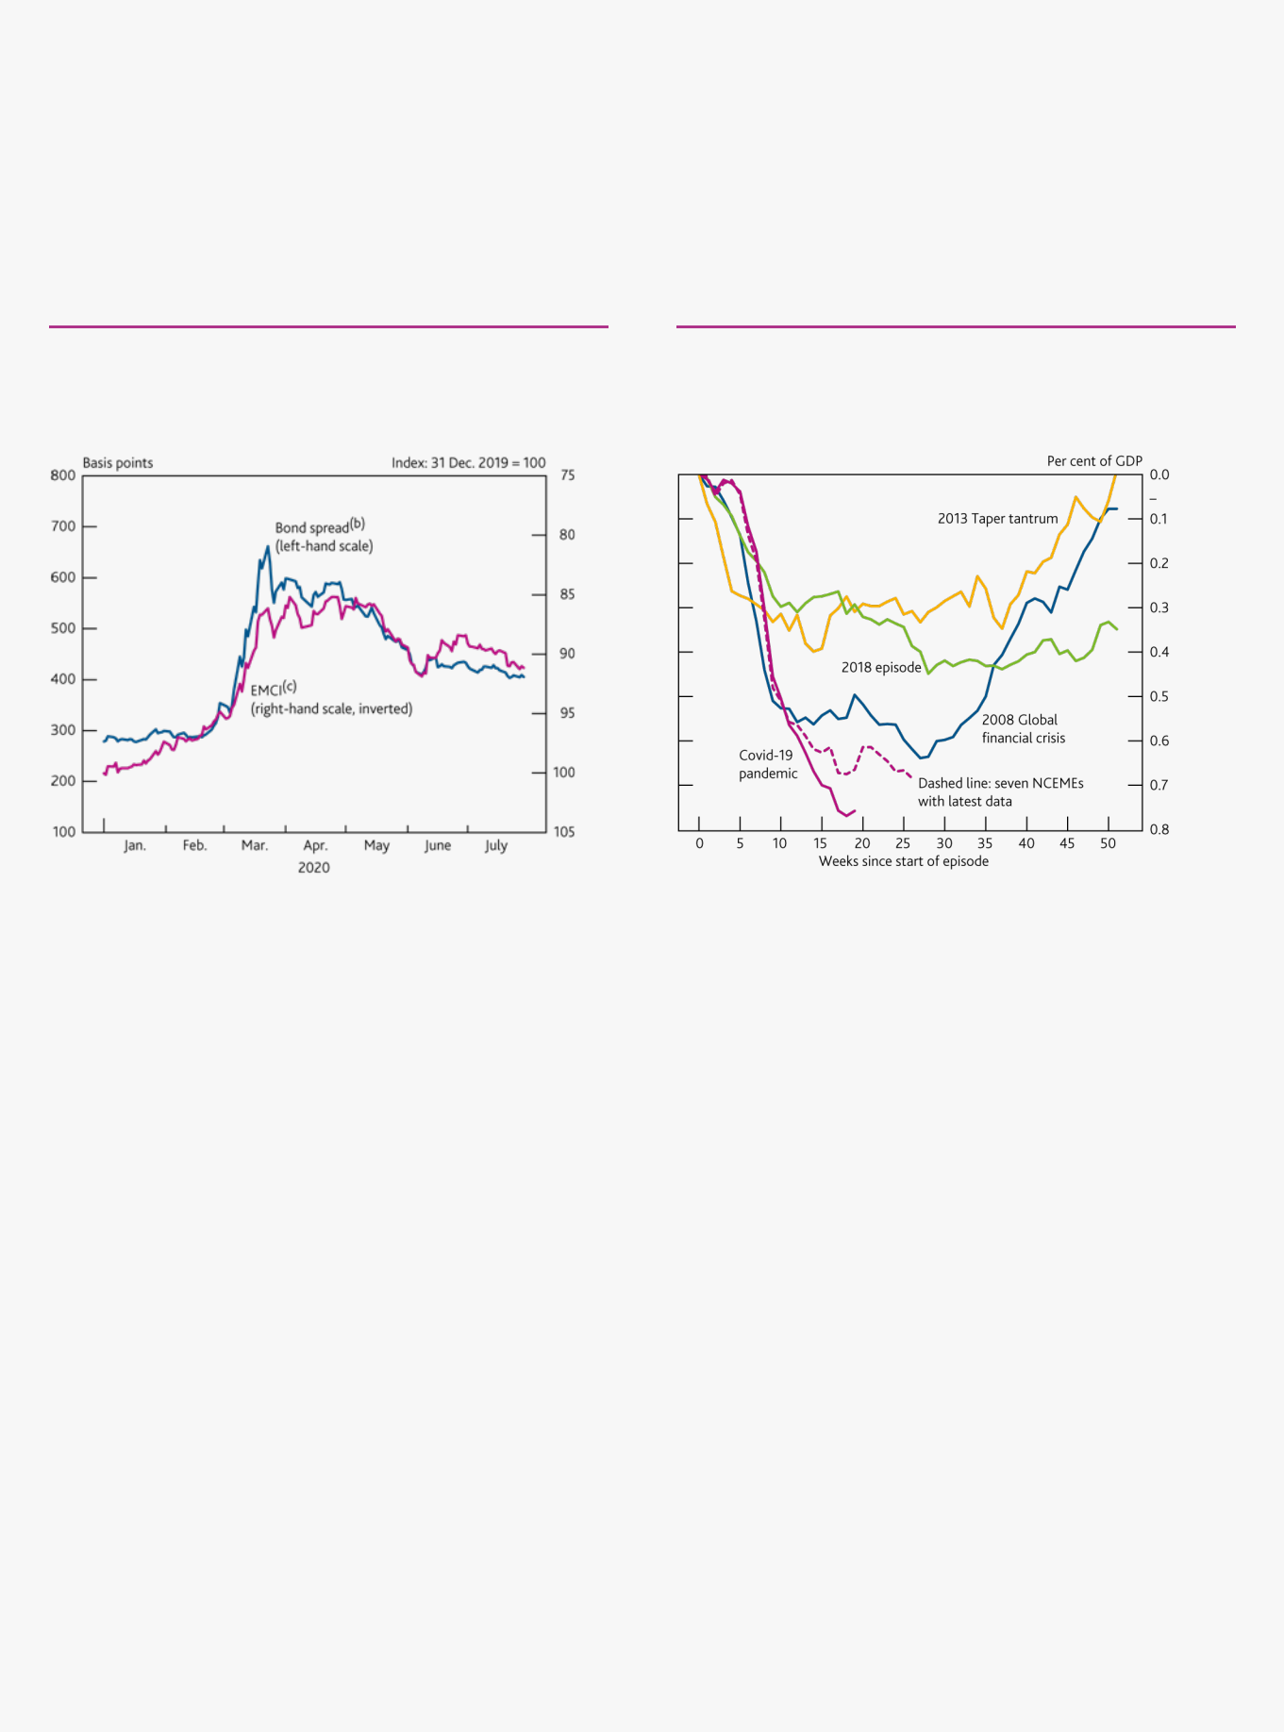

**Box 9**

**March’s sudden stop in capital flows to emerging markets**

During the turbulence in financial markets in March, financial conditions in emerging market economies aside from China (NCEMEs) came under particular pressure. 1 As concerns grew that NCEMEs would be hit hard by the spread of Covid-19, NCEME exchange rates depreciated and spreads on foreign currency sovereign bonds increased (**Chart A**). Yields on local currency bonds rose and the prices of emerging market (EM) equities fell sharply.

**Chart A** Emerging markets saw large falls in exchange rates and increases in bond spreads in March, which have only partly reversed

Spreads on EM dollar bonds (EMBIG) and EM currency index(a)

Sources: Eikon from Refinitiv, J.P. Morgan and Bank calculations.

1. Information has been obtained from sources believed to be reliable but J.P. Morgan does not warrant its completeness or accuracy. The Index is used with permission. The Index may not be copied, used, or distributed without J.P. Morgan's prior written approval. Copyright 2020, J.P. Morgan Chase & Co. All rights reserved.
2. J.P. Morgan composite emerging market bond index.
3. J.P. Morgan emerging market currency index.

**Chart B** NCEMEs also suffered sudden, large sales of bonds and equities by foreign investors

Weekly non-resident portfolio flows from 10 NCEMEs in recent

episodes(a)(b)(c)

Sources: Eikon from Refinitiv, IMF *World Economic Outlook* (*WEO*), Institute of International Finance and Bank calculations.

1. Ten NCEMEs are Brazil, Hungary, India, Indonesia, Mexico, Philippines, Poland, South Africa, Thailand and Turkey.
2. Seven countries with latest data are Brazil, Hungary, India, Indonesia, Philippines, South Africa and Thailand.
3. Start of episodes taken as 1 September 2008, 1 May 2013, 1 April 2018 and 17 January 2020 respectively.

During this episode, there were large-scale sales of NCEME equities and bonds by foreign investors. Weekly data suggested that the scale of these outflows of foreign portfolio capital was larger (both relative to GDP and the stock of foreign holdings of bonds and liabilities) than in the global financial crisis or in other recent episodes of market turbulence, such as the 2013 taper tantrum (**Chart B)**.

Different types of foreign investor — including pension funds and insurance companies as well as sovereign wealth funds (many of which are owned by oil producing countries) and hedge funds — could have been responsible for these portfolio outflows and there is little information available to identify their individual contributions. However, separate figures for outflows by investment funds are available. For the NCEMEs shown in **Chart B**, investment funds held less than a third of the stock of portfolio liabilities but the cumulative outflow to the end of April from these funds was around half the total portfolio outflows by foreign investors over this period. However, outflows from such funds only started a couple of weeks after large-scale portfolio outflows from NCEMEs began, so other types of portfolio investor appear to have been the initial cause of capital outflows from this group of countries.

These foreign portfolio flows make up only a part of total financial flows into or out of an economy. Information on the other components of overall financial flows — foreign direct investment (FDI) flows and foreign banking flows, as well as financial transactions by residents — is available for the first quarter of 2020 and shows a more nuanced picture than the stark view presented by the weekly portfolio figures. FDI flows, the least volatile source of external finance to NCEMEs, remained stable in 2020 Q1. As in the global financial crisis, portfolio flows were particularly sensitive to the shock (see [Eguren-Martin *et al* (2020))](https://www.bankofengland.co.uk/working-paper/2020/capital-flows-at-risk-push-pull-and-the-role-of-policy). Banking flows, which showed a sharp reversal during the

1. For a more detailed discussion of financial market developments during this period see recent speeches by Cunliffe, J (2020), [‘Financial System Resilience:](https://www.bankofengland.co.uk/speech/2020/jon-cunliffe-speech-at-investment-association) [lessons from a real stress’](https://www.bankofengland.co.uk/speech/2020/jon-cunliffe-speech-at-investment-association) and by Hauser, A (2020), [‘Seven moments in Spring: Covid-19, financial markets and the Bank of England’s operations’](https://www.bankofengland.co.uk/speech/2020/andrew-hauser-speech-hosted-by-bloomberg-via-webinar).

Financial Stability Report August 2020 Building the resilience of market-based finance 83

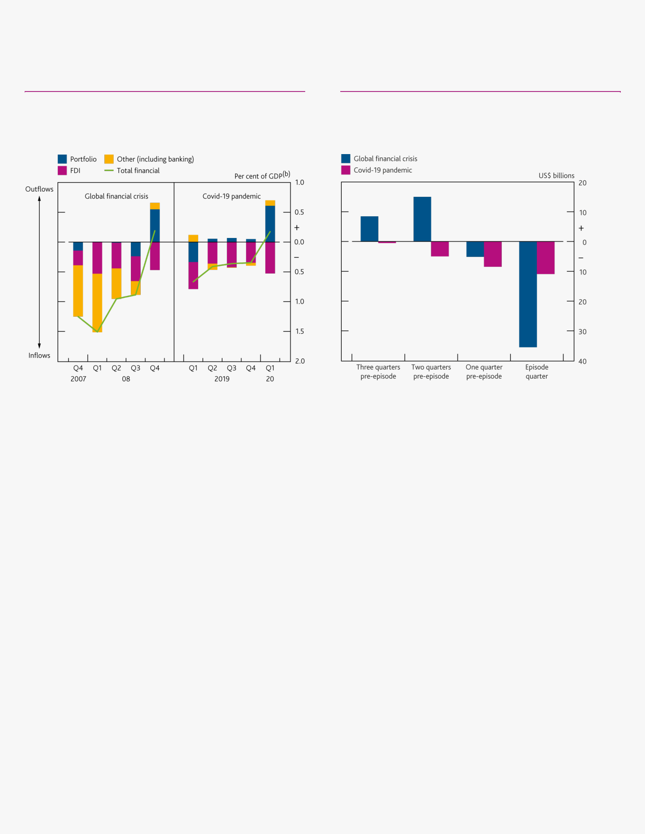

global financial crisis, appear to have been more stable during 2020 Q1 (**Chart C)**. The smaller role of banking flows during the recent period of stress was also seen in UK banks’ foreign claims, which fell by much less than during the global financial crisis (**Chart D**).

**Chart C** Banking flows have been more stable than in the global financial crisis

Financial flows (from balance of payments) to/from 10 large NCEMEs in two episodes(a)

**Chart D** UK banks’ claims on NCEMEs have fallen by much less than in the global financial crisis

Quarterly change in UK banks’ consolidated claims on 10 large NCEMEs(a)(b)

Sources: Eikon from Refinitiv, IMF, national sources and Bank calculations.

1. Brazil, Hungary, India, Indonesia, Mexico, Philippines, Poland, South Africa, Thailand and Turkey.
2. Four-quarter GDP to 2008 Q3 and 2019 Q4, respectively.

Sources: Bank of England and Bank calculations.

1. Brazil, Hungary, India, Indonesia, Mexico, Philippines, Poland, South Africa, Thailand and Turkey.
2. Respective 'episode quarters' used are 2008 Q4 and 2020 Q1.

In part, these differences reflect the greater role since the financial crisis of market-based finance and the reduced significance of international banks in providing external finance to emerging markets.2 The more limited reaction seen in banking flows may also reflect the strengthening in the capital positions of banks, both in the UK and internationally, since 2008. The differing nature of the shocks in the two episodes may also be a factor: in contrast to the Covid-19 shock, the global financial crisis was a shock that originated in the financial system and, in particular, directly affected international banks.

**The role of dollar funding issues and sales of local currency bonds**

The move by a wide range of investors to sell risky assets to raise dollars during the ‘dash for cash’ episode (see performance of the UK financial system during the Covid-19 pandemic chapter) contributed to the wave of portfolio outflows from NCEMEs. The increased general demand for dollars made it more difficult for emerging markets to access dollars themselves, putting pressure on their exchange rates and causing some central banks to intervene to support their currencies. The risk to governments and corporates from unhedged dollar borrowing is seen as one of the main vulnerabilities facing some NCEMEs.3 To reduce their currency risk, many emerging market governments have also been borrowing through local currency bond markets, leaving foreign investors holding the currency risk on these bonds. However, the latest episode saw outflows of foreign investors from both foreign currency and local currency markets (**Chart E**), as foreign investors in local currency bonds reacted to the losses they had incurred from weakening exchange rates by selling their holdings.4

The extensive policy actions taken by advanced and emerging economy central banks and governments in late March and early April appear to have helped to stabilise markets: spreads on emerging market dollar bonds and yields on local currency bonds have partially reversed and emerging market currencies have strengthened

1. The share of market-based finance (portfolio liabilities) in EME external liabilities rose from 23% in 2008 to 32% in 2017, while the share provided by bank loans fell from 36% to 24% over this period. See Carney, M (2019), [‘Pull, push, pipes: sustainable capital flows for a new world order’](https://www.bankofengland.co.uk/speech/2019/mark-carney-keynote-remarks-at-the-2019-institute-of-international-finance-spring-membership-meeting) for further details.
2. See the recent [CGFS Report](https://www.bis.org/publ/cgfs65.htm) on dollar funding for further details of issues around dollar funding for both advanced and emerging economies.
3. See [BIS Bulletin No. 5](https://www.bis.org/publ/bisbull05.htm) and [BIS Bulletin No. 18](https://www.bis.org/publ/bisbull18.htm) for fuller discussion of recent movements in EME bond markets and the link with EME exchange rates.

Financial Stability Report August 2020 Building the resilience of market-based finance 84

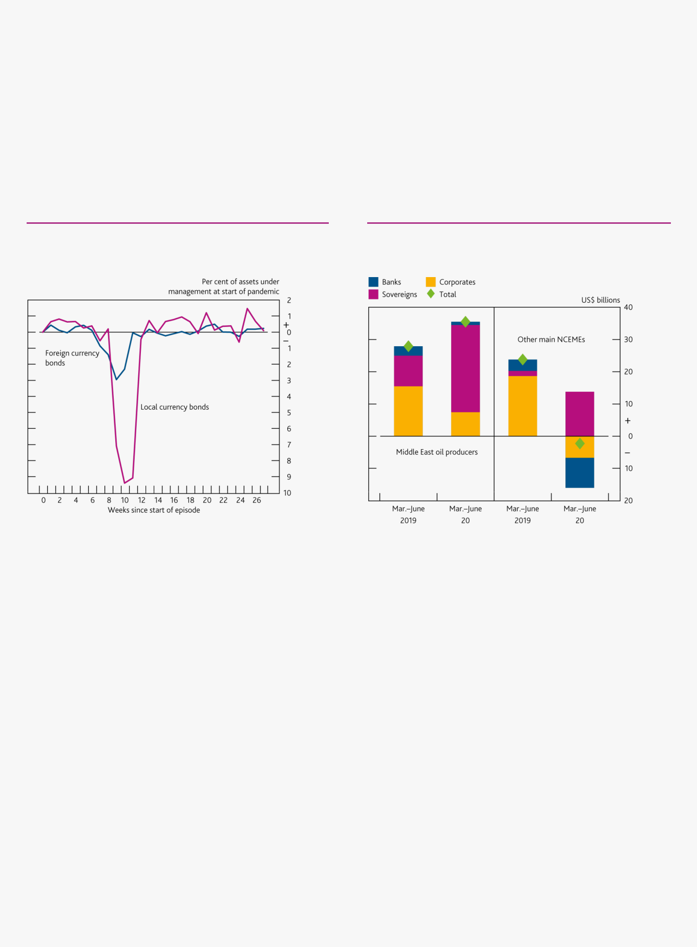

(**Chart A**). It is unclear to what extent this is due to the easing of dollar funding pressures rather than other factors such as greater bond market liquidity. The Federal Reserve Board reactivated its dollar swap lines, including to two larger emerging markets, Brazil and Mexico, and set up a new facility, allowing foreign central banks to repo their holdings of US Treasury bonds in exchange for cash. These moves were intended to reduce central banks’ need to sell US assets to support their currencies, so helping to ease pressure on the US Treasury market. Although EMEs have made only limited use of these facilities — Brazil has so far not used its dollar swap line, while Mexico made limited use of it — they are likely to have acted as a backstop, helping to stabilise markets. Separately, several NCEME central banks have set up purchase programmes for their own government bonds. Local currency yields have fallen back and exchange rates have broadly stabilised, suggesting that the combination of these purchase programmes and other policy actions has helped to improve market sentiment.5

**Chart E** Both NCEME local currency and foreign currency bond funds saw large outflows

Weekly bond flows(a)(b)

**Chart F** Much recent net bond issuance by NCEMEs has been sovereign bonds from Middle East oil producers

Net bond issuance (all currencies)(a)

Sources: EPFR Global and Bank calculations.

1. First week of Covid-19 pandemic taken as week ending 22 January 2020.
2. All countries in EPFR Global’s emerging markets grouping, excluding China, Korea and Taiwan.

Sources: Refinitiv — Deals Business Intelligence and Bank calculations.

1. Middle East oil producers are: Kuwait, Oman, Qatar, Saud Arabia and UAE.

Other main NCEMEs are: Argentina, Brazil, Chile, Colombia, Hungary, India, Indonesia, Malaysia, Mexico, Nigeria, Philippines, Poland, Russia, South Africa, Thailand and Turkey.

However, the improvement in sentiment may still be fragile. Bond issuance by emerging markets has recovered since March but net issuance (gross issuance less maturing bonds) has been concentrated in sovereign bonds, particularly those issued by Middle East oil producers. Total net issuance by other major NCEMEs was negative in the four months between March and June (**Chart F**). Non-resident portfolio flows and fund flows have stabilised but have fluctuated around zero since late May. Given that Covid-19 is already leading to a sharp slowdown in NCEME economic growth and Covid-19 cases have continued to grow rapidly in several NCEMEs, it is possible that NCEMEs could see further capital outflows from portfolio investors if general risk sentiment were to deteriorate again, or if their economic prospects were to be marked down further. This would have a direct impact on those UK financial institutions with exposures to these markets. It would also have a broader impact as weaker NCEME demand for UK exports would affect the UK’s own economic prospects.

5 See [BIS Bulletin No. 23](https://www.bis.org/publ/bisbull23.htm) for a more detailed discussion.

Financial Stability Report August 2020 Building the resilience of market-based finance 85



**Box 10**

**Accelerating the transition from Libor as end-2021 approaches**

It is essential to end reliance on Libor benchmarks before end-2021. After that point, Libor benchmarks could cease to be available at short notice.

Market volatility earlier this year highlighted the long-standing weaknesses of Libor, and authorities and industry working groups have worked to revise plans in response to the temporary disruption from Covid-19, which seek to ensure that the transition from Libor is delivered on that timeline. Market participants must accelerate and execute plans to deliver Libor transition, including the important milestones set out by industry working groups over the coming months.

Libor remains one of the predominant interest rate benchmarks used in global financial markets. It is estimated that about US$400 trillion of financial contracts reference Libor rates, across five major currencies and a range of tenors. Due to long-standing weaknesses in the way these rates are derived, continued use is no longer a sustainable model, with Libor’s continued production only guaranteed until the end of 2021. After that point, Libor benchmarks could cease to be available at short notice. To reduce the risk of disorderly outcomes, significant work is underway across global markets to transition to use of alternative reference rates in new and existing contracts, and to introduce robust and clearly defined fallback arrangements for those that continue to rely on Libor.

As covered in the [May *interim Report*,](https://www.bankofengland.co.uk/report/2020/monetary-policy-report-financial-stability-report-may-2020) market volatility earlier this year highlighted the long-standing weaknesses of Libor. During March, the limited market transactions underpinning Libor benchmarks left these rates almost entirely reliant on expert judgement from panel banks. Libor rates rose in the second half of March, increasing costs to borrowers with Libor-linked contracts. For those borrowers, this increase offset the positive impact of reductions in central bank policy rates. This has reinforced the importance of the transition to alternative reference rates in advance of end-2021.

As a result, international authorities and industry working groups have been clear that transition from Libor in advance of end-2021 remains essential, and have worked to revise plans to meet that timeline despite the temporary disruption to progress from Covid-19. These key messages were emphasised last month in a [statement](https://www.fsb.org/2020/07/fsb-statement-on-the-impact-of-covid-19-on-global-benchmark-reform/) from the Financial Stability Board, reflecting the priority placed on the transition by the G20, and in speeches from the [Governor of the Bank of England](https://www.bankofengland.co.uk/speech/2020/andrew-bailey-speech-as-part-webinar-hosted-by-the-boe-and-the-frb-of-ny-libor-entering-the-endgame) and the [President of the Federal Reserve Bank of New York.](https://www.newyorkfed.org/newsevents/speeches/2020/wil200713) In addition, industry working groups have demonstrated their continued commitment through clear communication of milestones and best practices for transition.

**Key priorities for the transition away from Libor in 2020**

Market participants and authorities must build on the work to revise plans in light of Covid-19 to deliver on Libor transition in the time available and lay the foundations for an acceleration in the second half of this year. All parties will need to work together to execute those plans at pace to ensure the risks of continued reliance on Libor are removed in advance of end-2021. In the UK, the main areas of focus this year are:

moving new business onto alternative risk-free rates, with reference to recommendations set by industry

working groups, particularly in loan markets where new markets remain nascent;

continuing progress in active conversion of legacy Libor-referencing contracts to alternative rates; and ensuring widespread adoption of appropriate fallback language in derivatives contracts, such as the

forthcoming International Swaps and Derivatives Association (ISDA) fallback wording and appropriate changes to central counterparties’ rulebooks, to mitigate risks.

Financial Stability Report August 2020 Building the resilience of market-based finance 86



The remainder of this box highlights key developments in delivering our transition strategy since the last *Report*, both in building new markets in risk-free rates, and in addressing the stock of legacy Libor-linked contracts.

**Progress in delivering the Libor transition strategy**

**Figure A** below summarises the main steps required from market participants and authorities to deliver an orderly transition from Libor. The first two steps of this strategy are complete, and looking ahead, the focus remains on deepening new risk-free rate markets (step 3), and addressing the stock of legacy Libor-linked contracts (steps 4–6), consistent with the key priorities set out above.

**Figure A** The Libor transition strategy

*Industry working groups continue to drive momentum towards transition milestones.*

Industry working groups have focused efforts on ensuring that market participants cease new Libor-linked issuance (step 3), and on facilitating conversion of legacy contracts (step 4). In the UK, the Working Group on Sterling Risk-Free Reference Rates (RFRWG), alongside the Financial Conduct Authority (FCA) and the Bank published a joint statement on [25 March,](https://www.fca.org.uk/news/statements/impact-coronavirus-firms-libor-transition-plans) followed by a further RFRWG statement on [29 April,](https://www.bankofengland.co.uk/-/media/boe/files/markets/benchmarks/rfr/rfrwg-further-statement-on-the-impact-of-coronavirus-on-timeline-for-firms-libor-transition-plans.pdf?la=en&hash=68299592AF83B04E3BF60BA3209AA9A73522E9D4) acknowledging the temporary impact of Covid-19 on progress, revising milestones, and emphasising that firms must increase the urgency with which they carry out their Libor transition programmes in order to meet the end-2021 deadline. Following this, on 28 July, the RFRWG published a suite of materials, including an updated version of its priorities and roadmap for 2020–21 which set out more granular milestones to manage transition away from sterling Libor-linked products by end-2021. The RFRWG’s [2020–21 updated priorities](https://www.bankofengland.co.uk/-/media/boe/files/markets/benchmarks/rfr/rfr-working-group-roadmap.pdf?la=en&hash=92D95DFA056D7475CE395B64AA1F6A099DA6AC5D) are:

By the end of 2021 Q1, lenders and borrowers should have taken necessary steps to cease issuance of Libor-linked loan products that expire after end-2021, including making non-Libor alternatives available and

incorporating contractual conversion mechanisms in new or refinanced Libor products by the end of 2020 Q3. During 2020, take steps to promote and enable widespread use of Sterling Overnight Index Average (SONIA)

compounded in arrears, noting that the Bank began publishing a compounded SONIA index on 3 August. Take steps to enable a further shift of volumes from sterling Libor to SONIA in derivatives markets.

Establish a clear framework to manage transition of legacy Libor products, to accelerate reduction of stock in sterling Libor contracts by the end of 2021 Q1, and complete active conversion where viable by the end of

2021 Q2–3.

Provide market input on issues around ‘tough legacy’ Libor contracts.

In the US, the Alternative Reference Rates Committee (ARRC) has also made a series of announcements on Libor transition in recent months. These include a set of key objectives, an updated transition timeline for 2021, and a set of recommended best practices and active steps that firms should take to transition away from Libor and towards the preferred risk-free rate for US dollars, the Secured Overnight Financing Rate. The ARRC’s [best practice](https://www.newyorkfed.org/medialibrary/Microsites/arrc/files/2020/ARRC-Best-Practices.pdf) stresses the importance of including ARRC-recommended fallbacks, or substantially similar language into contracts as soon as possible, specifying replacement rates for Libor in contracts at least six months in advance of when they would be effective, and ending the use of Libor in new contracts.

*Authorities and markets are increasingly focused on delivering the end-game for legacy Libor contracts.*

In parallel to the urgent and continuing work to build new markets in risk-free rates (step 3), as end-2021 nears, authorities’ and markets’ focus has increasingly shifted towards the ‘end-game’ — addressing the stock of legacy Libor-linked contracts (focusing particularly on steps 5 and 6 in **Figure A**).

Financial Stability Report August 2020 Building the resilience of market-based finance 87



Since the [May *interim Report*,](https://www.bankofengland.co.uk/report/2020/monetary-policy-report-financial-stability-report-may-2020) there have been two key developments in preparing for the end-game for legacy contracts. These represent significant steps forward in delivering the overall Libor transition strategy.

1) ISDA to publish fallback language for legacy Libor-linked derivatives contracts (step 5)

In July, the ISDA Board [announced](https://www.isda.org/2020/07/29/isda-board-statement-on-adherence-to-the-ibor-fallback-protocol/) that they will soon publish fallback language and a protocol for legacy Libor-linked derivative contracts. The ISDA fallback language will create a readily available avenue to adopt fallbacks into most derivatives contracts and replace Libor exposures with risk-free rate linked alternatives, once the fallbacks have been triggered. The Financial Policy Committee (FPC) welcomes the forthcoming publication of this language, noting that the impact of the fallbacks and protocol will only be significant if there is widespread take-up across the market. The FPC also encourages central counterparties to ensure their own rulebooks contain equivalent provisions to cover cleared derivatives. Looking ahead, firms should seek to incorporate appropriate fallback language into their legacy derivatives contracts, or otherwise give due consideration to how they are mitigating the risks of Libor being deemed unrepresentative, or ceasing to be available.

1. UK Government announces intention to legislate to address ‘tough legacy’ contracts (step 6)

It has been recognised for some time that there will be a narrow pool of ‘tough legacy’ Libor contracts that genuinely have no or only inappropriate alternatives and no realistic means of being renegotiated or amended ahead of end-2021. In May, the RFRWG’s Tough Legacy Taskforce published a report in which its market participant members concluded that, while firms should focus primarily on active transition, there was a case for the

UK Government to consider a legislative solution to help address the associated risks of market disruption where contracts cannot be converted.

On 23 June 2020, the UK Government [announced](https://www.parliament.uk/business/publications/written-questions-answers-statements/written-statement/Commons/2020-06-23/HCWS307/) its intention to legislate to strengthen the current regulatory

framework for critical benchmarks, such as Libor.1 The legislation, which the Government intends to introduce via the Financial Services Bill, will ensure that the FCA has the appropriate regulatory powers to manage and direct any wind-down period prior to eventual Libor cessation. In particular, the legislation would give the FCA the power to require an administrator to change the methodology of a critical benchmark. The power could be used in circumstances where the FCA has found that the benchmark is unrepresentative and that its representativeness will not be restored, in order to protect consumers and/or market integrity. These steps are intended specifically to address risks relating to the narrow pool of ‘tough legacy’ contracts.

The UK Government reiterated that contractual parties who can transition away from Libor should do so on terms that they themselves agree with their counterparties. This provides the best route to certainty for parties to contracts referencing Libor. By contrast, those who rely on regulatory action, enabled by the legislation that the Government plans to bring forward, will not have control over the economic terms of that action — and it may not be able to address all issues, or be practicable in all circumstances.

Separately, in the European Union (EU), the European Commission (EC) also recently published a [proposal](https://ec.europa.eu/finance/docs/law/200724-benchmarks-review-proposal_en.pdf) to amend the Benchmarks Regulation to provide for the EC to have a power to designate a replacement benchmark once it becomes clear that the cessation of certain benchmarks would result in significant disruption to the

functioning of EU financial markets.2 The EC has stated that the proposal aims to create a new framework to have a statutory replacement rate in place by the time Libor is no longer in use and that such rate would take the place of Libor in all contracts and financial instruments that mature after 2021.

**Looking ahead: next steps on Libor transition**

The Prudential Regulation Authority and FCA expect progress from firms against transition milestones across all key currencies, and expect to scrutinise what alternative risk mitigation has been put in place where industry best practice or timelines are not being met. The FPC will also continue to monitor progress closely and keep under review what further steps may be necessary in light of this as the end of 2021 approaches.



1. The amendments will be introduced to the Benchmarks Regulation 2016/1011 as amended by the Benchmarks (Amendment) (EU Exit) Regulations 2018.
2. [Benchmarks Regulation (EU) 2016/1011.](https://eur-lex.europa.eu/legal-content/EN/TXT/?uri=CELEX%3A32016R1011)

Financial Stability Report August 2020 Financial stability implications of the UK’s changing relationship with the EU 88

Financial stability implications of the UK’s changing relationship with the EU

The UK left the EU with a Withdrawal Agreement on 31 January 2020, entering an 11-month transition period. Negotiations on the shape of the future relationship between the UK and the EU are continuing.

The UK has completed its equivalence assessment of the EU’s financial services regulatory and supervisory regime. The EU has been undertaking equivalence assessments of the UK’s regime, but has stated it will not assess the UK in some areas, including the direct provision of cross-border investment banking services, in the short or medium term.

Most risks to UK financial stability that could arise from disruption to cross-border financial services should the transition period end without the UK and EU agreeing equivalence or other arrangements for financial services, have been mitigated. This reflects extensive preparations made by authorities and the private sector.

UK financial institutions continue to prepare to ensure the uninterrupted flow of services to EU firms and consumers after the end of the transition period. Thus far the Covid-19 pandemic has not materially delayed preparations in the financial sector overall.

Further action is needed to minimise disruption to cross-border financial services in some areas. Although such disruption would primarily affect EU households and businesses, it could increase volatility and spill back to the UK in ways that cannot be fully anticipated or mitigated.

The European Commission is considering granting time-limited equivalence of the regulatory framework for UK central counterparties (CCPs). But new EU legislation introduces greater complexity to the steps required before UK CPPs can be granted recognition. Disruption to cleared derivatives markets can be avoided by ensuring clarity on equivalence and recognition for UK CCPs by the end of September.

Irrespective of the particular form of the UK’s future relationship with the EU, and consistent with its statutory responsibilities, the FPC will remain committed to the implementation of robust prudential standards in the UK. This will require maintaining a level of resilience that is at least as great as that currently planned, which itself exceeds that required by international baseline standards, as well as maintaining UK authorities’ ability to manage UK financial stability risks.

Financial Stability Report August 2020 Financial stability implications of the UK’s changing relationship with the EU 89

*Negotiations on the shape of the future relationship are continuing. The UK and EU have also been undertaking equivalence assessments of each other’s financial services regulatory and supervisory regimes.*

The UK left the EU with a Withdrawal Agreement on 31 January 2020, entering an 11-month transition period that will end on 31 December 2020. Negotiations on a free trade agreement (FTA) covering the broad arrangements for trading goods and services between the UK and EU are continuing.

The UK and EU have also been undertaking assessments of each others’ regimes to inform future equivalence decisions. There are around 40 provisions in EU and UK legislation under which the supervisory and regulatory arrangements of a jurisdiction could be deemed equivalent for regulatory purposes. Some of these provisions facilitate cross-border financial services activity specified by the relevant legislation, others allow preferential treatment in accessing equivalent jurisdictions.

Equivalence determinations under certain provisions would mitigate some risks of disruption at the end of the transition period — set out below. However, risks to stability could remain thereafter from the potential for equivalence to be withdrawn at short notice. As a result, while respecting the ability of either jurisdiction to take equivalence decisions autonomously, the UK government has sought to include provisions for the structured withdrawal of equivalence as part of the broader FTA negotiations.

The UK’s equivalence assessment process is complete. The EU has stated that it will not assess the UK under nine provisions in the short or medium term, including MiFIR Article 47, which covers the direct provision of investment banking services across borders.1, 2 In this area, the EU has said it will not initiate an equivalence assessment before changes to the EU legal framework for investment firms have entered into force in the middle of 2021. This means that residual risks of disruption to cross-border banking services and derivatives transactions at the end of the transition period will not be mitigated by an EU equivalence decision under MiFIR Article 47.

Irrespective of the particular form of the UK’s future relationship with the EU, and consistent with its statutory responsibilities, the FPC will remain committed to the implementation of robust prudential standards in the UK. This will require maintaining a level of resilience that is at least as great as that currently planned, which itself exceeds that required by international baseline standards, as well as maintaining UK authorities’ ability to manage UK financial stability risks.

*Most risks to UK financial stability that could arise from disruption to cross-border financial services should the transition period end without the UK and EU agreeing equivalence or other arrangements for financial services, have been mitigated.*

The FPC reviewed its checklist of actions that would mitigate risks of disruption at the end of the transition period to important financial services used by households and businesses to support their economic activity if no equivalence or other further arrangements were in place for cross-border trade in financial services (**Table F.A**). The FPC also reviewed other risks that could cause some, albeit less material, disruption to activity if they are not mitigated (**Table F.B**).

Legislation creating temporary permissions and recognitions regimes is in place and other preparations have been made by UK authorities to ensure that UK households and businesses will be able to use existing and new services from EU financial institutions for a period after the end of 2020. Further legislation in relation to retained EU law is required to ensure the Bank of England can provide certain types of emergency lending, should it be needed in future.

UK financial institutions continue to prepare to ensure the continued flow of services to EU users, including by onboarding clients to their EU entities. They should continue to do so to further reduce risks of disruption. The Covid-19 pandemic has limited some people moves and reduced client engagement. Thus far this has not materially delayed preparations in the financial sector overall.

1. See [European Commission: ‘Getting ready for changes’,](https://ec.europa.eu/info/sites/info/files/brexit_files/info_site/com_2020_324_2_communication_from_commission_to_inst_en_0.pdf) 7 July 2020, pages 13–14.
2. Markets in Financial Instruments Regulation.

Financial Stability Report August 2020 Financial stability implications of the UK’s changing relationship with the EU 90

UK CCPs await clarity from EU authorities on future recognition and equivalence to allow them to continue servicing EU clearing members after the end of 2020. Disruption to cleared derivatives markets can be avoided by ensuring clarity before the end of September, when UK CCPs may have to begin offboarding EU clearing members in order to reduce the risk of material market disruption and to respect notice periods in CCP rulebooks.

The European Commission is considering granting time-limited equivalence of the regulatory framework for

UK CCPs. However, as yet incomplete amendments to the EU legislative framework in which third -country CCPs are recognised, known as ‘EMIR 2.2’, add complexity to the process and additional steps are required to grant recognition of UK CPPs. The Bank and European Securities and Markets Authority (ESMA) must negotiate a new co-operation agreement. And EMIR 2.2 requires third-country CCPs to be tiered according to whether they are, or are likely to become, systemically important to the financial stability of the EU or of one or more of its member states, or otherwise non-systemic.

If the new rules on tiering are in place by the end of September, UK CCPs must be tiered before recognition can be granted. If they are not in place, recognition could be granted on a temporary basis without tiering. However, if the rules come into force later this year, there is considerable uncertainty as to whether the temporary recognition of the untiered CCPs would remain valid, meaning risks of disruption would return in the absence of a further tiered recognition decision.

The FPC continues to judge that most risks to financial stability that could arise from disruption to cross-border financial services have been mitigated. However, some disruption is possible. Although such disruption would primarily affect EU households and businesses, it could increase volatility and spill back to the UK in ways that cannot be fully anticipated or mitigated. The FPC will continue to monitor progress in mitigating actions.

Financial Stability Report August 2020 Financial stability implications of the UK’s changing relationship with the EU 91

**Table F.A** Checklist of actions to avoid disruption to end-users of financial services at the end of the transition period

This checklist reflects the risk of disruption to end- users including households and companies if no further arrangements are put in place for cross-border trade in financial services for the end of the transition period on 31 December 2020. The risk assessment takes account of progress made in mitigating any risks. It assesses risks of disruption to end-users of financial services in the UK and, because the impact could spill back, also to end-users in the EU.(a)

Risks of disruption are categorised as **low**, **medium** or **high**. Arrows reflect developments since the FPC’s previously published checklist alongside the March 2020 [Financial Policy Summary.](https://www.bankofengland.co.uk/financial-policy-summary-and-record/2020/march-2020) **Blue text** is news since then.

The checklist is not a comprehensive assessment of risks to economic activity arising from the end of the transition period. It covers only the risks to activity that could stem from disruption to provision of cross-border financial services.

|  |  |  |  |  |
| --- | --- | --- | --- | --- |
|  | Risk to UK | Risk to EU |  |  |
|  |  |  |  |  |
|  |  |  | The passage of the EU (Withdrawal) Act 2018 and secondary legislation has |  |
| **Ensure a** |  |  | ensured that an effective framework for the regulation of financial services will |  |
| **UK legal and** |  |  | be in place, and that EU financial services companies can continue to serve |  |
|  |  | UK customers. |  |
| **regulatory** |  |  |  |
|  |  |  |  |
| **framework is** |  |  | Some secondary legislation is still required to ensure new EU legislation and |  |
| **in place** |  |  | provisions coming into force in 2020 can operate effectively following the end of |  |
|  |  |  | the transition period. Further legislation in relation to retained EU law is required to |  |
|  |  |  | ensure the Bank of England can provide certain types of emergency lending, should |  |
|  |  |  | it be needed in future. |  |
|  |  |  |  |  |
|  |  |  | The UK Government has legislated to ensure that the 16 million insurance policies |  |
|  |  |  | that UK households and businesses have with EU insurance companies can |  |
|  |  |  | continue to be serviced after the end of the transition period. |  |
| **Insurance** |  |  | UK insurance companies have restructured their business in order to service the |  |
| **contracts** |  |  | vast majority of their £ 60 billion of EU liabilities. They plan to continue to |  |
|  |  |  | progress restructuring of the £5 billion liability remaining through 2020. The |  |
|  |  |  | European Insurance and Occupational Pensions Authority has published |  |
|  |  |  | recommendations to national authorities supporting recognition or facilitation of |  |
|  |  |  | UK insurance companies’ continued servicing of EU contracts at the end of the |  |
|  |  |  | transition period. |  |
|  |  |  |  |  |
|  |  |  | Co-operation agreements between the Financial Conduct Authority (FCA), |  |
|  |  |  | ESMA and EU National Competent Authorities have been agreed, and the FCA and |  |
|  |  |  | ESMA have confirmed that they will apply from the end of the transition period. |  |
| **Asset** |  |  | This enables EU asset managers to delegate the management of their assets to |  |
|  |  | the UK. |  |
| **management** |  |  |  |
|  |  | The UK Government has legislated for EU asset management firms to continue |  |
|  |  |  |  |
|  |  |  | operating and marketing in the UK. And to operate in the EU, the largest UK asset |  |
|  |  |  | managers have completed their establishment of EU authorised management |  |
|  |  |  | companies. |  |
|  |  |  |  |  |
|  |  |  | The UK Government has legislated to ensure that UK households and businesses |  |
|  |  |  | can continue to be served by EU-based banks after the end of the transition period. |  |
|  |  |  | EU authorities have not taken similar action. As a result, major UK-based banks are |  |
|  |  |  | transferring their EU clients to subsidiaries in the EU so that they can continue |  |
|  |  |  | providing services to them. All material subsidiaries are now authorised, fully |  |
|  |  |  | operational and trading. |  |
|  |  |  | Firms continue to build the capacity of their EU entities. On average, about |  |
| **Banking** |  |  | two thirds of clients, including larger clients which represent a greater share of |  |
|  |  | activity, of major UK-based banks have now completed the necessary |  |
| **services** |  |  | documentation to enter into derivative trades with the EU entities. The number of |  |
|  |  |  | clients actively trading in the new entities is materially lower. Some operational |  |
|  |  |  | risks therefore remain, including if many clients seek to migrate to the EU entities |  |
|  |  |  | in a short period of time. These could amplify any other disruption in the market. |  |
|  |  |  | The EU has stated that in the short to medium term it will not assess the |  |
|  |  |  | equivalence of the UK’s regulatory and supervisory regime to its own for the |  |
|  |  |  | purposes of MiFIR Article 47, which covers investment services. This would have |  |
|  |  |  | allowed for material cross-border access for investment services, further reducing |  |
|  |  |  | the residual risk of disruption. |  |
|  |  |  |  |  |



Financial Stability Report August 2020 Financial stability implications of the UK’s changing relationship with the EU 92

|  |  |  |  |  |
| --- | --- | --- | --- | --- |
|  |  |  | Certain ‘lifecycle’(b) events may not be able to be performed on UK/EEA uncleared |  |
|  |  |  | derivative contracts after the end of the transition period. This could affect |  |
|  |  |  | £17 trillion of uncleared derivative contracts between the EU and UK, of which |  |
|  |  |  | £12 trillion is currently due to mature after 31 December 2020. In the absence of |  |
|  |  |  | mitigating actions, this could compromise the ability of derivatives users to manage |  |
| **Over-the-** |  |  | risks. |  |
|  |  | The UK Government has legislated to ensure that EU banks can continue to |  |
| **counter (OTC)** |  |  |  |
|  |  | perform lifecycle events on contracts they have with UK businesses. The European |  |
| **derivative** |  |  |  |
|  |  | Commission has not reciprocated for UK-based banks’ contracts with |  |
| **contracts** |  |  | EU businesses. Many temporary national regimes which would have enabled the |  |
| **(uncleared)** |  |  | performance of lifecycle events if the UK had left the EU without a Withdrawal |  |
|  |  |  | Agreement, will not be available at the end of the transition period. Some |  |
|  |  |  | EU member states have permanent national regimes which could enable lifecycle |  |
|  |  |  | events on certain contracts to be performed. |  |
|  |  |  | The EU has stated that in the short to medium term it will not assess the |  |
|  |  |  | equivalence of the UK’s regulatory and supervisory regime to its own for the |  |
|  |  |  | purposes of MiFIR Article 47, which covers investment services. This would have |  |
|  |  |  | mitigated risks of disruption to lifecycle events on the majority of contracts. |  |
|  |  |  |  |  |
|  |  |  | The UK Government has legislated to ensure that UK businesses can continue to |  |
|  |  |  | use clearing services provided by EU-based clearing houses. |  |
|  |  |  | To continue servicing EU clearing members after the end of the transition period, |  |
|  |  |  | the UK and UK CCPs will respectively require either permanent or temporary |  |
|  |  |  | equivalence and recognition. There are currently £60 trillion of derivative contracts |  |
| **OTC** |  |  | between UK CCPs and EU clearing members, £43 trillion of which is currently due to |  |
|  |  | expire after December. |  |
| **derivative** |  |  |  |
|  |  | Without clarity on equivalence and recognition arrangements by the end of |  |
| **contracts** |  |  |  |
| **(cleared)** |  |  | September, UK CCPs would need to begin closing out or transferring derivative |  |
|  |  |  | contracts with EU clearing members, in order to reduce the risk of material market |  |
|  |  |  | disruption — which would spill over to the UK — and to respect notice periods in |  |
|  |  |  | CCP rulebooks. |  |
|  |  |  | The European Commission is considering the adoption of a temporary equivalence |  |
|  |  |  | decision for the regulatory framework for UK CCPs. However owing to the as yet |  |
|  |  |  | incomplete EMIR 2.2 framework, the process for achieving recognition for UK CCPs |  |
|  |  |  | has become more complex, increasing the uncertainty associated with completing |  |
|  |  |  | the outstanding actions before the end of September. |  |
|  |  |  |  |  |
|  |  |  | The UK Government has legislated to allow the free flow of personal data from the |  |
|  |  |  | UK to the EU after the transition period. |  |
|  |  |  | The European Commission is undertaking an assessment of the adequacy of the |  |
|  |  |  | UK’s data protection standards. If the EU does not deem the UK’s data regime |  |
|  |  |  | adequate, both UK and EU households and businesses may be affected due to the |  |
| **Personal data** |  |  | two-way data transfers required to access certain financial services. |  |
|  |  |  | Companies can add standard contractual clauses (SCCs) into contracts in order to |  |
|  |  |  | comply with the EU’s cross-border personal data transfer rules in the absence of |  |
|  |  |  | adequacy. UK firms are generally well advanced in implementing these clauses. |  |
|  |  |  | In July, the Court of Justice of the European Union ruled that the use of SCCs are a |  |
|  |  |  | valid means of transferring personal data from the EU to non-EU countries. |  |
|  |  |  |  |  |



1. In most cases, the impact on EU end-users will apply to the wider European Economic Area (EEA).
2. These lifecycle events include amendments, compressions, rolling of contracts or exercise of some options.

Financial Stability Report August 2020 Financial stability implications of the UK’s changing relationship with the EU 93

**Table F.B** Other risks of disruption to financial services

These risks could cause disruption to economic activity if they are not mitigated and there are no further financial services arrangements in place at the end of the transition period. The FPC judges their disruptive effect to be somewhat less than that of those issues in its checklist.

|  |  |
| --- | --- |
| **Access to euro payment** | The Single Euro Payments Area (SEPA) schemes are currently used by UK payment service |
| **systems** | providers (PSPs, including banks) to make lower-value euro payments such as bank transfers |
|  | between businesses, mortgage and salary payments on behalf of their customers. |
|  | The European Payments Council has confirmed that the UK will retain SEPA access after the end |
|  | of the transition period subject to its continued compliance with the established participation |
|  | criteria. |
|  | Once the UK becomes a third country, processing some payments — notably direct debits — |
|  | will require additional information to be included for the payment instructions to meet |
|  | regulatory requirements. Firms continue to put the necessary information in place where |
|  | possible, but may not resolve all information gaps in time. This could result in disruption to both |
|  | EEA and UK customers and businesses seeking to make and receive payments. |
|  | UK firms will also need to maintain access to TARGET2 to use it to make high-value euro |
|  | payments. UK banks intend to access TARGET2 through their EU branches or subsidiaries or |
|  | correspondent relationships with other banks. |
|  |  |
| **Ability of EEA firms to trade on** | EU-listed or traded securities are traded heavily at UK venues which offer deep liquidity pools |
| **UK trading venues** | for a range of securities traded by UK and EU firms. The EU’s Trading Obligations require |
|  | EU investment firms to trade EU-listed or traded shares and some classes of OTC derivatives on |
|  | EU trading venues or venues in jurisdictions deemed equivalent by the EU. The UK will also have |
|  | analogous trading obligations when the transition period ends. |
|  | Firms and venues are taking action to ensure they can trade securities and affected derivatives in |
|  | both the EU and UK and other equivalent jurisdictions after the end of the transition period. |
|  | However, the process of adjustment might pose operational risks. And it would fragment |
|  | liquidity across jurisdictions and venues. |
|  | The EU and UK could deem each other’s regulatory frameworks as equivalent for the purposes |
|  | of relevant regulations, thereby comprehensively mitigating risks of disruption. ESMA has |
|  | proposed excluding from the EU Trading Obligation EU shares which are traded on third-country |
|  | venues in the local currency of the third country. Absent a finding of equivalence, this would |
|  | provide a partial mitigant to risks of disruption. It is unclear whether the proposal will be |
|  | adopted as action is required on the part of the European Commission and co-legislators to |
|  | effect the proposal before the end of the transition period. |
|  |  |
| **Servicing banking and** | Major UK banks’ and insurers’ continued actions to prepare their EU subsidiaries will enable |
| **insurance customers** | their provision of new services to many EU customers after the end of the transition period. |
|  | However, depending on the scope and availability of national regimes, the loss of passporting |
|  | might also impact the ability of UK banks and insurers to provide some services to existing |
|  | customers — particularly retail customers — resident in the EEA. |
|  |  |
| **Financial market** | After the end of the transition period, UK financial market infrastructures (FMIs) will no longer |
| **infrastructure** | be protected under EU law against payments or transfers being revoked, or collateral being |
|  | clawed back, in the event that an EEA member enters insolvency. |
|  | EEA countries accounting for most of the EEA members of UK FMIs have implemented national |
|  | legislation intended to provide settlement finality protection in the event of insolvency of local |
|  | firms using financial market infrastructure in non-EU countries. However, some member states |
|  | will need to take additional measures because previous preparations to maintain settlement |
|  | finality protection would only have applied if the UK had left the EU without a Withdrawal |
|  | Agreement. |
|  | The UK Government has legislated transitional provisions to allow central securities depositories |
|  | (CSDs) established outside the UK to continue to provide CSD services in the UK after the |
|  | transition period. However, for UK CSDs to continue to provide CSD services to issuers in |
|  | respect of securities issued under EU law after the end of the transition period, the UK and |
|  | UK CSDs will respectively require either permanent or temporary equivalence and recognition |
|  | from EU authorities. |
|  |  |

Financial Stability Report August 2020 Financial stability implications of the UK’s changing relationship with the EU 94

|  |  |
| --- | --- |
| **Prudential requirements** | The UK Government has legislated to allow regulators to delay the impact on |
|  | UK-based firms of prudential requirements on EU exposures that would apply after the |
|  | transition period. UK regulators have confirmed they will delay the application of some |
|  | requirements for 15 months, to end-March 2022. |
|  | EU regulations will subject EU banks’ and insurance companies’ UK exposures to stricter capital |
|  | and liquidity requirements. Some restrictions might also be imposed for EU Money Market |
|  | Funds and institutional investors on holdings of UK-managed or located exposures. |
|  | If the EU and UK were to deem each other’s regulatory and supervisory regimes as equivalent, |
|  | this would avoid the application of some of these requirements. |
|  |  |
| **Credit Rating Agencies (CRAs)** | EU rules will prevent some banks and insurance companies in the EU from calculating prudential |
|  | requirements using ratings issued by UK CRAs unless the ratings are endorsed by an EU CRA after |
|  | the end of the transition period. |
|  | In advance of the UK’s withdrawal from the EU, the FCA and ESMA reached a co-operation |
|  | agreement and undertook assessments to facilitate endorsements. The FCA and ESMA have |
|  | confirmed that their co-operation agreement will apply from the end of the transition period |
|  | and are engaged to ensure the assessments also continue to apply. The largest UK CRAs have |
|  | EU entities. The decision to endorse ratings ultimately lies with the CRA. |
|  |  |

Financial Stability Report August 2020 Annex: Macroprudential policy decisions 95

Annex: Macroprudential policy decisions

This annex lists any FPC Recommendations from previous periods that have been implemented or withdrawn since the previous *Report*, as well as Recommendations and Directions that are currently outstanding.1 It also includes those FPC policy decisions that have been implemented by rule changes and are therefore still in force.

Each Recommendation or Direction has been given an identifier to ensure consistent referencing over time. For example, the identifier 17/Q2/1 refers to the first Recommendation made at the 2017 Q2 Committee meeting.

**Recommendations implemented or withdrawn since the previous *Report***

There are no Recommendations that have been implemented or withdrawn since the [December 2019 *Report*.](https://www.bankofengland.co.uk/financial-stability-report/2019/december-2019)

**Recommendations and Directions currently outstanding**

There are currently no outstanding Recommendations or Directions awaiting implementation.

**Other FPC policy decisions**

Set out below are previous FPC decisions, which remain in force, on the setting of its policy tools. The calibration of these tools is kept under review.



**Countercyclical capital buffer (CCyB)**

The FPC agreed to maintain the UK CCyB rate at 0% in June 2020, unchanged from March. This rate is reviewed on a quarterly basis.

The UK has also previously reciprocated a number of foreign CCyB decisions — for more details see the Bank of England [website.](https://www.bankofengland.co.uk/financial-stability) Under PRA rules, foreign CCyB rates applying from 2016 onwards will be automatically reciprocated up to and including 2.5%.



**Recommendation on loan to income ratios**

In June 2014, the FPC made the following Recommendation (14/Q2/2):

**The Prudential Regulation Authority (PRA) and the Financial Conduct Authority (FCA) should ensure that mortgage lenders do not extend more than 15% of their total number of new residential mortgages at loan to income ratios at or greater than 4.5. This Recommendation applies to all lenders which extend residential mortgage lending in excess of £100 million per annum. The Recommendation should be implemented as soon as practicable.**

The PRA and the FCA have published approaches to implementing this Recommendation: the PRA issued a [Policy Statement](https://www.bankofengland.co.uk/prudential-regulation/publication/2014/implementing-the-fpcs-recommendation-on-loan-to-income-ratios-in-mortgage-lending) in October 2014, including rules, and the FCA issued general guidance in October 2014 which it clarified in February 2017.



1. The previous *Report* here refers to the *Financial Stability Report* which was published in December 2019. The *interim Financial Stability Report* published in May 2020 was not intended to satisfy the requirements of Section 9W of the Bank of England Act 1998.

Financial Stability Report August 2020 Annex: Macroprudential policy decisions 96



**FPC Recommendation on mortgage affordability tests**

In June 2017, the FPC made the following Recommendation (17/Q2/1), revising its June 2014 Recommendation:

**When assessing affordability, mortgage lenders should apply an interest rate stress test that assesses whether borrowers could still afford their mortgages if, at any point over the first five years of the loan, their mortgage rate were to be 3 percentage points higher than the reversion rate specified in the mortgage contract at the time of origination (or, if the mortgage contract does not specify a reversion rate, 3 percentage points higher than the product rate at origination). This Recommendation is intended to be read together with the FCA requirements around considering the effect of future interest rate rises as set out in MCOB 11.6.18(2). This Recommendation applies to all lenders which extend residential mortgage lending in excess of £100 million per annum.**

Lenders were required to have regard to the FPC’s June 2017 revision to its June 2014 affordability Recommendation immediately, by virtue of the existing FCA MCOB rule. At its September 2017 meeting the FPC confirmed that the affordability Recommendation did not apply to any remortgaging where there is no increase in the amount of borrowing, whether done by the same or different lender.

**Other FPC activities since the December 2019 *Report***

The Chancellor sent the FPC a remit and recommendations [letter](https://www.bankofengland.co.uk/letter/2020/remit-for-the-fpc-2020) on 11 March 2020. The FPC published its [response](https://www.bankofengland.co.uk/letter/2020/response-to-the-remit-letter-for-the-fpc-2020) alongside the June 2020 record.

In order to focus Committee and Bank staff time on dealing with the Covid-19 disruption, in June 2020 the FPC agreed to return to risks from the provision of cloud services in 2021.

In March 2020 the FPC, together with the Prudential Regulation Committee (PRC), agreed to cancel the 2020 annual cyclical scenario (ACS) stress test of major UK banks and to pause the 2019 biennial exploratory scenario (BES) on liquidity until further notice.

In May 2020 the FPC, together with the PRC, agreed to postpone the launch of the 2021 Climate BES from the second half of 2020 until at least mid-2021. At the same time, the Committee emphasised that climate change represented a material financial risk to firms and the financial system, and remained a strategic priority for the FPC. The Committee therefore welcomed the Bank’s intention to continue its work in this area even during the current stress.

The FPC reviewed the Bank’s strategy in relation to its financial stability objective on 1 May 2020 ― no revisions were proposed.

In June 2020 the FPC, together with the PRC, decided to postpone any decision on an enduring approach for incorporating IFRS 9 into the capital framework after transitional measures for the implementation of IFRS 9 were extended by the Basel Committee on Banking Supervision, with relief now extending to 2025. This relief also now applies in the UK.

In June 2020, the Committee welcomed the approach taken in the Government’s announcement to amend and strengthen the UK’s existing regulatory framework for critical benchmarks, including providing for clearer powers for the FCA as a means to help mitigate tail risks in Libor transition.

Given the material developments related to the outbreak and spread of Covid-19 the FPC published an [*interim*](https://www.bankofengland.co.uk/report/2020/monetary-policy-report-financial-stability-report-may-2020)[*Financial Stability Report*](https://www.bankofengland.co.uk/report/2020/monetary-policy-report-financial-stability-report-may-2020) in May 2020, which was published alongside the [May *Monetary Policy Report.*](https://www.bankofengland.co.uk/report/2020/monetary-policy-report-financial-stability-report-may-2020) The *interim Financial Stability Report* set out the FPC’s view of the performance of the financial system through the Covid-19related disruption and outlook for UK financial stability.

Financial Stability Report August 2020 Annex: Macroprudential policy decisions 97

In March, the FPC welcomed work undertaken by the Bank and the PRA to identify a number of other prudential supervisory and policy measures, targeted at alleviating operational burdens faced by firms and financial market infrastructure providers in the current environment.

In May 2020, the FPC supported the PRA’s decisions to:

Offer firms a ‘rule modification by consent’ to permit the exemption of loans extended under the

Government’s Bounce Bank Loan Scheme from the total exposure measure of the UK leverage ratio

requirement; and

Offer firms a ‘rule modification by consent’ to bring forward the Basel 3.1/Capital Requirements Regulation 2 change to netting of pending settlements.

In May 2020, the FPC supported the PRA’s decision to maintain systemic risk buffer rates at the level set in December 2019.